Department for Transport (DfT)
Lead Non-Executive Board Member
February 2026

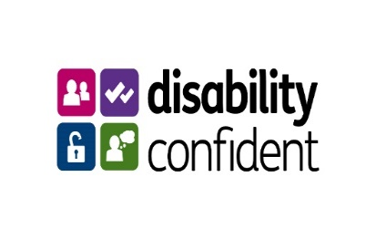
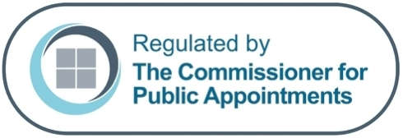


Contents

Welcome Note from the Rt. Hon Heidi Alexander MP, Secretary of State for Transport 3
Welcome Note from Jo Shanmugalingam, Permanent Secretary of DfT 4
About Department for Transport 5
About the role 6
Essential criteria 8
How to apply 9
Indicative timetables: 10
Selection process 10
Additional information 11
Appointment term 11
Time commitment 11
Remuneration 11
Location 12
Availability 12
Security clearance 12
Equal Opportunities Monitoring 12
Disability Confident 12
Nationality 13
Standards in public life 13
Disqualification for appointment 13
Registration of interests 14
Political activity 14
Due diligence 14
Data Protection 14
Complaints 15

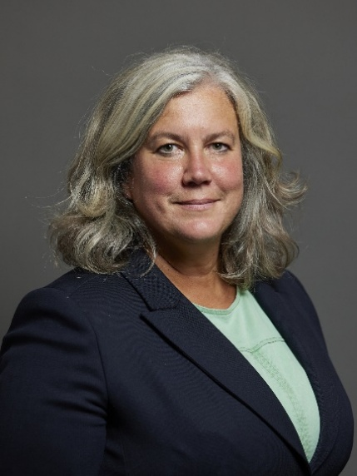
Welcome Note from the Rt. Hon Heidi Alexander MP, Secretary of State for Transport
Dear Applicant,

Thank you for your interest in the Lead Non-Executive Board Member role on the Department for Transport Board.
The Department for Transport covers all modes of transport – roads, rail, air and sea. With our partners and agencies, our work affects everyone in the country. Our purpose is to ensure that the UK has a safe, secure, efficient and reliable transport system that works for the people who depend on it; supporting a strong, productive economy and the jobs and homes people need.
This is an important time for the Department for Transport. We are investing heavily in infrastructure and public transport to improve journeys, boost connections and support economic growth. Central to our mission is delivering transport that works for everyone in our society. We are recruiting for a Lead Non-Executive Board Member to join our team and provide expertise and challenge at the highest levels of the Department to help us achieve our mission.
We strongly welcome applications from all backgrounds. As part of the Department’s commitment to diversity, we believe our public appointments should reflect our customers - the travelling public – who come from all walks of life and have different experiences. We very much welcome fresh talent, expertise, and perspectives, to help us better understand the needs of the communities we serve and support better decision making for all. This includes people who may have never applied for a public appointment – but could bring new ideas, insights and energy.
If you are interested in the role and work of Department for Transport, I would like to encourage you to apply.
Our dedicated DfT Public Appointments Team would be happy to talk through the process and answer your questions.

Rt. Hon Heidi Alexander MP
Secretary of State for Transport

Welcome Note from Jo Shanmugalingam, Permanent Secretary of DfT
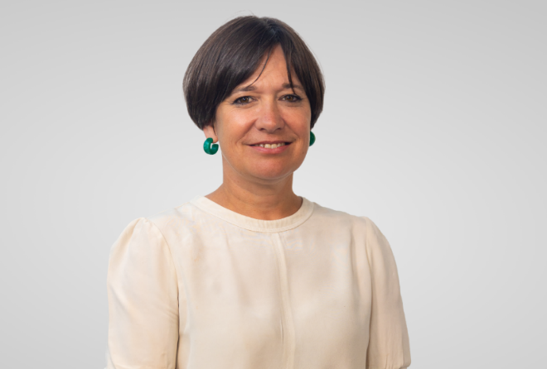

This is a pivotal moment for transport in the UK. The Government is driving forward an ambitious agenda with transport at its heart - from reforming public transport through public ownership of rail and locally controlled bus services, to delivering major infrastructure projects like HS2, Northern Powerhouse Rail and the Lower Thames Crossing. We're modernising our airspace, expanding our airports, and leading the way on decarbonisation and tech transformation internationally. Transport has never been more central to national priorities, and is the engine behind the Government’s growth mission, central to unlocking housing, and with a vital role in the transition to Net Zero. This role will be instrumental in shaping that future across Government and with industry, working closely with the Secretary of State and civil service leadership team.

As a member of the DfT Board, you will also play a critical role in supporting and challenging the Department on our delivery of the Government’s objectives, forming part of a collaborative team committed to delivering for Ministers and the travelling public.

If you are someone who can bring a wealth of relevant expertise and experience to the role, we would love to hear from you.

Jo Shanmugalingam
Department for Transport Permanent Secretary

About Department for Transport
Very few things affect everyday life the same way that transport does. It’s much more than getting from A to B. It’s about enabling individuals to take part in
society. To make connections to work and leisure, education and health, business and the wider world.

At the Department for Transport (DfT) we’re working to improve every kind of
journey. We’re harnessing new technology to create safer, more sustainable transport. And, creating better connections between people and places, we’re enabling greater growth opportunities for communities UK-wide. It all means that here, you are part of something very different and special.

DfT is a ministerial department, supported by 23 agencies and public bodies. DfT and our agencies employ around 15,000 staff, of whom about 3,400 are in the
core Department, and we have the largest and most complex capital project portfolio in Government, delivered principally through delivery partners including Network Rail, HS2 Ltd and Highways England.

We are looking to broaden our presence around the country and have grown new locations in Leeds and Birmingham.

Our Secretary of State’s priorities are:

- Improving performance on the railways and driving forward rail reform
- Improving bus services and growing usage across the country
- Transforming infrastructure to work for the whole country, promoting social
- Mobility and tackling inequality
- Delivering greener transport
- Better integrating transport networks

More information about DfT can be found on our website.

About the DfT Board
The Departmental Board is an advisory body that supports and challenges both the Department for Transport’s ministers and the Permanent Secretary as Principal Accounting Officer. The DfT Board does not decide policy or exercise the powers of ministers.

About the role
We are looking for a Lead Non-Executive Board Member (NEBM). They will support and challenge us at the very top of the organisation during this exciting time and provide high level, quality expertise to help us deliver on our commitments.

Lead Non-Executive Board Member:
Reports to: Secretary of State for Transport

Duration: An initial term of up to 3 years, with the possibility of re-appointment

Remuneration: £20,000 per year for up to 15 days attendance per year

Your key responsibilities, will be to:

- Support and challenge the most senior levels of DfT management including Ministers and the Permanent Secretary, acting as both a trusted advisor and critical friend.
- Utilise your expertise of tackling major national and international projects and programmes in a large organisation in the public, private or voluntary sector to support and advise the Board on the most important issues facing DfT.
- Quickly develop an understanding of a range of highly complex issues to challenge and support the operational delivery and commercial implications of policy proposals, major projects and programmes, strategic and organisational issues.
- Provide valuable insights to discussions on the leadership and performance of DfT at meetings involving the most senior individuals in the organisation.
- Be a leading member of Board sub-committees within the DfT corporate governance framework. This could involve chairing or becoming a member of the Department’s Investment or Delivery Committees, Nominations Committee or the Group Audit and Risk Assurance Committee.

You will play a key role in the effective strategic and operational leadership of DfT in line with the Government’s priorities. You will be expected to bring experience of working with very senior stakeholders and demonstrate that you can bring substantial expertise to a department that has a central role in the Government’s growth agenda.

As the Lead NEBM, you will work closely to support and advise the Secretary of State and the Permanent Secretary in their leadership of the organisation and meet with them regularly to reflect on your role and review performance. You will convene the wider NEBM team to synthesise their views for the organisation and ensure they are supported in their work across the Department. You will also sit as a member on the Department’s Investment Committee and be the Chair of the Department’s Nominations Committee.

Essential criteria
All candidates must be able to provide evidence of the following criteria:

- Leadership: the ability to set strategic vision and drive forward priorities of the organisation with a strong track record in relevant senior leadership role.
- Knowledge: a clear understanding of the work, priorities and challenges of the Department for Transport and the context within which it operates.
- Relationship building: ability to build strong stakeholder relationships, including with Ministers and Senior Government officials and external stakeholders.
- Communication: strong communication and interpersonal skills with the ability to listen, accept challenge and constructively challenge others in discussions with clarity and respect.
- Judgement: effective decision-making skills with the ability to critically analyse a wide range of information to make clear and objective evidence-based recommendations to support the delivery of the Department for Transport's objectives.
- Collaboration: ability to work closely with the executive board and other key stakeholders, providing support, constructive challenge and assurance as appropriate.

Please note, should a large number of applications be received, a shortlist may be undertaken using the following lead criteria:
- Criteria 1: the ability to set strategic vision and drive forward priorities of the organisation with a strong track record in relevant senior leadership role.

How to apply
If you wish to apply for this role, please apply through the Cabinet Office’s Public Appointments website by midday on Wednesday 11th March.
Any applications submitted after the closing date and time, or that are missing any of the following documents, will not be accepted.
- A CV or equivalent biographical information (no more than two A4 pages, minimum 12 font, minimum 12 font) setting out your career history and including details of any professional qualifications.
- Provide a summary of why you are interested in the role and how you meet the specification and essential criteria. This can be in a form that allows you most ably to present your interest and credentials, for example a short, bullet-point slide presentation (no more than 5 slides), a short video (no more than 2 mins) or supporting letter (no more than two A4 pages, minimum 12 font). Make sure you refer to the contents of this document and provide specific examples. If you wish to provide your supporting summary in video format, please contact DfTpublicappointments@dft.gov.uk in advance of the closing date.

- You will also be asked to provide diversity data, and to declare any potential conflicts of interest or reputational issues.
Should you require further information or would benefit from a conversation with one of our existing Non-Executive Board Members, please email DfTpublicappointments@dft.gov.uk in advance of the closing date so it can be arranged.

Indicative timetable:
Please note that these dates are only indicative at this stage and could be subject to change. Please let us know if you are unable to meet these timeframes.

Advert Launch | 17 February 2026
Advert Closing Date | Midday on 11th March 2026
Short List Meeting | March/April 2026
Final Panel Interviews | May 2026
Meeting with Secretary of State (if required) | TBC

Selection process
This role is being competed in accordance with the Governments Governance Code on Public Appointments (October 2025), which sets out the regulatory framework for public appointments processes. The Code is based on three core principles – merit, openness, and fairness.
The selection panels for this role will be as follows:
- Lead NEBM:
  - Panel Chair: Jo Shanmugalingam (DfT Permanent Secretary)
  - Panel members: Jayne-Anne Gadhia (Lead Non-Executive Board Member, HMRC) and Steve Holliday (Senior Independent Panel Member).

At the shortlisting meeting the selection panel will assess each application against the essential criteria and decide who to invite for interview.
Interviews are expected to take place at the Department for Transport offices in London and will last for between 45 and 60 minutes. Further details about the format will be provided to you in advance.
The decision to appoint to this role rests with the Secretary of State. Appointable candidates may be invited to meet with the Secretary of State or another Department for Transport Minister, before they make a final decision.
Please note: Expenses incurred by candidates during the recruitment process will not be reimbursed except in exceptional circumstances and only when agreed in advance with the DfT Public Appointments Team.

Additional information

Appointment term
Your appointment as the Lead NEBM of DfT Board will be made by the Secretary of State.
The appointment will be for an initial term of up to 3 years, with the option of re-appointment by mutual agreement.
It should be noted that this post is a public appointment; Non-Executive Board Members are neither employees of the Crown nor the Department for Transport. Such appointments are not normally subject to the provisions of employment law.
Appointments may be ended prior to the conclusion of the period of appointment.

Time commitment
The anticipated time commitment for the Lead NEBM is a minimum of 15 days per year. The role involves attendance at Board meetings either in person or remotely, providing specialised advice as required, preparation time, travel, and work outside of meetings.

Remuneration
- £20,000 per year for up to 15 days attendance
- If invited to chair a sub-committee, additional remuneration will be provided.
- Remuneration is taxable through payroll, and the appointment is not pensionable.
- Board Members can claim reimbursement for reasonable travel and subsistence costs necessarily incurred at rates set centrally by the Department for Transport.
- Applicants should note that the successful candidates cannot be remunerated for this role if they are being paid for an existing full-time role from the public purse.

Location
The home location for the role will be Great Minster House in London, although travel may be necessary to other DfT Offices including Hastings, Birmingham, Leeds and Swansea.

Availability
The successful candidate is expected to commence the role in late spring/early summer 2026, subject to the successful completion of pre-appointment checks and security clearance.

Security clearance
The successful candidate will be required to have or be willing to obtain security clearance to Security Check (SC) level. Pre-appointment checks will also be undertaken on immigration and criminal convictions. It usually takes between 4-6 weeks to obtain the security clearance. The role will be offered on a conditional basis until the successful candidate has passed all checks.

Equal Opportunities Monitoring
We believe that by being a diverse and inclusive workplace, where everyone is valued, we are more motivated, higher performing and more committed to our team. We welcome all applicants, regardless of gender, sexual orientation, social background, religious beliefs, ethnicity, or age.
As part of the application process, we ask candidates to complete equal opportunities monitoring information in the application portal. This will help us to monitor selection decisions to assess whether equality of opportunity is being achieved. This part of the form will be treated as confidential and used for statistical purposes only. The form will not be treated as part of your application.

Disability Confident
The Department for Transport values and promotes diversity and is committed to equality of opportunity for all and to the appointment of disabled people. As part of the Disability Confident scheme, we will select the disabled candidates who best meet the essential criteria for the role. ‘Best meet’ is defined as providing/demonstrating strong examples of all essential criteria.
In order to guarantee an interview to disabled candidates (as defined by the Equality Act 2010) who best meet all the essential criteria for the role and wish to be considered under the Disability Confident Scheme, we need candidates to declare a disability and that they wish to be considered under the Scheme.
What do we mean by a disability?
To be eligible for consideration under the Scheme, you must be considered disabled under the Equality Act 2010.This means that you must have or have had in the last 12 months, a physical or mental impairment which has a substantial long-term adverse effect on your ability to carry out normal day-to-day activities. This includes those whose disability has lasted, or is likely to last, for 12 months, or if the disability or condition is likely to progress or recur. You do not have to be registered as a disabled person to apply under this scheme.

Nationality
This is a non-reserved post and therefore open to UK Nationals, British Nationals Overseas, British Protected Persons, Commonwealth Citizens, EEA Nationals and certain non-EEA family members and Swiss Nationals under the Swiss EU Agreement. There must be no employment restriction or time limit on your permitted stay in the UK. You will not be asked to produce evidence to confirm your eligibility at the application stage, but you will be required to do so should you be invited to the final panel interview.

Standards in public life
You will be expected to demonstrate high standards of corporate and personal conduct. All successful candidates will be asked to subscribe to the Review Body’s “Codes of Practice”. Candidates will be expected to abide by the “Seven Principles of Public Life” set out by the Committee on Standards in Public Life.

Disqualification for appointment
There are circumstances in which an individual will not be considered for appointment. They include:
- people who have received a prison sentence or suspended sentence of three months or more in the last five years.
- people who are the subject of a bankruptcy restrictions order or interim order.
- in certain circumstances, those who have had an earlier term of appointment terminated.
- anyone who is under a disqualification order under the Company Directors Disqualification Act 1986.
- anyone who has been removed from trusteeship of a charity; and
- Roles listed under the House of Commons Disqualification Act 1975 or the Devolved Administrations equivalent.

Registration of interests
The purpose of these provisions is to avoid any danger of Board members being influenced, or appearing to be influenced, by their private interests in the exercise of their public duties.
Public appointments require the highest standards of propriety, involving impartiality, integrity, and objectivity, in relation to the stewardship of public funds and the oversight and management of all related activities. This means that any private, voluntary, charitable, or political interest which might be material and relevant to the work of the body concerned should be declared. It is important, therefore, that you consider your circumstances when applying for a public appointment and identify any potential conflicts of interest, whether real or perceived.
There is a requirement to declare any actual or potential conflict of interest you may have in being appointed to the Board upon applying. Any actual or perceived conflicts of interest will be fully explored by the Panel at interview stage.

Political activity
Board Members will need to show political impartiality during their time on the Board and must declare any party-political activity they undertake in the period of their appointment. Details of the successful candidate’s declared political activity must be published by appointing departments when the appointments are publicised.
Your political activity will be kept separate from your application and will only be seen by the Panel prior to interview – the Panel may at that stage explore with candidates any potential for conflict of interest. It is appreciated that political activities may have given you relevant skills, including experience gained from committee work, collective decision making, resolving conflict and public speaking. If, therefore, you have had such experience and you consider it relevant to your application for this post, you may if you choose include it separately in the main body of your application.

Due diligence
Due diligence will be carried out as part of the application process. As well as checks made regarding the above, searches will be carried out via internet search engines and any public social media accounts. It will be seen by the Panel prior to interview – the Panel may at that stage explore with candidates any findings.

Data Protection
The Department for Transport (DfT) is the joint controller, with the Cabinet Office, for any personal data which you provide to us as part of your application.
Information provided as part of this application will be kept securely within DfT and destroyed within 5 years of the conclusion of the recruitment campaign.
DfT uses this form to gather evidence on DfT’s public appointments.
The lawful basis that applies to this processing is that it is necessary for the performance of a task carried out in the public interest to inform DfT’s recruitment policies in accordance with the Department’s public sector equality duties. For processing special category personal data (disability, religion, sexual orientation and ethnicity), we rely on Article 9(2)(g), reasons of substantial public interest (equality of opportunity and treatment).

Complaints
If you are not completely satisfied with the way your application is handled at any stage of the competition, please raise any complaint in the first instance with:
Via email: DfT Public Appointments DfTPublicAppointments@dft.gov.uk
Public Appointments Team
Shareholding, Appointments and Inquiries
Department for Transport
Great Minster House
33 Horseferry Road
London
SW1P 4DR

We will reply to your complaint within 20 days.
If you remain unsatisfied, please contact the Office of the Commissioner for Public Appointments. The Commissioner can only investigate complaints relating to regulated Public Appointments.

