


CONTENTS

- Ministerial foreword
- About The Insolvency Service

Role Description

Person Specification

Terms of Appointment

Application process

Application guidance

Contact information
- Indicative timeline

Overview of the selection process

Additional information for candidates

APPENDIX A – Current Board composition

Ministerial Foreword


Dear Candidate,
Thank you for your interest in this exceptional opportunity to join the Insolvency Service as a Non-Executive Director. This is your chance to help shape the future of one of the UK's most impactful government agencies at a genuinely transformative moment in its history as it launches its new strategy.

What We're Looking For
The Insolvency Service is recruiting two Non-Executive Directors to replace retiring board members. We are seeking two outstanding individuals who will bring:
• Deep expertise in personal insolvency allowing them to challenge and support the proposed reforms currently being framed, ensuring the insolvency regime remains world-class whilst becoming more accessible and proportionate, and/or
• Proven change management experience to guide the agency’s digital transformation, operational modernisation, and cultural evolution to enhance their capabilities whilst maintaining service excellence.

Why This Role Matters
The Insolvency Service is a UK government Executive Agency supporting economic growth by maintaining business integrity and confidence. With around 1,800 staff at 11 sites across the UK, it acts as a safety net for the British economy and has: returned £57.5 million to creditors; processed over 69,000 redundancy payments; disqualified more than a thousand directors for misconduct; and completed 169 criminal prosecutions, in the last year. These efforts support individuals recovering from financial hardship and help maintain business confidence in the UK.

A Pivotal Moment for Leadership
Your expertise will be vital to help drive the new strategy to transform the Insolvency Service into a digital-first regulator with greater powers to tackle advanced economic crime. This shift involves investing in AI, data analytics, specialist skills, and updating regulatory frameworks to foster innovation while ensuring strong protections.

The Board Environment
You will support the Board and the Non-Executive Chair to oversee the agency’s strategy, management, and governance. The Board meets up to ten times a year, mainly in Stratford but also at regional offices nationwide.
Please apply if you want an exciting opportunity to help influence an organisation making a meaningful impact on thousands of lives whilst strengthening the UK's economic confidence.

Blair McDougall MP
Minister for Small Business and Economic Transformation
About The Insolvency Service

Our Mission
The principal role of the Insolvency Service is to deliver economic confidence. We do this by supporting those in financial distress, tackling financial wrongdoing, and maximising returns to creditors. We provide the frameworks that deal with insolvency and the financial misconduct that sometimes accompanies or leads to it.
Our aim is a corporate and personal insolvency regime which is regarded as fair and that gives businesses and investors confidence to take the commercial risks necessary to support economic growth. To achieve this, we will maintain and develop a world-class insolvency law and regulatory framework; deliver key public services to support that framework; deliver and promote an effective investigation and enforcement regime; and ensure an organisation devoted to continuous improvement.

Our Structure
We are an executive agency of the Department for Business & Trade (DBT) with headquarters in Stratford, London. We have around 1,800 staff operating from locations across Great Britain.

Responsibilities
We:
- administer bankruptcy, debt relief orders and Breathing Space applications
- administer and investigate certain bankruptcies and compulsory company liquidations, and act as trustee or liquidator where no private sector insolvency practitioner is in place
- provide estate accounting for bankruptcy and liquidation estate funds
- make redundancy payments from the National Insurance Fund to employees made redundant because of an insolvency
- investigate trading companies and take action to wind them up if it is in the public interest

- work to disqualify unfit company directors if there is evidence of misconduct
- investigate and prosecute breaches of company and insolvency legislation and other criminal offences on behalf of DBT
- take action to impose restrictions on those subject to bankruptcy or a debt relief order where their actions recklessly or deliberately contributed to their insolvency
- act as an impartial source of information for the public on insolvency and redundancy matters
- advise DBT ministers and other government departments and agencies on insolvency and redundancy related issues
- act as oversight regulator of the Recognised Professional Bodies that authorise insolvency practitioners

- support Companies House in upholding the integrity of the companies register and delivering the corporate transparency reforms through sharing intelligence and targeting and prosecuting non-compliance.
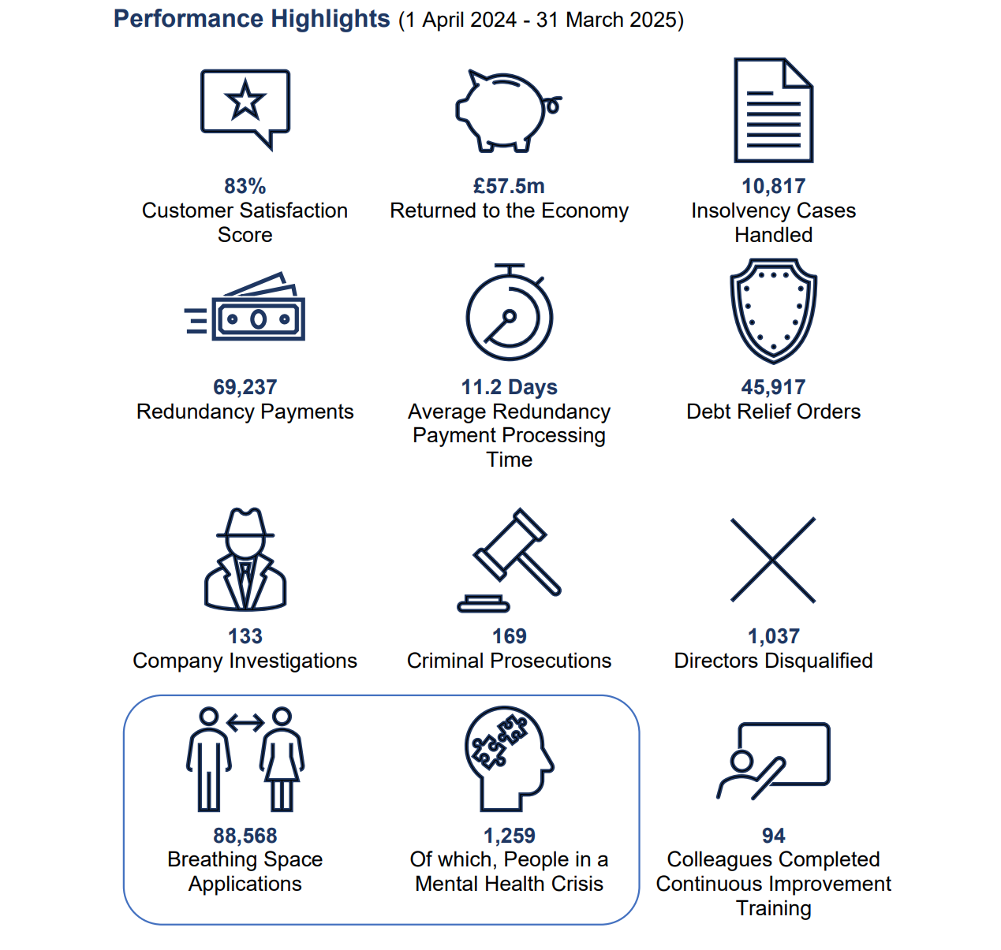

Role Description

All Non-Executive Directors (NEDs) contribute substantially to decisions covering the strategy for the organisation and the overall direction of the business value. They offer wise counsel, advice and challenge, based on their own experiences and successful track records of achievement within competitive environments.
As part of this campaign, the Insolvency Service is looking in particular for individuals with a personal insolvency background and/or change management background. The two incoming NEDs will have the following responsibilities:
- Provide advice, guidance and challenge to the Chief Executive and Executive Directors to support sound strategic and collective decision making in the Insolvency Service.
- Support the delivery of the strategic priorities and contribute to developing and deciding long-term strategies, using skills, experience, and judgement to scrutinise the short and long-term performance of the organisation.
- Ensure the integrity of financial information is maintained, and that financial controls, systems, and risk management are kept robust and defensible.

Person Specification

We are seeking two new Board members to complement the skillset of the existing Board:
- one with senior expertise in personal insolvency
- and the other with expertise in change management.

Essential criteria
For both roles, candidates must demonstrate:
- Proven strategic senior leadership and governance experience, ideally at board level or equivalent in a significant organisation.
- Strong analytical and communication skills with the ability to interpret complex information and contribute to strategic decision-making.
- Ability to work collaboratively, providing constructive challenge and support in a board setting.
- Independence of judgement, bringing a fresh, external perspective to organisational strategy and oversight through the analysis of complex information to reach practical decisions.
- A track record of responding to external change and overseeing risk, particularly in complex or regulated environments.
- Commitment to public service values and ethical standards, with a clear understanding of the responsibilities of public sector governance.
- Outstanding senior-level career achievement in a relevant field (personal insolvency or change management).

Desirable Criteria
Candidates should also bring specific domain level expertise in at least one of the following areas:

Personal Insolvency Expertise NED
- Deep knowledge of personal insolvency, bankruptcy or debt advice such as a practitioner, charity leader or academic.
- Experience in reform, policy development or advocacy within the insolvency or financial inclusion space.
- A respected reputation in the insolvency field, with the ability to challenge and support reform programmes.

Change Management Expertise NED
- A track record of leading digital transformation or major change programmes in a complex organisation.
- Recent familiarity with emerging technologies and their application in service delivery or operational efficiency.
- Understanding of user-centred design, delivering transformational change and innovation in public services to deliver service improvements and cost savings, including impacts on people, process, and technology.

Terms of Appointment

Appointment Term
An initial period of 3 years
Remuneration
£11,000 annual remuneration
Time Commitment
20 days per annum
Location
Board meetings take place in London and at times rotate to different locations across the UK.
Nature of Appointment
This is a Ministerial Appointment by the Secretary of State for Business and Trade. The post holder would be an officeholder and not an employee of the Department for Business and Trade nor The Insolvency Service.
Availability
Successful candidates will be encouraged to take up their appointment at the end of March 2026, following the successful completion of pre-appointment checks and security clearance.
Conflicts of Interest
You must inform Department of Business and Trade and The Insolvency Service if you have any conflict of interest that might affect your ability to undertake this role. You should disclose information on any relevant business interest, public appointment, or position of authority, including other connections with commercial, public or voluntary bodies. This information will be collected as part of the online application process.

Application Process

How to apply
GatenbySanderson, an executive search agency, has been appointed to support Department of Business and Trade on these appointments.
If you wish to apply, please visit: https://gs-inss-nonexecutivedirectors.co.uk/

Please ensure that you provide the following:
- a Curriculum Vitae (CV) - (no longer than two pages) which provides your contact details, details of your education and qualifications, employment history, directorships, membership of professional bodies and details of any relevant publications or awards.
- a supporting statement - (no longer than two pages) setting out how you meet each of the criteria for appointment, as set out in the person specification for the role. Please note that the Supporting Statement is an important part of your application and is as much the means by which you will be assessed as your CV.
- contact telephone numbers as well as your personal email address.

Note: As of October 2025, the Office of Public Appointments will require all applicants to create/have an account on the Public Appointments Website and use that to submit your equality and outside interests declarations as part of the application process. A candidate's application will not be considered without this.

Public Appointments Advert:
https://apply-for-public-appointment.service.gov.uk/roles/9004

You will also have the opportunity to advise us of any reasonable adjustment requirements or apply under the Disability Confident Scheme before you submit your application.
The closing date for applications is Monday 2 February 2026 at 5.00pm.
Once submitted, GatenbySanderson will acknowledge your application.

Application Guidance

Please ensure your CV includes:
- your full name, title, contact number and your personal email address.
- maximum two sides A4, minimum 11 Arial black font, setting out your career history in chronological order, and including the dates you occupied those roles.
- does not include any information that can identify children or your Sensitive Personal Data.
Guidance on supporting statement format
- The supporting statement is your opportunity to demonstrate to the Advisory Assessment Panel how you can demonstrate the skills and experience required for the role and that you meet the criteria set out in the person specification.
- Please provide subheading and separate paragraphs in relation to how you meet each criterion.
- Write all acronyms in full when first used.
- Ensure your full name and the title of the post are clearly noted at the top of your supporting statement.
- The maximum page limit for your supporting statement is two sides A4, minimum 11 Arial font black.
- Do not include any information that identify children or any of your Sensitive Personal Data.

The Advisory Assessment Panel reserves the right to only consider applications that contain all the elements listed above, and that arrive before the published deadline for applications.

Contact Information

For a confidential discussion about these roles, please do contact our recruitment advisers at GatenbySanderson who will be delighted to speak to you:

Russell Brandon, Researcher
russell.brandon@gatenbysanderson.com

Hilda Gjika, Delivery Consultant,
hilda.gjika@gatenbysanderson.com

Darra Power-Mooney, Principal Consultant
darra.power-mooney@gatenbysanderson.com

GatenbySanderson will respect the privacy of any initial approach or expression of interest in this role, whether formal or informal.

Indicative Timeline

The timeline for this campaign is indicative and subject to change. Candidates are asked to note the below timetable, whilst exercising flexibility through the recruitment and selection process.

Closing date for applications | 5pm 2 February 2026
Shortlist meeting | Week of 16 February
Final Panel Process  • Informal Meetings  - Final Panel Interviews  (expected to be in London) | Week of 23 February
Decision | Early March 2026

Overview of the Selection Process

Public appointments are made on merit following a fair and open competition process which is conducted in accordance with the Governance Code for Public Appointments. We will deal with your application as quickly as possible and will keep you informed at key stages. We aim to conclude the appointment process within three months of the deadline for applications – this is in accordance with the Governance Code.
Assessment Advisory Panel
- Panel Chair – DBT Senior Civil Servant, Matilda Curtis, Deputy Director in Company Law and Governance

- The Insolvency Service Chair: Mark Austen

- Independent Panel Member (IPM): To be confirmed

Advisory Assessment Panels (AAP) are chosen by ministers to assist them in their decision-making. These include a departmental official and an independent member. For competitions recruiting non-executive members of a board (apart from the Chair), the panel will usually include a representative from the public body concerned.
AAPs perform a number of functions, including agreeing an assessment strategy with ministers, undertaking sifting, carrying out interviews in line with the advertised criteria and deciding objectively who meets the published selection criteria for the role before recommending to ministers which candidates they find appointable. It is then for the minister to decide who to appoint to the role.
The assessment process
- Ministers are responsible and accountable to Parliament for the public appointments made within their department.
- An Advisory Assessment Panel (“Panel”) is appointed by Ministers to assist them in their decision making. The role of the Panel is to decide, objectively, which candidates meet the eligibility criteria for the role.
- You will be invited to a preliminary discussion with GatenbySanderson. If you have applied under the Disability Confident Scheme and you meet all the essential criteria, then you will also be invited for a discussion.
- At the shortlisting meeting the Panel will assess applications against the eligibility criteria and decide which candidates have best met the criteria, who should be recommended for interview.
- Those shortlisted will be invited to an interview.

- The Panel will meet again to interview candidates and determine who is appointable to the role. The Panel may invite you to make a brief presentation at the start of the interview and will go on to question you about your skills and experience, including asking specific questions to assess whether you meet the criteria set out for the post. The Panel will also explore with you any potential conflicts of interest or any other issues arising from your personal and professional history which may impact on an appointment decision.
- Details of the panel’s assessment of interviewed candidates are provided to Ministers, including whether they have judged a candidate to be appointable to the role. It is then for Ministers to determine merit and decide who should be appointed. In some circumstances, Ministers may choose not to appoint any candidates and re-run the competition.
- Ministers may choose to meet with candidates before deciding the outcome. Candidates should therefore be prepared for a short time gap between interview and a final appointment decision being made. Candidates who have been interviewed will be kept informed of progress.
- Once the decision on the appointment has been made, interviewed candidates will be advised of the outcome of their application, including whom they may approach for feedback. Successful candidates will be issued with their Terms & Conditions, and a letter of appointment should they agree to take up the position.

Further information about appointments, including tips on applying, can be found on guidance pages on gov.uk.

Eligibility criteria

In general, you should have the right to work in the UK to be eligible to apply for a public appointment. The Government expects all holders of public office to work to the highest personal and professional standards. You cannot be considered for a public appointment if:
- you are disqualified from acting as a company director (under the Company Directors Disqualification Act 1986).
- have an unspent conviction on your criminal record.
- your estate has been sequestrated in Scotland, or you enter into a debt arrangement programme under Part 1 of the Debt Arrangement and Attachment (Scotland) Act 2002 (asp 17) as the debtor or have, under Scots law, granted a trust deed for creditors.

When you apply, you should declare if:
- you are, or have been, bankrupt or you have made an arrangement with a creditor at any point, including the dates of this.
- you are subject to a current police investigation.
You must inform the Department if, during the application process, your circumstances change in respect of any of the above points.
When you apply you should also declare any relevant interests, highlighting any that you think may call into question your ability to properly discharge the responsibilities of the role you are applying for. You should also declare any other matters which may mean you may not be able to meet the requirements of the Code of Conduct of Board Members (see Outside interests and reputational issues section below).
If you need further advice, please contact russell.brandon@gatenbysanderson.com

Security clearance
The successful candidate will be required to undertake Baseline Personnel Security Standard checks in line with the Civil Service guidelines.

Demystifying Vetting
For further information on National Security Vetting please visit the following page https://www.gov.uk/government/publications/demystifying-vetting
These short videos address common concerns and preconceptions which applicants may have about national security vetting.
Further information on National Security Vetting can be found on the Gov.uk website here.

Additional Information for Candidates

Equality and diversity

We encourage applications from talented individuals from all backgrounds and across the whole of the United Kingdom. Boards of public bodies are most effective when they reflect the diversity of views of the society they serve, and this is an important part of the Government’s agenda. We collect data about applicants’ characteristics and backgrounds, including information about people’s educational and professional backgrounds, so that we can make sure we are attracting a broad range of people to these roles and that our selection processes are fair for everyone. Without this information, it makes it difficult to see if our outreach is working, if the application process is having an unfair impact on certain groups and whether changes are making a positive difference.
When you submit your application, your responses are collected by the Cabinet Office and the government department(s) managing your application. The data is used to produce management information about the diversity of applicants. You can select “prefer not to say” to any question you do not wish to answer. The information you provide will not be seen by the Advisory Assessment Panel who review applications against the advertised criteria and conduct interviews.

Disability confident

We are a member of the Government’s Disability Confident scheme. We use the Disability Confident scheme symbol, along with other like-minded employers, to show our commitment to good practice in employing people with a disability. The scheme helps recruit and retain disabled people. As part of implementing the scheme, we guarantee an interview for anyone with a disability whose application meets the essential criteria for the role, set out in the advert, and who has asked that their application is considered under the scheme. Indicating that you wish your application to be considered under the scheme will in no way prejudice your application. By ‘essential criteria', we mean that you must provide evidence which demonstrates that you meet the level of competence required under each of the essential criteria, as set out in the job advert. When you apply you will have the opportunity to select if you would like your application considered under this scheme.

Reasonable adjustments

We are committed to making reasonable adjustments to make sure applicants with disabilities, physical or mental health conditions, or other needs are not substantially disadvantaged when applying for public appointments. This can include changing the recruitment process to enable people who wish to apply to do so. Some examples of common changes are:

- ensuring that application forms are available in different or accessible formats.
- making adaptations to interview locations.
- allowing candidates to present their skills and experience in a different way.
- giving additional detailed information on the selection / interview process in advance to allow candidates time to prepare themselves.
- allowing support workers, for example sign language interpreters.
- making provision for support animals to attend.

When you apply you will have the opportunity to request reasonable adjustments to the application process.

Principles of public life

The Seven Principles of Public Life (also known as the Nolan Principles) apply to anyone who works as a public officeholder.
- Selflessness: Holders of public office should act solely in terms of the public interest.
- Integrity: Holders of public office must avoid placing themselves under any obligation to people or organisations that might try inappropriately to influence them in their work. They should not act or take decisions in order to gain financial or other material benefits for themselves, their family, or their friends. They must declare and resolve any interests and relationships.
- Objectivity: Holders of public office must act and take decisions impartially, fairly and on merit, using the best evidence and without discrimination or bias.
- Accountability: Holders of public office are accountable to the public for their decisions and actions and must submit themselves to the scrutiny necessary to ensure this.
- Openness: Holders of public office should act and take decisions in an open and transparent manner. Information should not be withheld from the public unless there are clear and lawful reasons for so doing.
- Honesty: Holders of public office should be truthful.
- Leadership: Holders of public office should exhibit these principles in their own behaviour and treat others with respect. They should actively promote and robustly support the principles and challenge poor behaviour wherever it occurs.
Code of conduct for board members
The Government expects all holders of public office to work to the highest personal and professional standards. In support of this, all non-executive board members of UK public bodies must abide by the principles set out in the Code of Conduct for Board Members of Public Bodies. The Code sets out the standards expected from those who serve on the boards of UK public bodies and will form part of your terms and conditions of appointment.
Management of outside interests and consideration of reputational issues:

Holders of public office are expected to adhere and uphold the Seven Principles of Public Life and the Code of Conduct for Board Members of Public Bodies. Before you apply you should consider carefully:
- any outside interests that you may have, such as shares you may hold in a company providing services to government.
- any possible reputational issues arising from your past actions or public statements that you have made.
- and/or - any political roles you hold or political campaigns you have supported, which may call into question your ability to do the role you are applying for.
You will need to answer relevant questions in relation to these points when making an application. Many conflicts of interest can be satisfactorily resolved and declaring a potential conflict does not prevent you from being interviewed. If you are shortlisted for an interview, the panel will discuss any potential conflicts with you during that interview, including any proposals you may have to mitigate them and record that in their advice to ministers.
Alongside your own declaration, we will conduct appropriate checks, as part of which we will consider anything in the public domain related to your conduct or professional capacity. This may include searches of previous public statements and social media, blogs or any other publicly available information. The successful candidate(s) may be required to give up any conflicting interests, and their other business and financial interests may be published in line with organisational policies.
Details of declared political activity will be published when the appointment is announced, as required by the Governance Code (political activity is not a bar to appointment, but must be declared).
If you have queries about this and would like to discuss further, please contact russell.brandon@gatenbysanderson.com

Status of appointment
As this is an office holder appointment, you will not become a member of the Civil Service. You will not be subject to the provisions of employment law.
Appointment and tenure of office
Appointments are for the term set out in this pack, with the possibility of re-appointment for a further term, at the discretion of Ministers. Any re-appointment is subject to satisfactory annual appraisals of performance during the first term in the post. There is no automatic presumption of reappointment; each case should be considered on its own merits, considering a number of factors including, but not restricted to, the diversity of the current board and its balance of skills and experience. In most cases, the total time served in post will not exceed more than two terms or ten years in any one post.
Remuneration, allowances and abatement
Remuneration for this role is treated as employment income and will be subject to tax and National Insurance contributions, both of which will be deducted at source under PAYE before you are paid. You can claim reimbursement for reasonable travel and subsistence costs which are properly and necessarily incurred on official business, in line with the travel and subsistence policy and rates for the organisation to which you are applying. However these payments are taxable as earnings and will be subject to tax and national insurance, both of which will be deducted at source under PAYE before you are paid.
Pension and redundancy
This is an office holder appointment and does not attract any benefits under any Civil Service Pension Scheme. You will not be eligible for redundancy pay as you are not an employee. No other arrangements have been made for compensation upon the end of your term of appointment because an office holder who is appointed for a limited duration would have no expectation of serving beyond that period.
How to complain
We aim to process all applications as quickly as possible and to treat all applicants with courtesy. Please contact GatenbySanderson in the first instance if you would like to make a complaint regarding your application sara.prescott@gatenbysanderson.com They will acknowledge your complaint upon receipt and respond within 15 working days.
Data protection
The Cabinet Office will use your data in line with our privacy policy. The Department for Business and Trade will use your data in line with their departmental privacy notice for candidates applying for a public role at DBT.

Appendix A –

Current Board Composition

Main board

The main board:
- handles all aspects of our organisation, including performance, finances and strategic direction
- reports to the Department for Business and Trade on our governance, strategy, priorities and progress

Main board members

- Mark Austen (Chair)
- Samantha Durrant (Non-Executive Director)
- Rob Hunt (Non-Executive Director)
- Gary Kildare (Non-Executive Director)
- Lorcan O’Connor (Non-Executive Director)
- Frances Coulson (Non-Executive Director)
- Matilda Curtis (DBT Representative)

For board profiles please visit https://www.gov.uk/government/organisations/insolvency-service



GatenbySanderson
Finding senior leaders for complex, high-profile roles in regulated environments.

Leeds Oﬃce
14 King Street LS1 2HL
0113 205 6071

London Oﬃce
18 King William Street EC4N 7BP
0207 426 3960

Birmingham Oﬃce
55 Colmore Row B1 2AA
0121 644 5700

Manchester Oﬃce
29 John Dalton Street M2 6DS
0113 205 6071

