


Appointment of
Member of IPSA’s Board (Former MP)
June 2025
Welcome from the Speaker of the House of Commons


Thank you for your interest in the role of Board Member (Former Member of Parliament) of the Independent Parliamentary Standards Authority (IPSA).
IPSA was created by the Parliamentary Standards Act 2009, as the world’s first fully independent regulator of MPs’ financial remuneration.
Today, it regulates and administers the business costs and determines the pay of the 650 elected MPs in the UK and administers the payroll of their 3,500 staff.
It has three principal aims: to resource and support MPs appropriately to carry out their parliamentary functions; to assure the public that MPs’ use of taxpayers’ money is well regulated; and to enable IPSA’s people to be a high-performing, professional team.
In recent years, IPSA has embarked on a programme of change, focusing on providing a higher-quality, more responsive service and a simpler regulatory framework which has helped MPs and their staff do their work, while commanding public confidence. Getting this right is crucial for a well-functioning Parliament and healthy democracy.
Under the Parliamentary Standards Act 2009, the IPSA Board has a Chair and four other members, some of whom are required to have particular professional backgrounds. We are now looking to recruit an individual who has been (but is no longer) a Member of Parliament.
We are looking for an individual who will bring parliamentary experience, political understanding and broader professional expertise to the IPSA Board. They will help the Board set IPSA’s direction during the next stage of its development, including on matters such as pay and pensions, corporate strategy, and organisational transformation, and to apply their professional expertise to help guide IPSA to do so ambitiously but with due consideration for the experience of Members. This demanding role requires integrity and independence and offers a real opportunity to deliver lasting change and contribute personally to the future of our democracy.
I hope that a diverse range of people with the right mix of experience and skills will apply to take on this important role.


Rt Hon Sir Lindsay Hoyle MP, Speaker of the House of Commons

A message from IPSA’s Chair

On behalf of everyone at IPSA, I am delighted that you have indicated your interest in applying to become a member of IPSA’s Board.
It is an important time to join our organisation as we continue to transform our regulatory approach. Our revised model supports MPs to better decide how they want to carry out their parliamentary work, within the guardrails set by IPSA.
We have a clear purpose, strong values and robust strategic objectives, expressed in our Corporate Plan 2024-27, through which we will continue to play our part in supporting Parliament and maintaining trust in democracy.
The statutory requirements for membership of the Board of IPSA are specific. The Board is made up of myself and four individuals, each bringing experience and skills from our different backgrounds. This gives us a breadth of views that are central to our work and a great strength. But our respective contributions are not limited to our areas of expertise. We are individually and collectively responsible for all that the Board decides, working with the Executive and embodying the organisation’s values.
In this recruitment, we are seeking a candidate whose experience can help IPSA to not only navigate a changing risk landscape and support the organisation’s transformation, but also offer valuable insight in relation to the effect of IPSA’s approach to regulation and customer service provision on MPs and their staff. We are looking for candidates who can support reforms to our regulatory approach and continuous operational improvement in line with our statutory remit.
Within this field, we are keen to attract a diverse range of individuals who meet the statutory requirements and have a deep understanding of transformative change in regulatory environments. In particular, we would value experience of scrutinising organisational risk management, compliance, and horizon-scanning for evolving, emerging risks in the external environment. We would also value applications from candidates committed to the effective and secure use of technology and data as enablers of customer service.
Membership of the Board can, at times, be challenging and bring public scrutiny. But, most of all, it is an important and fascinating task, and one we have been entrusted by Parliament to perform on behalf of the electorate.
IPSA is committed to doing all we can to promote a diverse and family-friendly Parliament, and as an employer we are working hard to demonstrate this commitment to diversity, equality, and inclusion. We are anxious to reflect in our own organisation, including the Board, the diverse population that MPs represent.
I hope you find the information in this recruitment pack and on our website helpful in making your decision to apply.


Richard Lloyd OBE, Chair, IPSA
Summary
We are looking to recruit a former Member of Parliament to serve on the Board of the Independent Parliamentary Standards Authority (IPSA).
IPSA is the independent body that regulates and administers public funding in support of MPs’ parliamentary duties. It was set up by the Parliamentary Standards Act 2009, which provides that its Board should be made up of a Chair and four members, one of whom (the “Parliamentary Member”) must have been (but is no longer) a member of the House of Commons.
This is a part-time position, requiring approximately 2-3 days’ work a month, remunerated at a rate of £550 a day. Board members are expected to attend meetings of the Board in London once every two months and sub-committee meetings, as required.
The key requirements of the post are an understanding of the role of MPs and the challenges they and their staff face, and an ability to command confidence across the political spectrum. Also required are some experience of contributing to an organisation’s strategy, governance, or performance at a senior level, and ability to work collaboratively at Board level, improving Board and organisational performance.
This role is an opportunity to contribute personally to the future of our parliamentary democracy by influencing the future direction of IPSA and ensuring it meets the needs of MPs and the expectations of the public.
The recruitment is being managed by an independent panel on behalf of the Speaker of the House of Commons, with the assistance of the executive search company, Saxton Bampfylde. The panel will report a list of appointable candidates to the Speaker who will make the final selection, after consulting the Speaker’s Committee on the IPSA (SCIPSA). The recommended candidate will then be subject to approval by the House of Commons and to appointment by His Majesty the King.
The selection panel is committed to attracting a diverse range of candidates and would welcome applicants from all backgrounds, communities and regions of the United Kingdom, particularly from groups who are currently under-represented on the IPSA Board.
The deadline for applications is 12 midnight on 6 July 2025.
About IPSA
The Independent Parliamentary Standards Authority (IPSA) is the independent body that regulates and administers public funding in support of MPs’ parliamentary duties. Created by the Parliamentary Standards Act 2009, we make fair and impartial decisions about MPs’ pay, pensions and business costs.

Our purpose
Our purpose is to support trust in democracy with great service, fair rules and wise spending.

Our vision
We want to enable MPs to focus on what really matters by providing an exemplary, seamless regulatory service.

Our values
Our values are deeply ingrained principles that guide all that we do. They are a fundamental part of our identity, cornerstones of our culture, and are never compromised.
They are:
- Staying connected – we’re connected to each other and our customers by a common purpose.

- Seeing the bigger picture – we have foresight and always try to see the bigger picture. We anticipate needs to ensure the service we deliver is seamless.

- Being open – we listen to understand, and we act with tact and empathy.

- Doing the right thing - we make independent decisions based on balanced and fair judgments. If we make a mistake, we fix it quickly.

- Making a difference - we are knowledgeable, friendly and helpful. We understand our customers and deliver exemplary service.

Our structure
IPSA’s work is organised around five main functions: MP Services, Strategy and Change, Finance, Policy and Engagement, and Legal, Audit, Risk and Assurance. There are currently 98 members of the IPSA team.

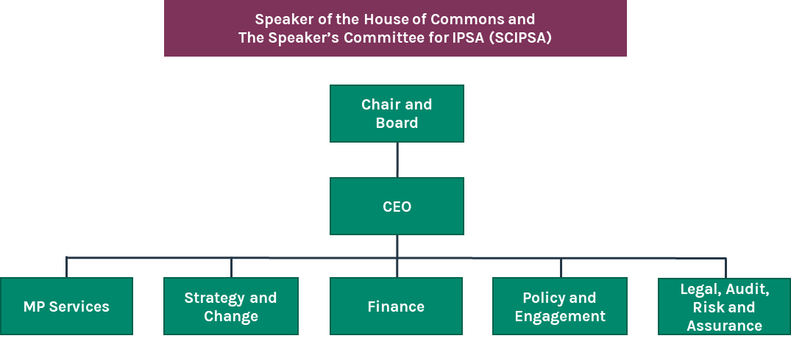

Our background
IPSA is independent of Parliament, the Government and of political parties.
We started operations at the General Election in May 2010. Since 2011, we have also had responsibility for setting MPs’ pay and pensions, on which we must consult and announce a determination within the first year of a Parliament, and at other times as may be appropriate.
Our oversight of MPs’ expenditure represented a clean break from the old system of ‘allowances’. The principles which we set in relation to MPs’ business costs need to be clear, proportionate and fair. We take a risk-based approach to reviewing MPs’ expenditure, ensuring fast reimbursement alongside value for money and assurance for the UK taxpayer.
We are in the process of implementing a new regulatory approach which will provide MPs with greater flexibility to make decisions about what to spend money on to best service their constituents within a framework of clear expected standards of behaviour and action.
In 2025-26, IPSA has an annual budget for MPs’ staffing and businesses costs of c£280m, and an operational budget of £11.8m.
We process almost 4,800 MPs’ staff contract changes every year, alongside 450 office and accommodation registrations, answer hundreds of calls and emails every day whilst supporting MPs and their staff to self-serve online.
The Speaker’s Committee for IPSA
IPSA’s work is overseen by the Speaker’s Committee for the IPSA (SCIPSA). The Committee has a responsibility to ensure that IPSA’s estimate is consistent with the efficient and cost-effective discharge of its functions.
The Committee has eleven members - the Speaker of the House of Commons, the Leader of the House of Commons, the Shadow Leader of the House of Commons, the Chair of the Committee on Standards, three further MPs from the governing party, one MP from the third largest party, and three lay members. Lay members are defined as individuals who have never served as Members of Parliament, they each serve five-year terms, and their appointment is agreed by the House of Commons.
SCIPSA also considers the candidates proposed by the Speaker for the posts of IPSA’s Chair and Board members when vacancies arise, following an open competition. The candidates for these posts are then approved by the House of Commons and appointed by His Majesty The King.

The role of IPSA’s Board
The Board provides the strategic leadership of IPSA, safeguarding its independence, acting as an advocate for its values and delivering its objectives: meeting its statutory duties; helping to maintain confidence in Parliament; and providing efficient and cost-effective administration of services which meet the needs of taxpayers, MPs and their staff.
The Board ensures that IPSA exercises its statutory obligations, including:
- The review and setting of MPs’ salaries;
- The review and development of the MPs’ pensions scheme; and
- The operation and review of the Scheme of MPs’ business costs (‘the Scheme’).
The Board sets the strategic priorities for IPSA as an organisation ensuring it is efficient, cost-effective and fit-for-purpose and delivers its objectives. In doing so, the Board:
- Contributes to the development and articulation of IPSA’s vision, values, strategies and plans, and shares, champions and demonstrably lives the values;
- Sets the policy framework for MPs’ business costs;
- Oversees the development of, and approves, a Corporate Plan, Annual Report and Estimate of IPSA’s use of resources; and
- Sets the risk appetite and approves the framework of internal controls in support of the achievement of IPSA’s strategic objectives.
The Board also:
- Reviews and approves the Scheme for MPs’ business costs and assesses and ensures compliance with Scheme rules;
- Determines the salaries to be paid to MPs, including mechanisms for review and up-rating of salaries;
- Scrutinises the performance of the organisation in meeting its objectives and holds the Executive to account for their delivery;
- Determines and reviews the procedures used by the Compliance Officer;
- Proposes and, from time to time, revises a Code of Conduct for members of IPSA’s Board; and
- Appoints and determines the terms and conditions of the Chief Executive Officer.
The Board meets normally once every two months, either in person at IPSA’s offices or occasionally via virtual meeting platforms, with notice given well in advance. The Board currently has three subcommittees: the Audit and Risk Assurance Committee, the People Committee, and the Improving IPSA Assurance Group. The respective remits of the subcommittees are detailed in the Board’s Standing Orders.
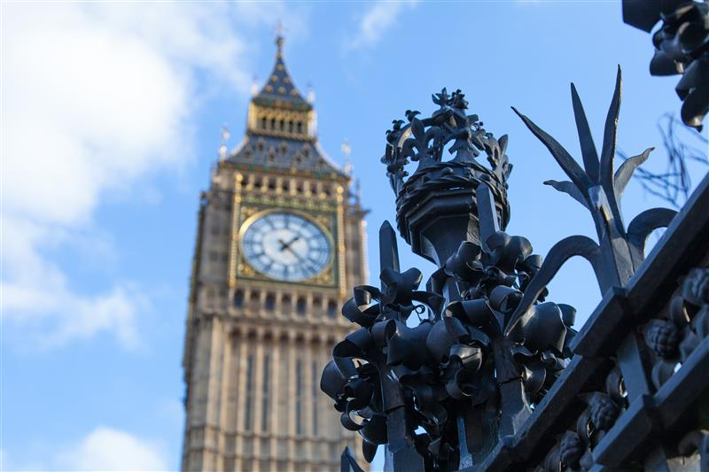

The role of IPSA Board Member (Former MP)
Statutory requirements
The Parliamentary Standards Act 2009 requires that:
- The Board of IPSA is made up of a Chair and four members.
- At least one member must have held, but no longer hold, high judicial office;
- At least one member must be eligible for appointment as a statutory auditor by virtue of Chapter 2 of Part 42 of the Companies Act 2006; and
- At least one of the members (the ‘Parliamentary Member’) has been (but is no longer) a member of the House of Commons.
- Apart from the Parliamentary Member, no one who has been an MP at any time within the last five years may be a member of the Board of IPSA.

Role description
As the Parliamentary Member of the IPSA Board, you will use your parliamentary and wider life experience to help set IPSA’s strategic direction, ensure robust governance, and support the organisation’s ongoing transformation. You will play a vital role in maintaining public trust in Parliament by ensuring IPSA’s work is effective, fair, and responsive to the needs of MPs, their staff and the public.

Key responsibilities
Working with other members of the Board, you will:
- Support the Chair and IPSA’s Executive in developing its Corporate Plan, approving its Annual Report and Accounts, Business Plan, and budget Estimate.
- Establish with the Board the strategic direction of IPSA and ensure compliance with IPSA’s statutory duties including reviewing and setting MPs’ pay, reviewing and developing the MPs’ pension scheme, and establishing the Scheme of MPs’ Business Costs.
- Work closely with the Chair and Executive to maintain strategic direction and monitor performance, including risk management and the promotion of IPSA’s vision and values.
- Represent IPSA in meetings with external stakeholders as agreed with the Chair.
- Commit to IPSA’s values, abides by the Board’s code of conduct, and support equality, diversity, and inclusion.
- Be a member of the Audit, Risk, and Assurance Committee and either the People Committee or the Improving IPSA Assurance Group.


Essential criteria
- Have recently served as a Member of the House of Commons and not currently be an MP.
- Awareness of the UK’s political environment, and an understanding of the role of MPs and the challenges they and their staff face, with a demonstrable ability to command confidence across the political spectrum.
- Experience of contributing to, or scrutinising, an organisation’s strategy, governance, or performance at a senior level, assessing complex information, making balanced judgements, and providing constructive challenge.
- Ability to work collaboratively at Board level, fostering open, constructive, and robust dialogue, continuously improving Board and organisational performance, and respecting the boundaries between non-executive and executive responsibility.
- Proven ability to work effectively with a diverse range of colleagues and stakeholders, and a commitment to public service values, equality, diversity and inclusion.
- Demonstrable integrity, independence, and sound judgement.

Desirable criteria
- Recent experience working as a Board member in an executive or non-executive capacity, supporting or leading organisational change.
- Experience of improving organisational capability and performance through the adoption of digital technology.
- Understanding of principles-based regulation.

Terms of appointment

Remuneration: £550 per day.
Length of term: up to five years (with the possibility of reappointment subject to open competition).
Time commitment: this role requires a commitment of approximately 2–3 days a month. Board meetings are usually held in London, once every two months.

Independence and political activity
The IPSA Board’s Code of Conduct requires that Board members must observe the highest standards of impartiality, integrity and objectivity in carrying out their duties and responsibilities. IPSA operates in a political environment and must maintain the confidence of MPs of all parties and their staff as well as the public. Political restrictions are set out in statute, and the IPSA Board’s Code of Conduct.
There is no bar on the former Parliamentary Member of the Board continuing to be a party member but they must be able to demonstrate independence and command confidence across the political spectrum. They may not occupy paid party-political posts or hold particularly sensitive or high roles in a political party, nor engage in specific political activities or matters directly affecting the work of IPSA. Further details are included in the IPSA Board’s Code of Conduct.
In the interests of transparency, applicants will be asked to disclose political activity within the last 10 years.

Standards in Public Life
Although the appointment does not come within the remit of the Commissioner for Public Appointments, it is being made using a process which takes into account the relevant guidance in the Government’s Governance Code. The Seven Principles of Public Life must be upheld by all those taking up Public Appointments.

Security clearance and checks
Successful candidates will be required to complete pre-employment checks. They will be required to have, or be willing to obtain, a Counter-Terrorism Check (CTC). This involves successful completion of the Baseline Personnel Security Standard (BPSS) and a security questionnaire, a check of both spent and unspent criminal records, a check of Security Service (MI5) records, and of company records (e.g. personal files, staff reports, sick leave returns and security records).
The process will also be subject to standard employment reference checks, and social media footprints will be reviewed as part of the recruitment process.


Appointment process

Saxton Bampfylde
Saxton Bampfylde has been engaged as an executive search firm to support the recruitment panel in the appointment of the role.

Applications
Applications should be made no later than 12 midnight on 6 July 2025. Candidates should apply for this role through our website at saxbam.com/appointments using the code: GBTKB. Please click on the ‘apply’ button and follow the instructions to upload a CV and cover letter
and complete online.

As part of the application process, you will also be asked to complete the following:

- The names and contact details for two referees. These must be people who know you in a professional capacity to comment on your suitability for the post and will be expected to have authoritative and personal knowledge of your achievements. References will be taken by telephone for all candidates selected for final interview as soon as the interview arrangements have been made. Referees should be advised accordingly, please include their details with your application.

- Diversity Monitoring form.

- Candidates invited to interview will be asked to complete a Conflicts of interest, political activity and statutory eligibility declaration form. This may include:
  - Any personal or financial interests which may reasonably have a bearing – or have the potential to be perceived to have a bearing – on your impartiality or objectivity. These will include both pecuniary and non-pecuniary interests which members of the public might reasonably think could influence the judgement of the Chair and Board Members of IPSA.
  - Paid and unpaid appointments, consultancy, trusteeships, directorships, advisory and voluntary roles; and
  - Any financial connection that you or your close family members or associates have that may be connected to the work of the IPSA. (For these purposes an associate is defined as someone who is not a family member but with whom you have frequent or significant contact, or shared interests, and where a connection which is not disclosed might give rise to perceptions of a conflict of interest);
  - any political activity undertaken in the last 10 years;
  - a confirmation that the candidate meets the statutory eligibility requirements of the role.
GDPR personal data notice
According to GDPR guidelines, we are only able to process your sensitive personal data (such as racial or ethnic origin, political opinions, religious or philosophical beliefs, trade union membership or sexual orientation) with your express consent. You will be asked to complete a consent form when you apply. Please do not include any sensitive personal data in your CV (although this can be included in your covering letter if you wish to do so), remembering also not to include contact details for referees without their prior agreement.

Indicative timeline
We will offer as much flexibility as we can, but it may not be possible to offer alternative dates for interviews. We ask you to note the below timetable and exercise flexibility throughout the recruitment and selection process to meet the dates given.
- Applications close: 6 July 2025
- Longlist interviews with Saxton Bampfylde: 28 July to mid-August 2025
- Shortlist meeting with panel: w/c 25 August 2025
- Opportunity for informal meetings with senior stakeholders for shortlisted candidates: w/c 8 September 2025
- In-person panel interviews: w/c 22 September 2025
At the interview stage, Saxton Bampfylde will take up references for all short-listed candidates. These would be sought before the final panel interview. In addition, due diligence and social media checks will be conducted before interviews.

Candidates will be briefed and kept fully informed throughout the process.

Feedback will be available only to those candidates who are longlisted. Feedback will also be provided at subsequent stages.
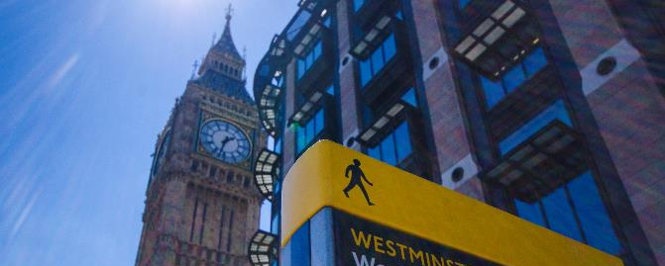
The appointment process
This appointment is made in accordance with the process set out in the Parliamentary Standards Act 2009. The Act provides that a preferred candidate is selected by the Speaker on merit, on the basis of a fair and open competition, and with the agreement of the Speaker’s Committee for the IPSA. The Board member is to be appointed by His Majesty the King following an address by the House of Commons.
The Speaker has appointed a panel to manage the recruitment process and to make recommendations in respect of the proposed appointment. The panel will interview the shortlisted candidates and report to the Speaker the candidates whom they consider appointable. The Speaker will consult SCIPSA and make the final selection from the panel’s list of appointable candidates. An appointment motion will then be debated in the House of Commons. If approved by the House of Commons, His Majesty the King will then be asked to make the appointment.
The selection panel will be as follows:
- Philippa Helme CB, Independent Chair
- Cindy Butts, Lay Member, House of Lords Conduct Committee and former Lay Member, SCIPSA
- Richard Lloyd OBE, Chair of IPSA
- Theresa Middleton CBE, Lay Member, SCIPSA.

Commitment to equality, diversity and inclusion
The selection panel is committed to attracting a diverse range of candidates and would welcome applicants from all backgrounds, communities and regions of the United Kingdom, particularly from groups who are currently under-represented on the IPSA Board.
The panel will be exercising the ‘Equal Merit’ approach at the longlisting, shortlisting, and interview stages.
If you have a disability or any kind of access requirement, please let us know if we can make any reasonable adjustments to enable you to apply for and succeed in this role.
The panel is committed to progressing all applicants that make a claim under the Disability Confident Scheme to the next stage of the recruitment process, where sufficient evidence of meeting the person specification has been provided.
To be eligible, your disability must be within the definition laid down in the Equality Act 2010. A disabled person is defined by the Equality Act 2010 as someone who has a physical or mental impairment, which has a substantial and long-term adverse effect on their ability to perform normal day-to-day activities. For the purposes of this policy, these words have the following meanings:
- ‘substantial’ means more than minor or trivial;
- ‘long-term’ means that the effect of the impairment has lasted, or is likely to last, 12 months (there are special rules covering recurring or fluctuating conditions);
- ‘normal day-to-day activities’ include everyday things like eating, washing, walking and going shopping.
Should you consider yourself eligible to apply for this post under the Disability Confident Scheme, you will be able to indicate this in the online application portal.
Similarly, a veteran or reservist can apply under the Armed Forces and Veteran Scheme. If you apply under this scheme and meet the minimum criteria for the role, you’ll progress to the next stage of our application process.
If you are a veteran or reservist, please make sure you indicate that you would like to be considered for the scheme when you are applying for a role.


Complaints
If at any point you are dissatisfied with the recruitment process for this role, please contact Kevin Candy, Secretary to SCIPSA at candyk@parliament.uk.

LONDON
9 Savoy Street
London WC2E 7EG

EDINBURGH
46 Melville Street
Edinburgh EH3 7HF

saxbam.com

Partners in Panorama - Search around the world
panoramasearch.com

