

Science and Technology Advisory Council (STAC)
  - Department for Energy Security and Net Zero

  - Member application cover sheet
  - Application closing date: 12 January 2025 (19:00)

Please contact the STAC secretariat at stac.secretariat@energysecurity.gov.uk if you have any questions or require further information.
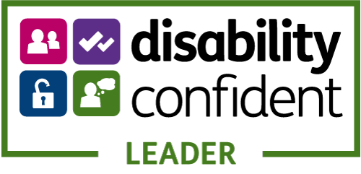
If you need a version of this document in a more accessible format, please email alt.formats@energysecurity.gov.uk. Please tell us what format you need. It will help us if you say what assistive technology you use.

Application information
Name: | Click or tap here to enter text.
Route advert found: | Choose an item.

Expertise
Please select all boxes below that align with your expertise, qualifications, or positions held.
Area of expertise | Expertise held
Energy transition and decarbonisation of industry and buildings | ☐
Energy infrastructure, systems and networks | ☐
Energy security and resilience | ☐
Earth, atmospheric, and climate sciences | ☐
Next generation energy technologies | ☐
Enabling emerging technologies (such as digital, artificial intelligence and advanced manufacturing), | ☐
Green/clean industries and skills | ☐
Economics | ☐
Social or behavioural science | ☐
Data science | ☐
Statistics | ☐
Modelling | ☐
Other | Click or tap here to enter text.

Confirmation of requirements
Requirement | Confirmation
I confirm that to submit my application I will include the following documents: cover sheet; CV; Diversity Information and Conflicts of Interest Form. | ☐
I confirm I would be prepared to complete and return a separate form in relation to referees, if required upon shortlisting. | ☐
I confirm I would undertake Baseline Personnel Security Standard checks, or additional Security Check (SC) clearance, in line with the Civil Service guidelines, if appointed and required for the role. | ☐
The applications of individuals who were not appointed in this recruitment campaign will be retained for a period of 4 years to allow such individuals to be called upon with opportunities to participate in STAC sub-groups, as required and if suitable. I confirm I will inform the STAC Secretariat (stac.secretariat@energysecurity.gov.uk) if I am not content for my application to be handled in this way. | ☐

Supporting statement
Please detail how your personal skills, qualities and experience provide evidence of your suitability for the role, with reference to the criteria in the person specification of this advert (maximum 500 words).
Click or tap here to enter text.

