Diversity and Outreach Honours Committee - Chair

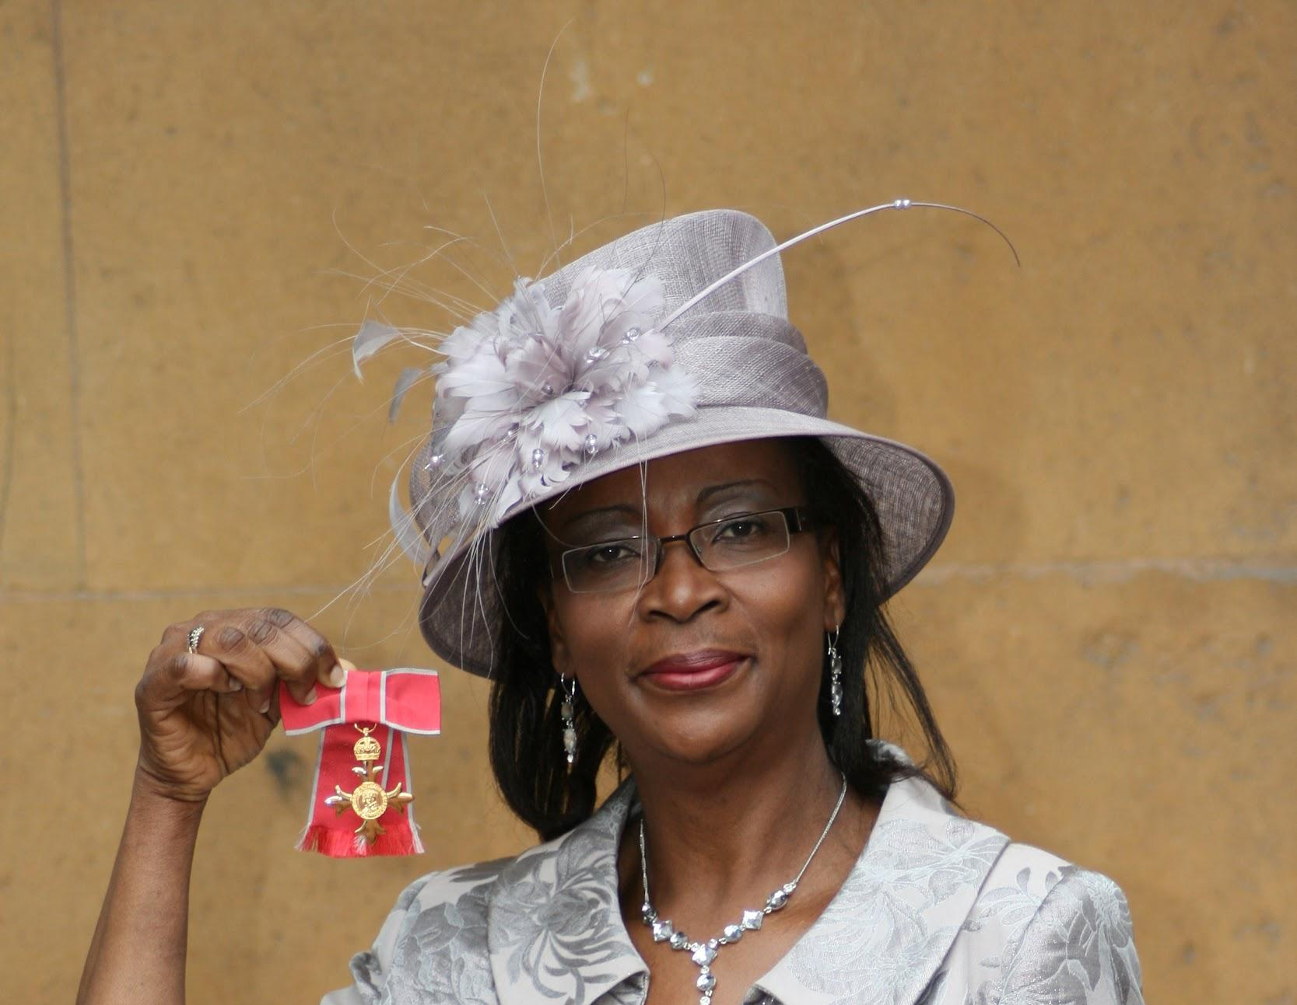 | 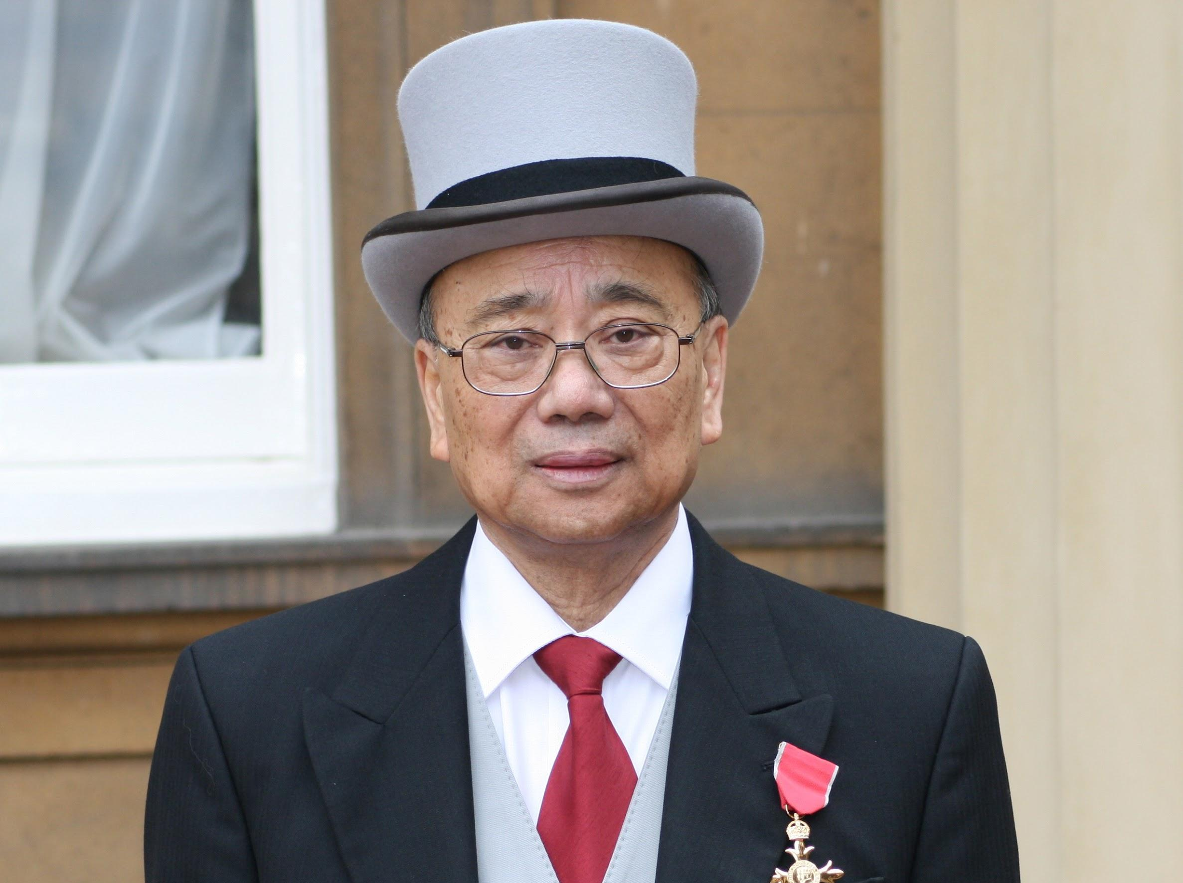 | 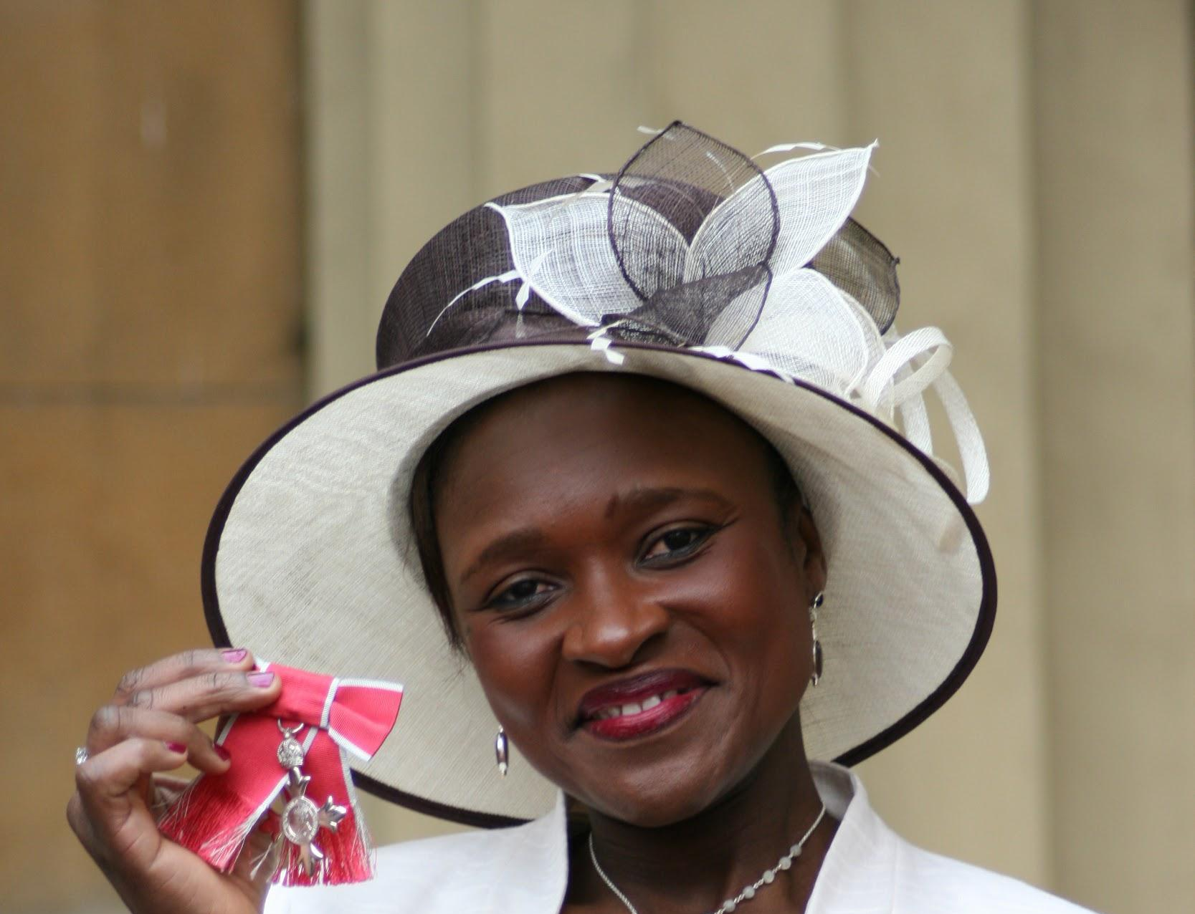 | 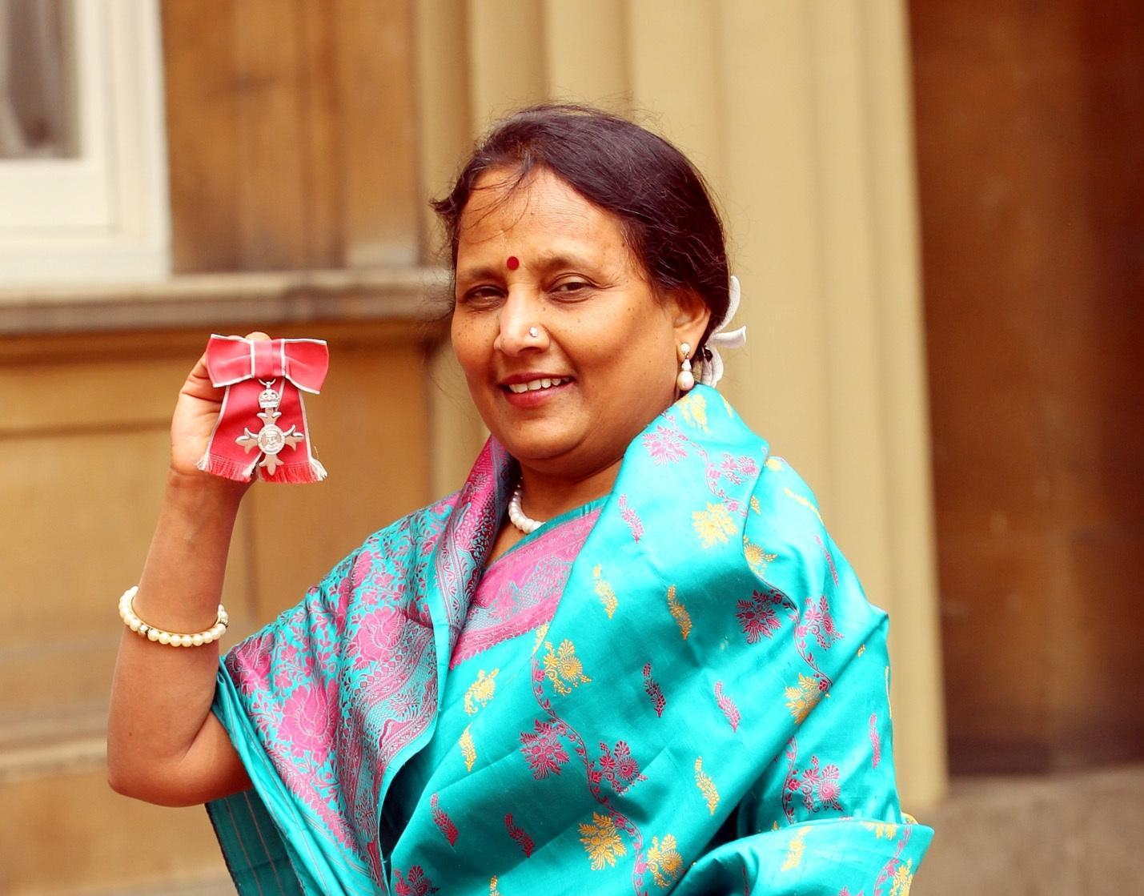 | 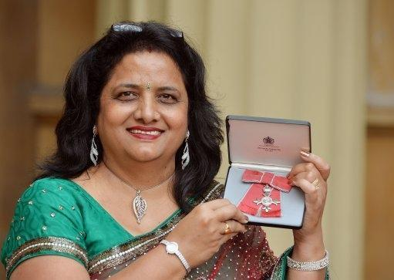
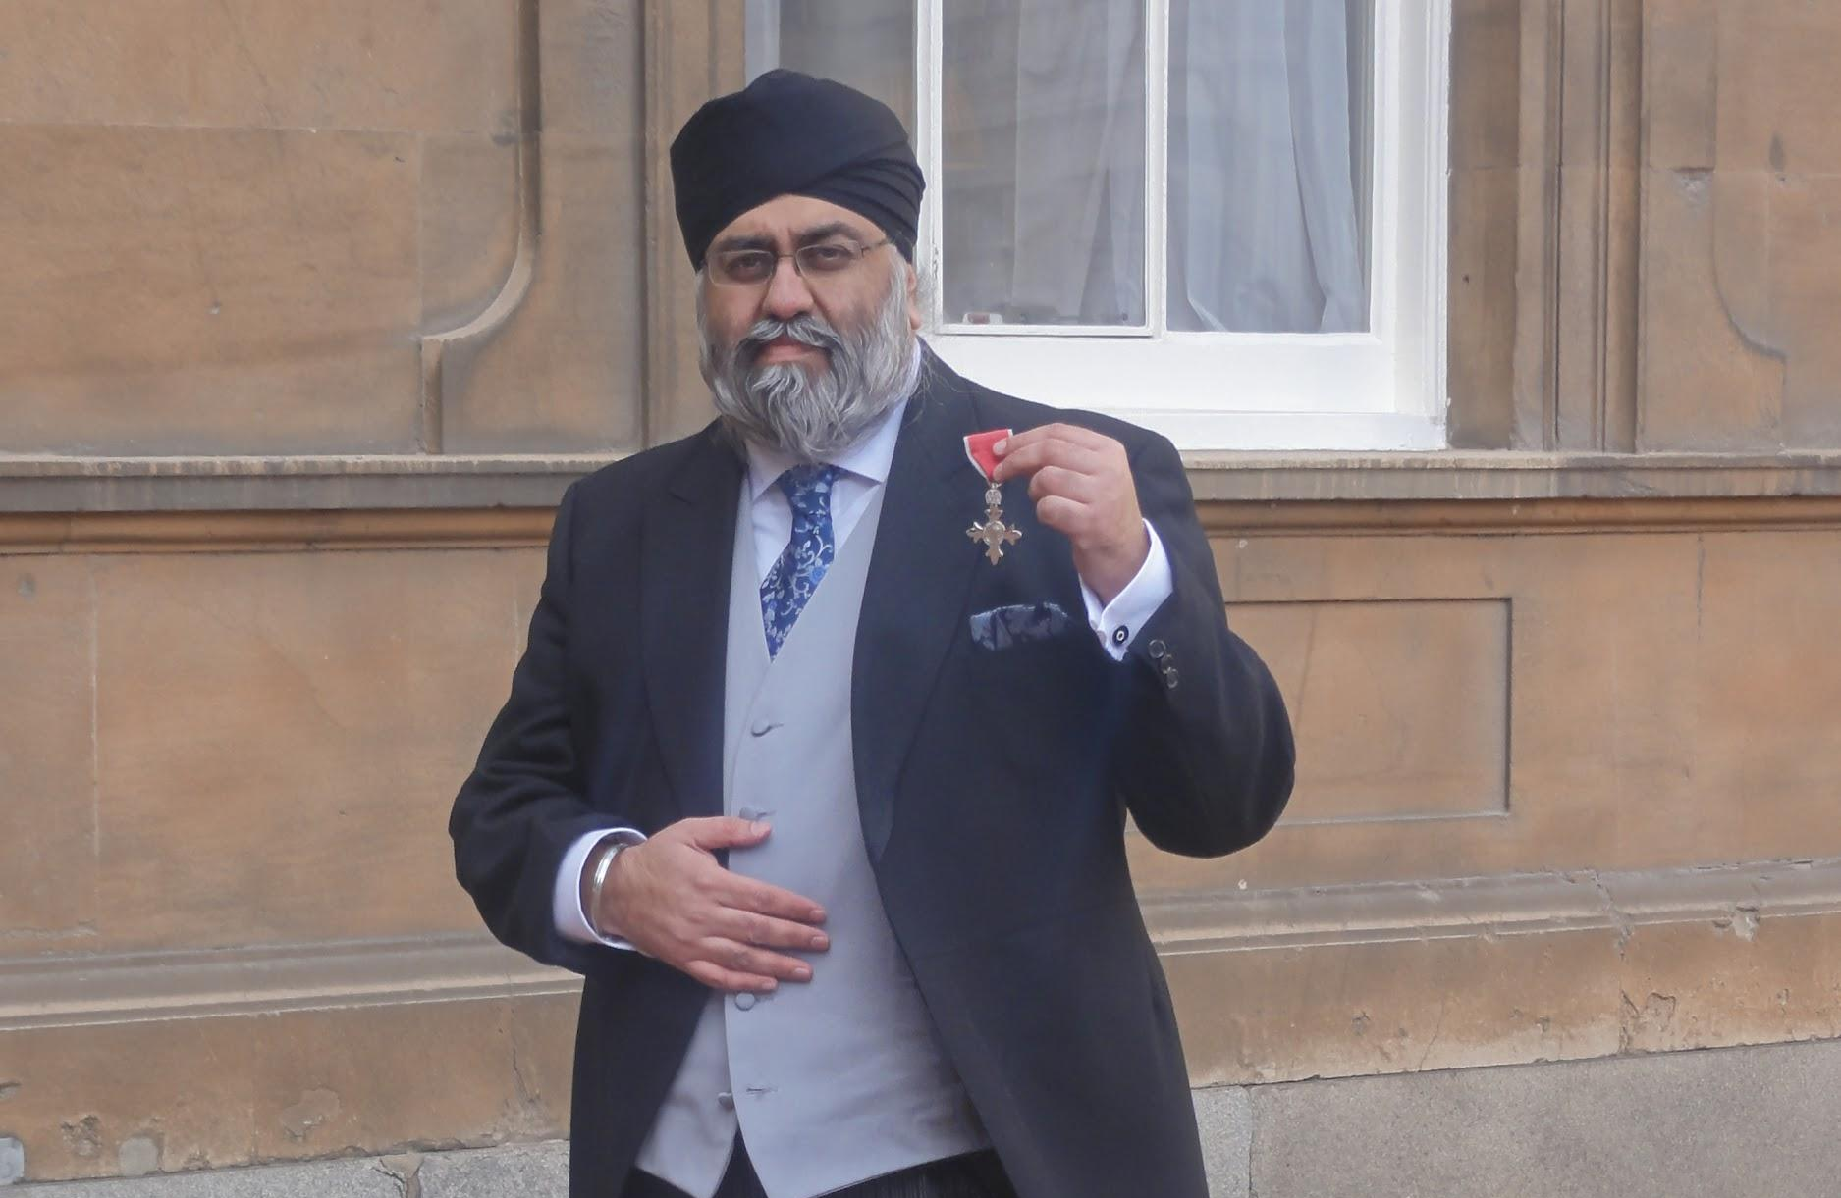 | 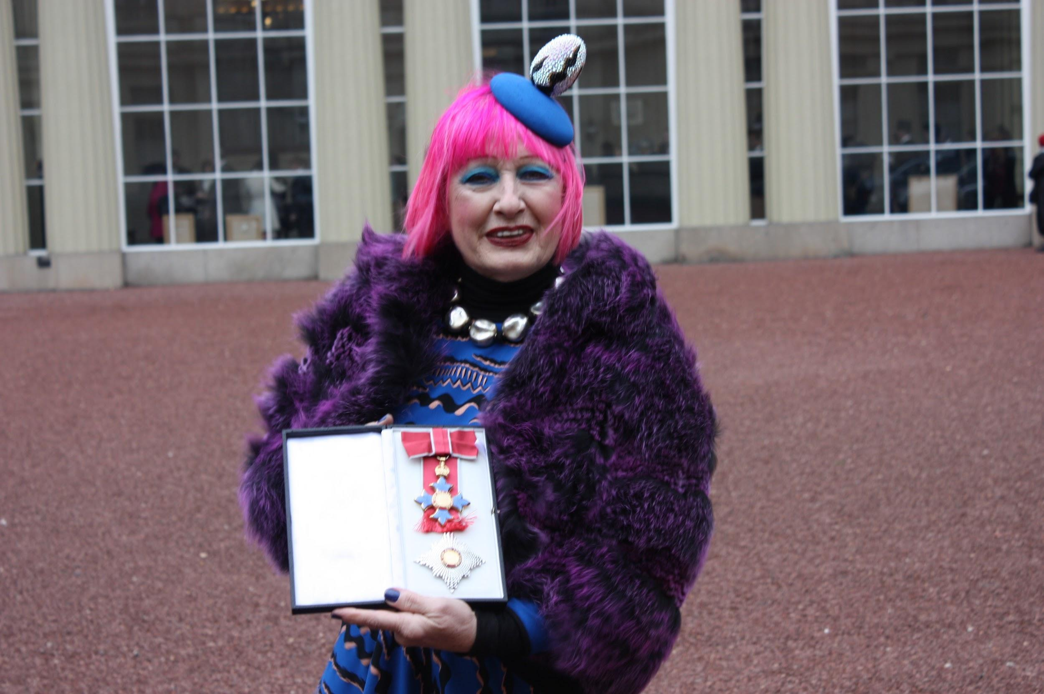 | 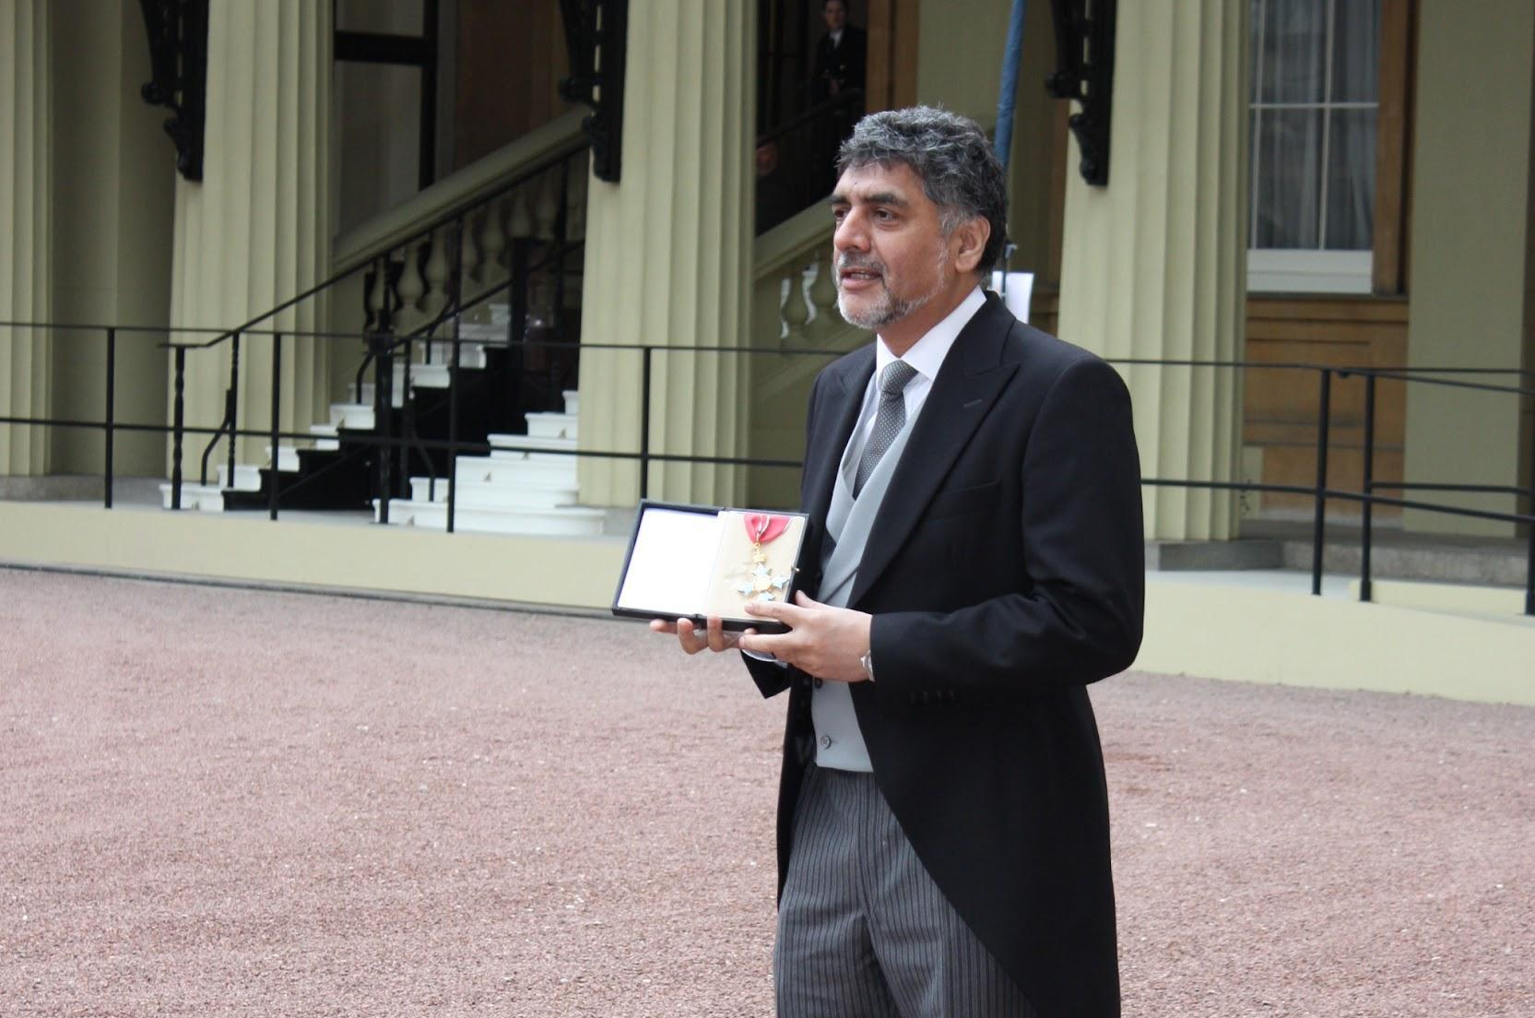 | 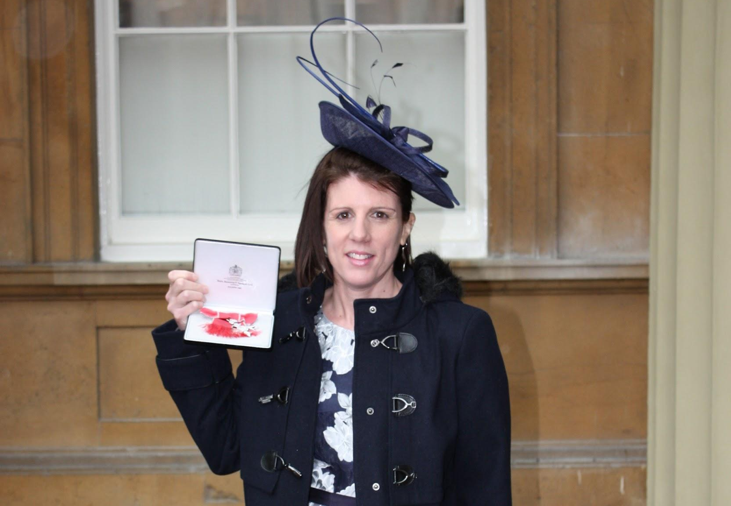 | 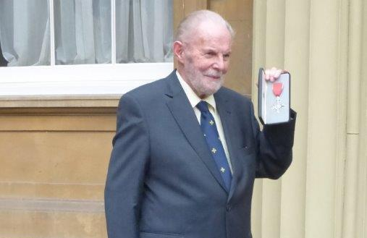
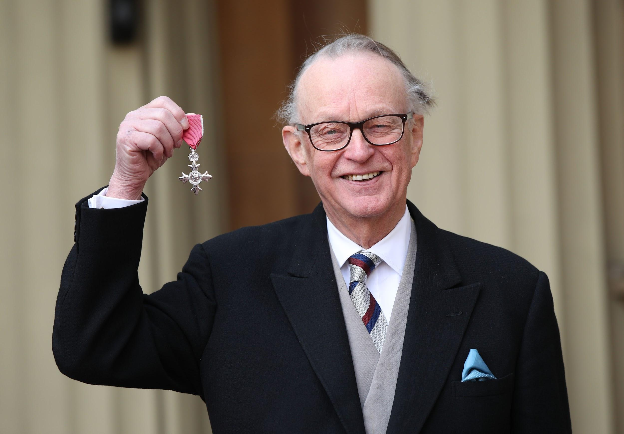 | 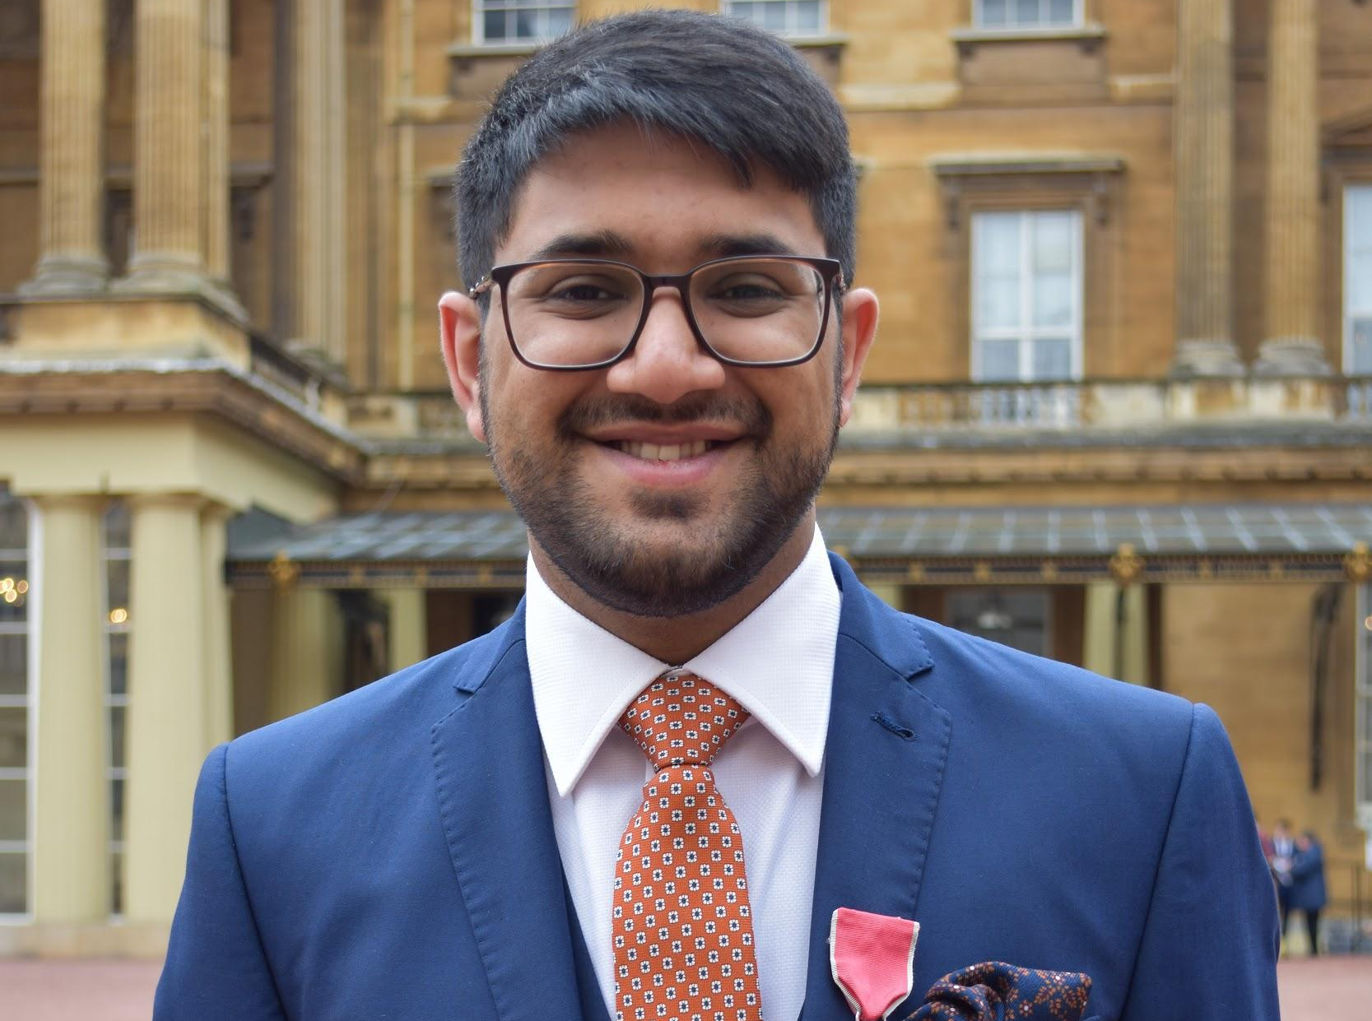 | 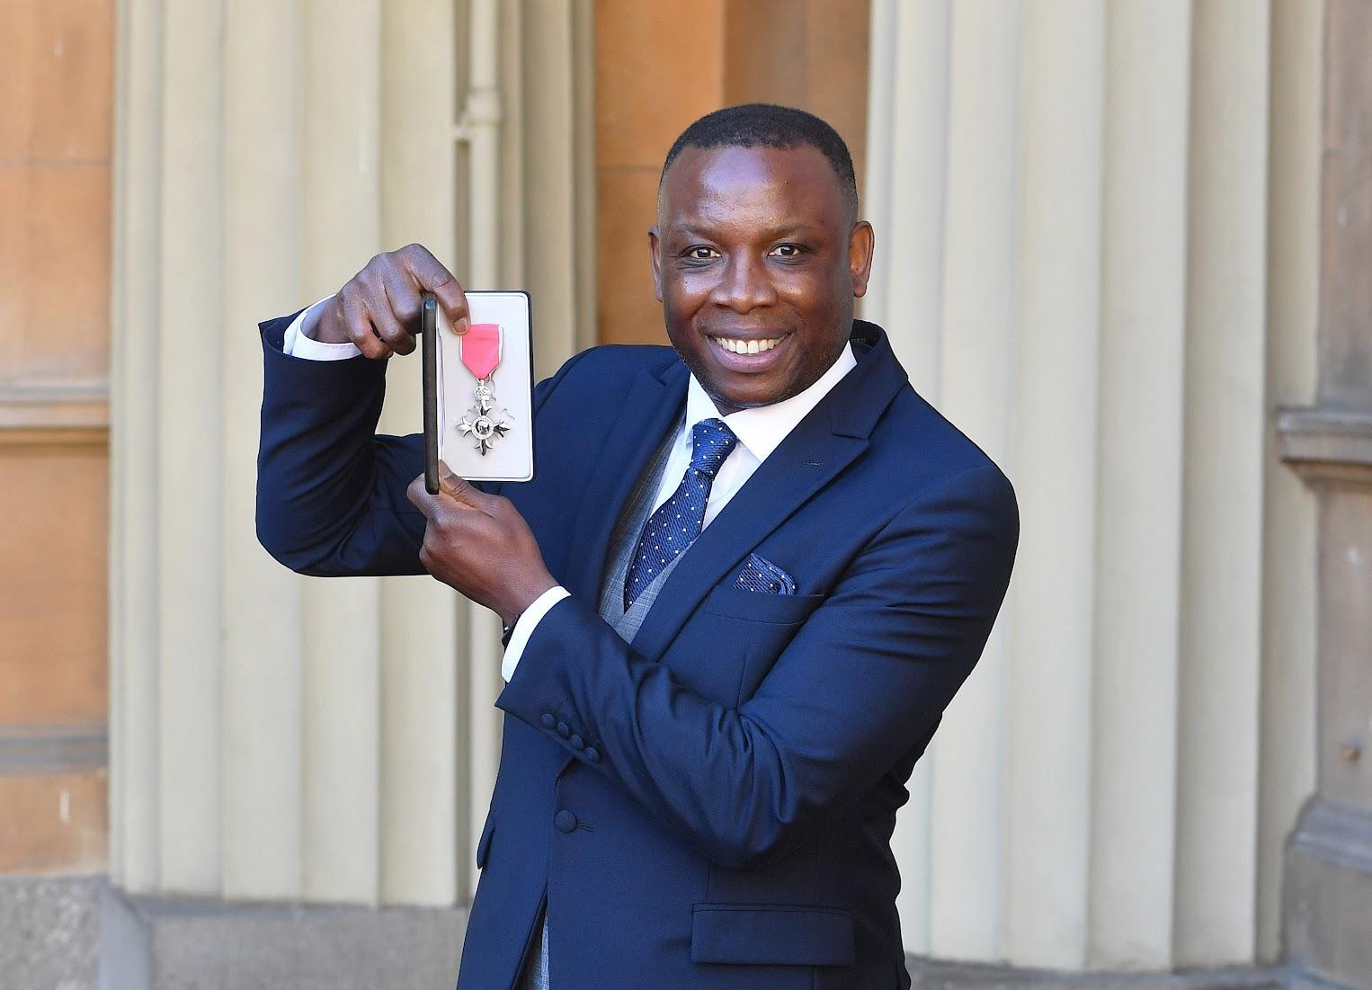 | 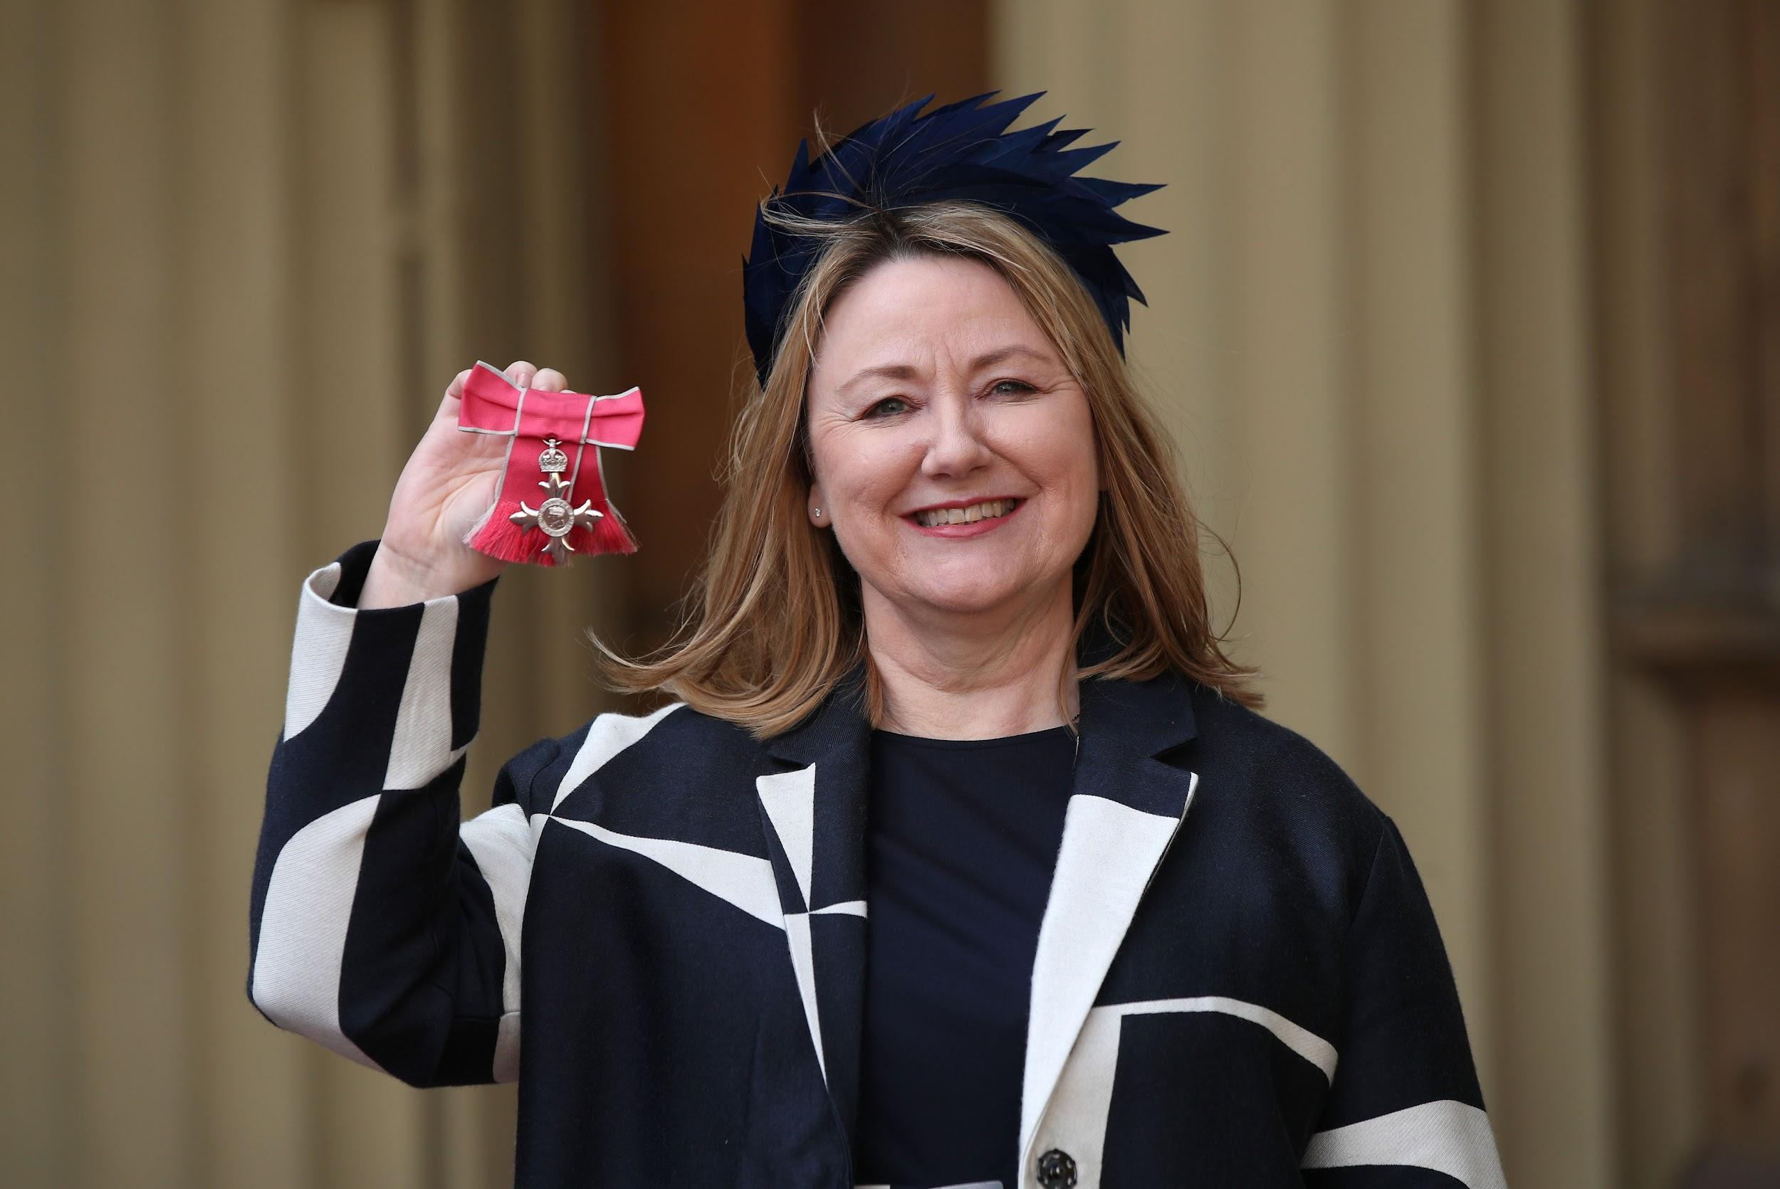 | 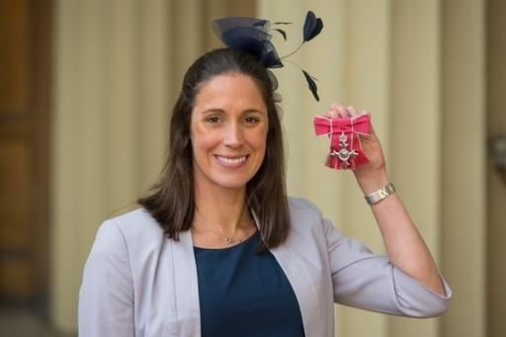
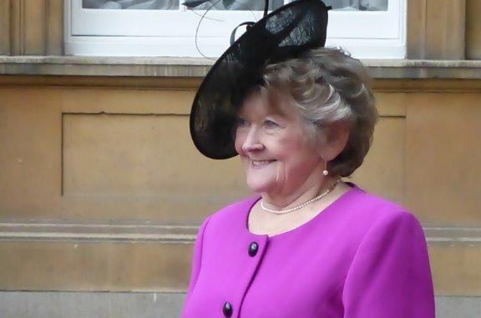 | 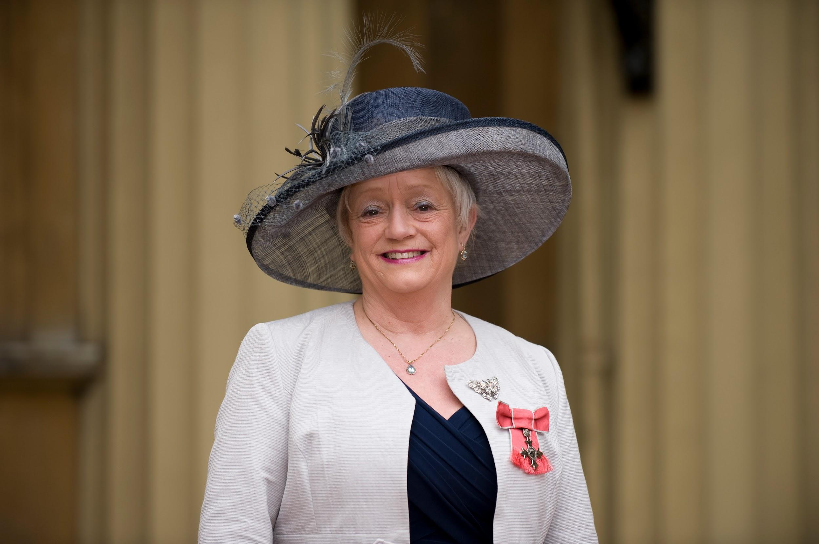 | 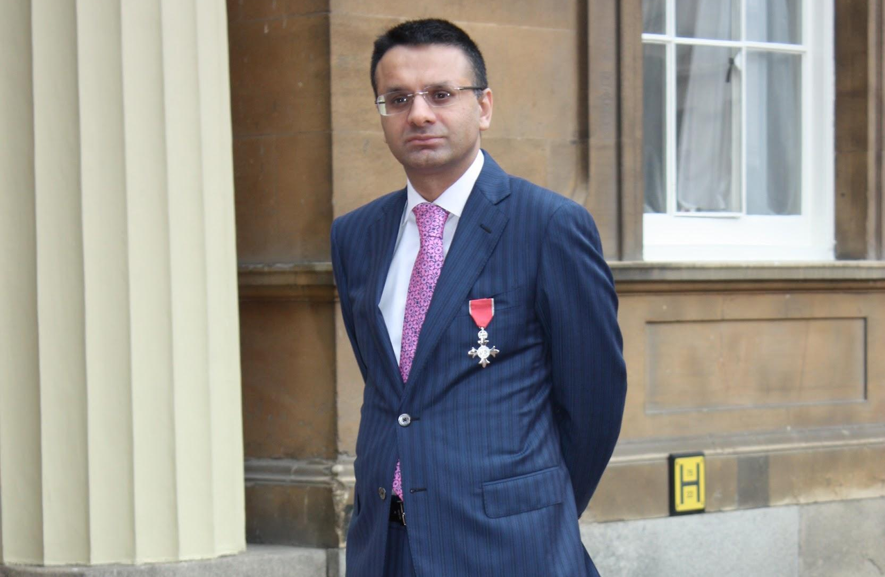 | 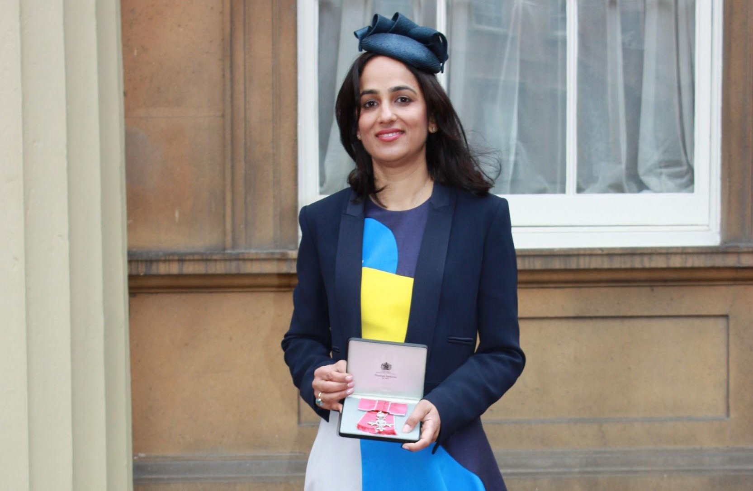 | 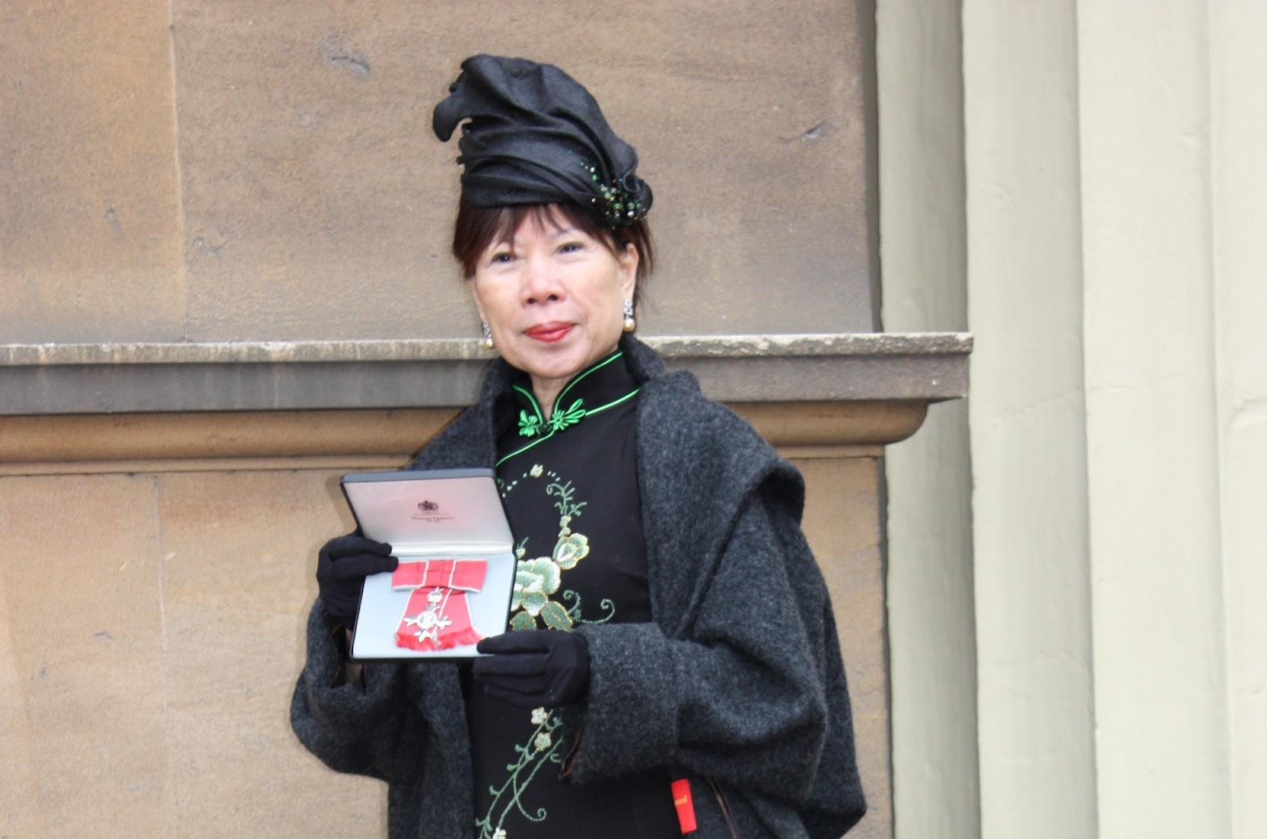

CANDIDATE INFORMATION PACK

Closing date for this post is: Monday 7th April at 5pm

Prime Minister's strategic priorities for the honours system

The Prime Minister would like to see the honours system be properly diverse and reflective of UK society. There should be representation from the length and breadth of the country and all sections of society, reflecting the incredible contributions made across every part of the United Kingdom. The honours system should also seek to reward individuals in all stages of life, young and old.

The Prime Minister would like to see more recipients from underrepresented communities and would like to see further variety in the types of work rewarded. Honours should not be automatic or assumed due to a job or position an individual holds, unless it can be demonstrated that there has been service above and beyond the call of duty.

Honours should be awarded based on merit, regardless of background, for those who give service above and beyond to better the lives of others.

The Prime Minister would like to see the honours system especially recognise:

- Those working to kickstart economic growth, delivering economic stability, increasing productivity in every part of the country to make everyone better off.
- Those working to deliver clean and renewable energy, helping fight climate change, and helping the UK accelerate to Net Zero.
- Those working to prevent and address crime and anti-social behaviour, improving their local communities.
- Those working to break down barriers to opportunity including: Educators working to increase standards in schools and giving children the best start in life; social enterprises, entrepreneurs and businesses that work to dismantle access barriers; and those working to increase access to arts, music and sport.
- Health professionals working to improve the NHS, ensuring fewer lives lost to the biggest killers; and those working in mental health services.
- Those providing an exceptional service to citizens, and setting the highest standards in public life, across the United Kingdom and overseas.

Diversity and Equality of opportunity
Diversity of opportunity is something the Cabinet Office cares passionately about.
Applications are encouraged from all candidates regardless of ethnicity, religion or belief, gender, sexual orientation, age, disability, and gender identity. We particularly welcome applications from women, those with a disability, those from a black or ethnic minority background and those living outside of London and the South East. We want to explore the widest possible pool of talent for these important appointments.
Offering an Interview to Disabled People (GIS scheme)
As a Disability Confident employer, we will ensure that disabled applicants who meet the minimum criteria for this position will be offered an interview.
The Equality Act 2010 defines a person as disabled if they have a physical or mental impairment and the impairment has a substantial and long-term adverse effect on their ability to carry out normal day-to-day activities. If you wish to indicate that you are disabled or have a long-term health condition, please complete the Disability Confident - Offering an Interview to Disabled People declaration in the supporting documents and send it with your application.
Location
Meetings are usually held in London but travel to other parts of the UK may be required.

Background to the Honours System
The modern honours system is intended to recognise merit, achievement and excellence in all areas of UK life. The Prime Minister of the day sets strategic priorities for the honours system. Successive Prime Ministers have asked that the system honours people who give service above and beyond – and not those who are just doing their job.
Honours lists are published twice a year at New Year (usually 30 or 31 December) and on the Sovereign’s Official Birthday (currently the middle of June). Three separate lists make up the New Year and Official Birthday lists:
The Prime Minister’s List – managed by the Cabinet Office.
- This list is for those contributing to the UK. It consists of around 1,300 people (although some people living outside the UK may also be considered);

The Overseas and International List – managed by the Foreign, Commonwealth and Development Office (FCDO).
- This is for members of the Diplomatic Service and for those UK citizens working in the UK’s interests abroad. It consists of around 150 people; and

The Defence Services List – managed by the Ministry of Defence (MOD).
- This is for members of the Armed Forces, consisting of around 200 people.
There are ten independent committees which assess nominations for the Prime Minister’s List. The majority of awards recommended by the honour’s committees are in the Order of the British Empire. The Honours Diversity and Outreach Committee operates separately from the ten independent honours committees and has responsibility for overseeing and increasing overall equitable representation in the honours system.
Typically, the Prime Minister’s List is made up of around 30 people appointed as Dames or Knights, with around 120 people awarded a CB/CBE. These are considered the highest honours and in all they represent no more than 15% of the list.
The overwhelming majority of people recognised will receive OBEs, MBEs and BEMs, and generally represent those who have made valuable contributions at a relatively local level.

Role of the Independent Committees

The ten Independent Honours committees meet twice a year, in advance of each honours list being published, between January and March for the Birthday honours round and between September and October for the New Year honours round. The Chair of the Diversity and Outreach Committee is expected to attend a minimum of six meetings each year to coincide with these, including 2-4 Diversity and Outreach Committee meetings annually, as well as two Main Honours Committee meetings in March and October. There is extensive pre-reading for each committee meeting. Additionally, the Chair will be expected to attend a number of outreach events on an agreed timetable throughout the year (which may often include travel across the UK).
As a member of the Diversity and Outreach committee, you will:
- Attend each honours committee meeting;
- Read and develop views on the honours committee papers in advance of the meeting;
- Play a role in supporting Government departments to build pipelines of diverse future nominees;
- Act as an ambassador for the honours system in numerous outreach activities
As Chair, you are expected to lead members of the Committee to:

- Provide expertise from across the diversity agenda;
- Represent the honours system publicly, including at senior levels to key stakeholders;
- Hold independent committees and Government departments to account on issues relating to representation;
- Lead the committee and shape the agenda and deliverable outcomes;
- Participate in Diversity and Outreach Committee Working Groups as required;
- Promote the honours system and the work of the Diversity and Outreach Committee to external stakeholders across the UK, via both virtual and physical events and other communication channels.

Additionally, you will be required to:

- Attend the Main Honours Committee of all the independent chairs to agree recommendations for the whole honours list;
- Participate in recruitment of new independent committee members as needed;
This is a high-profile area of work, which attracts considerable public and media interest.
Committees are supported by the Honours and Memorialisation Secretariats, which currently consists of approximately 25 team members who are based in the Cabinet Office.
Current committee membership can be found at www.gov.uk/honours.
About the Diversity and Outreach Committee

The Diversity and Outreach Committee assists the committee process in delivering an honours system which is representative of UK society.

Its purpose is to ensure that the honours system is properly reflective of UK society through a programme of policy improvements and interventions; targeted regional and sectoral outreach and publicity of the honours system; and advice to both the independent committees and Government departments. The Diversity and Outreach Committee is also guided by the Prime Minister’s strategic priorities for the honours system and as a secondary function has an additional role in advising about how these are reflected in each honours list.

The Diversity and Outreach Committee is led by an independent chair, with support from the Honours and Memorialisation Secretariats in the Cabinet Office. The membership of the Committee comprises a member from each of the ten independent honours committees, based on their sector-specific expertise, experience, interest and commitment. Membership is in the public domain.

The Diversity and Outreach Committee’s purpose is to:

- work to ensure the honours system is properly reflective of UK society;
- support targeted regional and sectoral outreach and publicity of the honours system;
- identify policy improvements or interventions regarding improving diversity in the honours system and make recommendations to the HD Committee;
- recommend courses of action to the independent honours’ committees, honours secretaries and the Honours and Memorialisation Secretariats to improve diversity and overall representation;
- support the work of the independent committees by ensuring they are sighted on best practice in this area, remain mindful of and committed to diversity targets, and undertake discussions and the evaluation of candidates in an open and even handed way; and
- support pipeline-building activities across all committees and all honours levels.

About the Cabinet Office
The Cabinet Office supports the Prime Minister and ensures the effective running of government. The Department is the corporate headquarters for government, in partnership with HM Treasury, and takes the lead in certain critical policy areas.
The Cabinet Office has responsibility for:
- supporting collective government, helping to ensure the effective development, coordination and implementation of policy;
- supporting the National Security Council and the Joint Intelligence Organisation, coordinating the government’s response to crises and managing the UK’s cyber security;
- promoting efficiency and reform across government through innovation, better procurement and project management, and by transforming the delivery of services;
- promoting the release of government data, and making the way government works more transparent;
- creating an exceptional Civil Service, improving its capability and effectiveness; and
- political and constitutional reform.
The Department’s priorities are to:
- support the Prime Minister and Cabinet to deliver the government’s programme;
- drive efficiencies and reforms that will make government work better;
- create a more united democracy; and
- strengthen and secure the United Kingdom at home and abroad.
Person Specification and Eligibility Criteria
All candidates must demonstrate, in their CV and supporting letter, how they meet the following criteria, through their knowledge, skills and experience.
Person Specification and Eligibility Criteria
Due to the nature and high profile of the honours system, the work and outcomes often attract considerable public and media interest. The candidate should therefore be someone of outstanding integrity and be open to promoting the honours system within their sector or region.
The successful candidates should be experts in their field whose expertise has been gained by paid, voluntary or academic work in these areas. They must be able to command the confidence of other experts in the sector and will be persons of distinction in their own fields.
They will be able to act with independence of judgement and be individuals of the highest standards of probity and discretion. They will need to be sympathetic with the aims of the honours system and have an awareness of the importance of diversity and representation in the honours process.
The successful candidate will need to demonstrate the following skills:
- Practical experience of diversity and equality matters and an understanding of the honours system so this experience can be effectively applied;
- A proven track record of leading, as well as championing and improving diversity (including geographical diversity);
- The ability to act with independence of judgement and meet the highest standards of probity and discretion;
- Strong communication skills;
- The ability to operate through and influence stakeholders;
- The ability to operate as an independent chair in a committee environment

First-hand experience of supporting the honours system, in any role, is desirable but not essential.

For these posts, a person cannot be appointed to an honours committee if they are employed in the civil service of the state, have unspent criminal convictions, are subject to bankruptcy, or disqualification as a company director.

There must be no employment restrictions, or limit on your permitted stay in the UK.

Conditions of Appointment
Remuneration, allowances and abatement
Members can claim reimbursement for reasonable travel and subsistence costs incurred on Committee business.
This post is not remunerated and is not pensionable.
Appointment and tenure of office
- Committee members and chairs are appointed by the Cabinet Secretary for a five year term, in the first instance.
- It will be important that the successful applicant’s other commitments (whether paid or unpaid) do not cast any doubt on their ability to act impartially in discharging the role; any potential conflict of interest must be declared.
- All committee members are required to adhere to the Seven Principles of Public Life (see Appendix 1).
Time commitment
This is a part-time post. The Chair is expected to attend a minimum of six meetings each year – 2-4 Diversity and Outreach Committee meetings annually; two Main Honours Committee meetings in March and October; and outreach events on an agreed timetable (which may include travel).
In addition, the Chair of the Diversity and Outreach Committee must:
- ensure they understand their duties, rights and responsibilities, and that they are familiar with the function and role of independent honours committees and the honours system;
- ensure they act in accordance with the Code of Practice for members and the Seven Principles of Public Life (see Appendix 1);
- comply with any rules set by the Cabinet Office regarding the reimbursement of expenses, the acceptance of gifts and hospitality, conflict of interest and declaration of interests; and
- not misuse information gained in the course of their public service for personal gain or for political purposes. Nor should they use the role of public service to promote their private interests or those of closely connected persons, firms, businesses or other organisations.

Indicative timetable and how to apply
Timetable for recruitment
Closing date: 7th April 2025 at 5pm

Shortlisting: w/c: 21st April 2025

Interviews held: w/c 26th May 2025
Provisional appointment start date: July 2025
Due to limited availability of selection panel members, shortlisted candidates should ensure that they are available to attend on the advertised interview date as it is unlikely that an alternative date can be accommodated.
In order for us to progress your application please submit the following completed documentation:
1. A Curriculum Vitae (maximum of two A4 pages) with your education, professional qualifications and full employment history. Please ensure your full name is clearly noted at the top of your CV.
2. An accompanying Supporting Letter (maximum of two A4 pages) – setting out your suitability for the role and how you meet the essential criteria set out in the person specification. Please ensure your full name is clearly noted at the top of your letter.
3. Diversity monitoring form (attached separately) - this form will not be disclosed to the panel involved in assessing your application.
4. Disability Confident form – offering an interview to disabled people declaration, if applicable (attached separately).
Please submit your application via the Cabinet Office Public Appointments website.
General enquiries about Honours Committee recruitment can be made to: coappointments@cabinetoffice.gov.uk

How We Will Handle Your Application
Appointments to the independent honour’s committees follow the OCPA principles and are made by the Prime Minister, in tandem with the agreement from the Cabinet Secretary.
We will deal with your application as quickly as possible and will keep you informed at key stages:
- Your application will be assessed against the candidate profile and your experience relevant to the post. Please ensure that your application includes a supporting letter (as set out above), providing evidence that demonstrates how you meet the criteria. Submitting a Curriculum Vitae alone will not be sufficient.
- At the shortlisting stage, a selection panel will decide which candidates will be invited for interview, taking account of the evidence provided by the candidates. You will be advised of the outcome of your application (by email) as soon as possible. If successful, you will be invited to an interview in central London.
We regret that we are only able to offer detailed feedback to candidates who have been unsuccessful at the interview stage.
If you have a complaint about the way your application has been handled at any stage of the process, please see the section on “How to complain” below.
Candidates should be aware that due diligence will be carried out on candidates shortlisted for interview. This will include searches of previous public statements and social media, blogs or any other publicly available information.
Use of your personal information
Your personal information will be held in accordance with the General Data Protection Regulation. You will not receive unsolicited paper or electronic mail as a result of sending us any personal information. No personal information will be passed on to third parties for commercial purposes.
When we ask you for personal information, we promise we will:
- only ask for what we need, and not collect too much or irrelevant information;
- ensure you know why we need it;
- protect it and insofar as is possible, make sure nobody has access to it who shouldn't;
- ensure you know what choice you have about giving us information;
- make sure we don't keep it longer than necessary; and
- only use your information for the purposes you have authorised.
We ask that you:
- give us accurate information;
- tell us as soon as possible of any changes; and
- tell us as soon as possible if you notice mistakes in the information we hold about you.
If you apply for a post, the manner in which we share information with the interview panel is described above.
Our data protection policy is in line with the General Data Protection Regulation.
If you would like these details to be removed from our records as soon as this recruitment exercise is complete, please inform the Cabinet Office Appointments Team (COPA) at coappointments@cabinetoffice.gov.uk

Standards in Public Life, Political Activity, Disqualification from Appointment and Conflicts of Interest
Standards in public life
Members of the independent honour’s committees will need to confirm that they understand the standards of probity required of public appointees outlined in the “Seven Principles of Public Life” drawn up by the Committee on Standards in Public Life (see Appendix 1 below).
Political Activity
Members of the independent honour’s committees will need to show political impartiality during their time on the committee and must declare any party-political activity they undertake in the period of their appointment.
Due to the nature of independent honours committees it is not appropriate for independent members of the committee to occupy paid party-political posts or hold sensitive, senior or prominent positions in any political organisation. Nomination for election to political office, for example, the House of Commons, the Northern Ireland Assembly, Scottish Parliament, the European Parliament, is not considered compatible with membership of independent honours committees.
Subject to the above, committee members are free to engage in political activities, provided that they are conscious of their general responsibilities and standards for public life and exercise proper discretion.
You are required to fill out a Political Activity Declaration as part of your application (please see monitoring forms), which will be kept separate from your application and will only be seen by the selection panel prior to interview. However, it is appreciated that such activities may have given you relevant skills, including experience gained from committee work, collective decision-making, resolving conflict and public speaking. If, therefore, you have had such experience and you consider it relevant to your application for this post, you should include it separately in the main body of your application.
If you are successfully appointed to the post, details of your response to the Political Activity Declaration will be included in any announcement of your appointment.
Disqualification from appointment
Anyone in the categories listed below will not be considered for appointment as a member of an independent honour’s committees (also see ‘Political Activity’ above):
- Employed in the Civil Service of the state
- Unspent criminal convictions
- Bankruptcy
- Disqualification as a company director.
Conflict of interests
The Honours and Memorialisation Secretariats maintains a register of committee members’ interests to avoid any danger of the committee member being influenced, or appearing to be influenced, by their private interests in the exercise of their duties. Candidates invited to interview will be questioned about any real or perceived conflicts of interest. These do not constitute an automatic bar to appointment, but they must be manageable.

Appendix 1
The Seven Principles of Public Life
All candidates for public appointments are expected to demonstrate a commitment to, and an understanding of, the value and importance of the principles of public service. The seven principles of public life are:
Selflessness
Holders of public office should act solely in terms of the public interest.
Integrity
Holders of public office must avoid placing themselves under any obligation to people or organisations that might try inappropriately to influence them in their work. They should not act or take decisions in order to gain financial or other material benefits for themselves, their family, or their friends. They must declare and resolve any interests and relationships.
Objectivity
Holders of public office must act and take decisions impartially, fairly and on merit, using the best evidence and without discrimination or bias.
Accountability
Holders of public office are accountable to the public for their decisions and actions and must submit themselves to the scrutiny necessary to ensure this.
Openness
Holders of public office should act and take decisions in an open and transparent manner. Information should not be withheld from the public unless there are clear and lawful reasons for so doing.
Honesty
Holders of public office should be truthful.
Leadership
Holders of public office should exhibit these principles in their own behaviour. They should actively promote and robustly support the principles and be willing to challenge poor behaviour wherever it occurs.

