Education Honours Committee - Member x 3
Honours Independent Committee

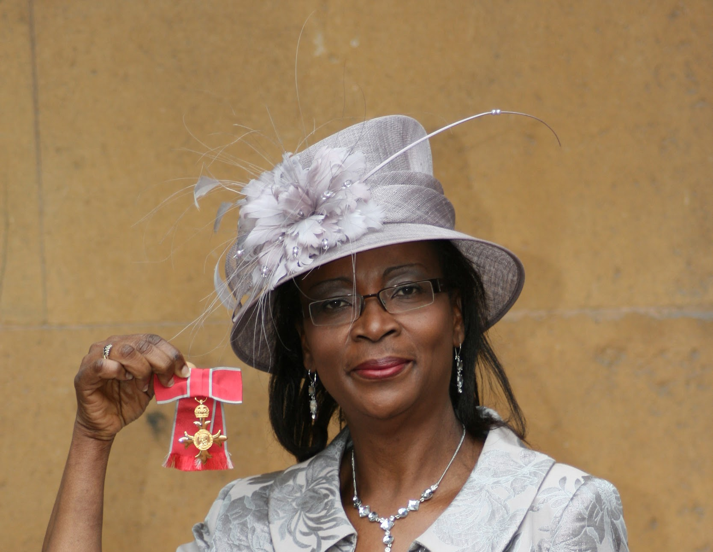 | 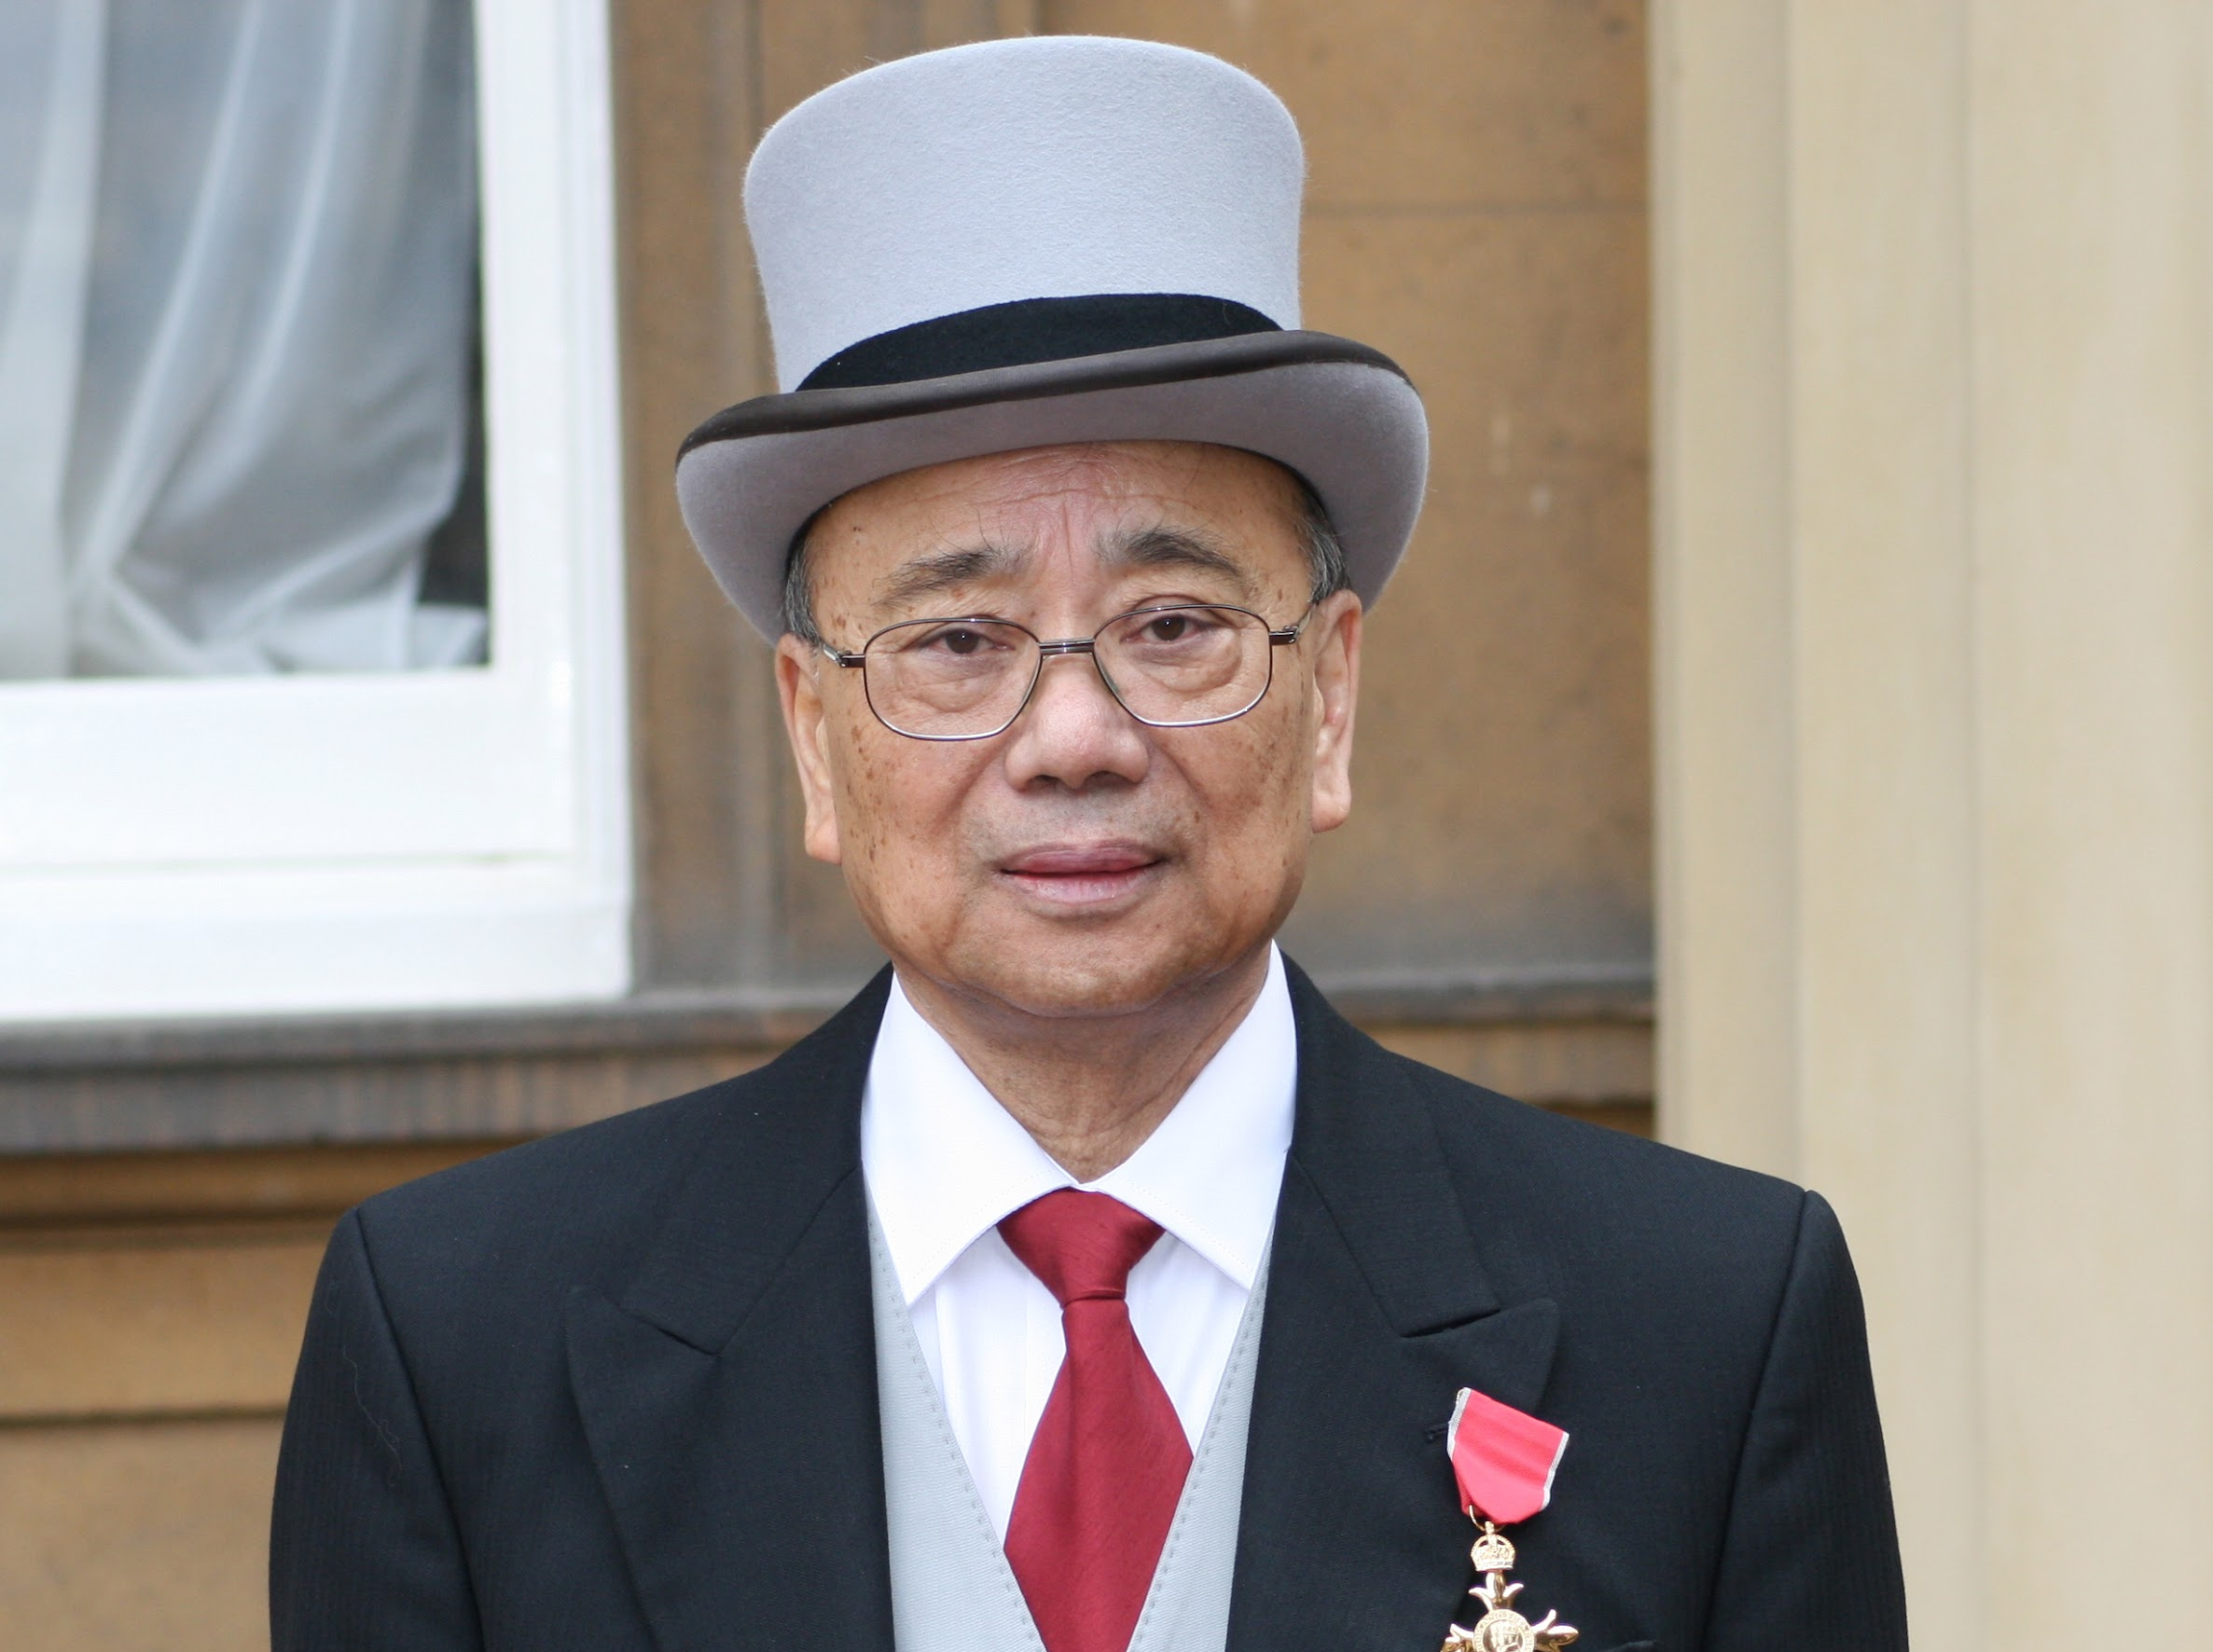 | 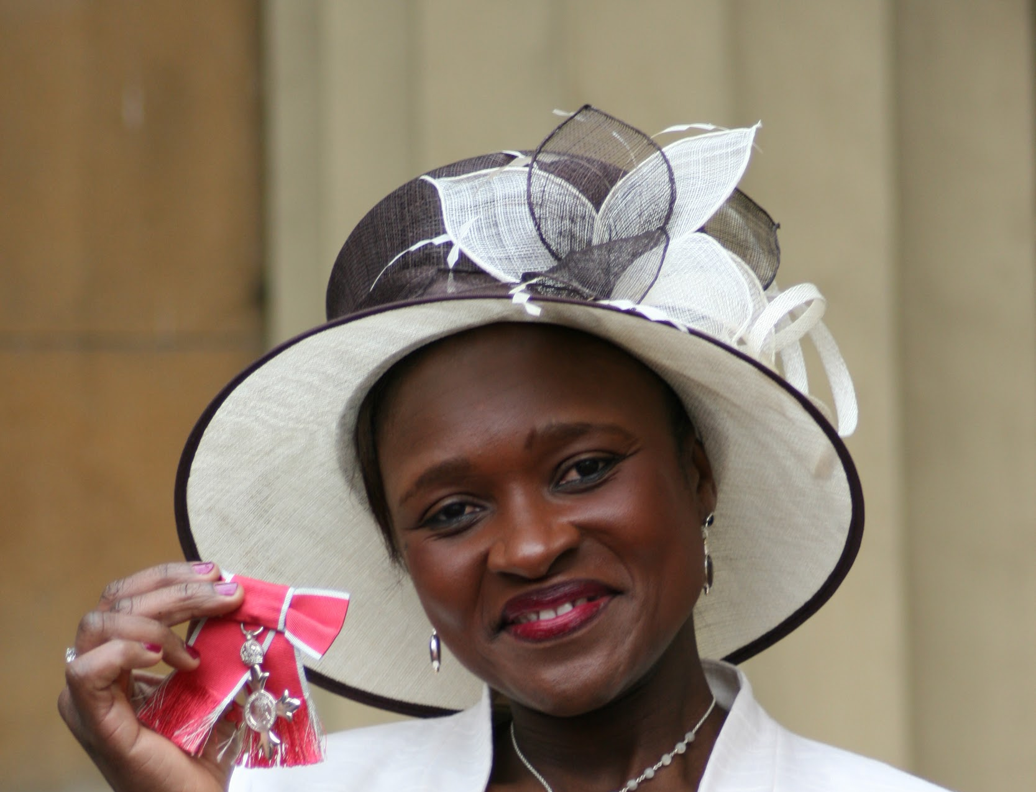 | 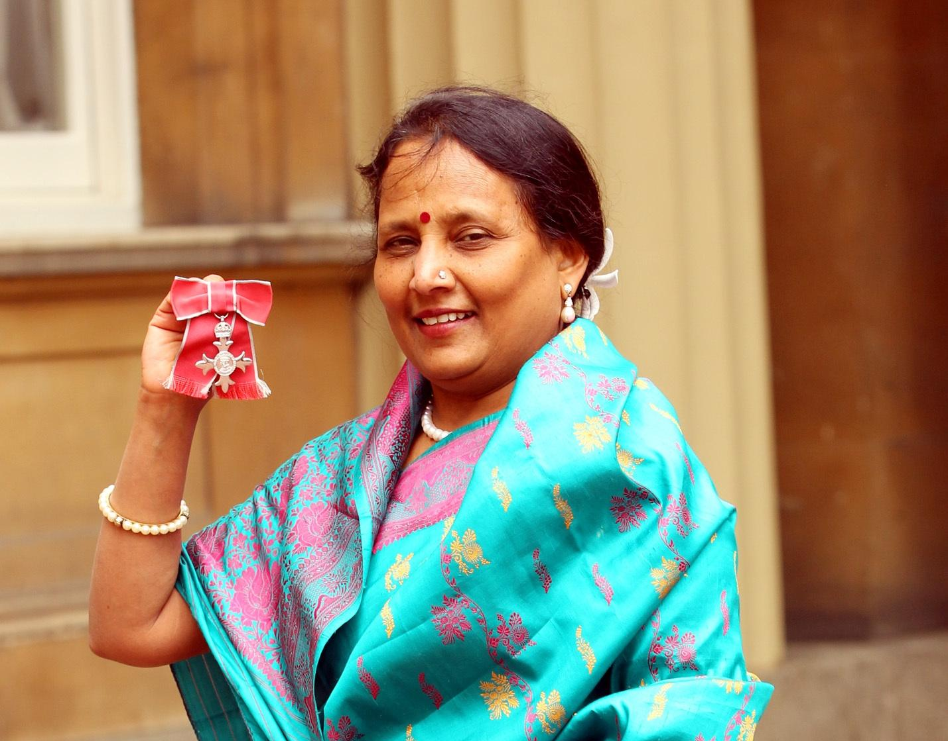 | 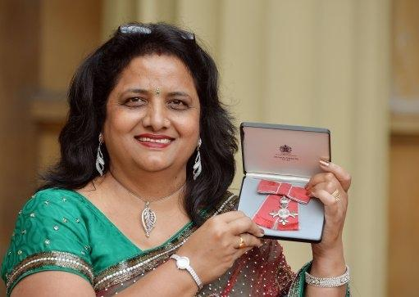
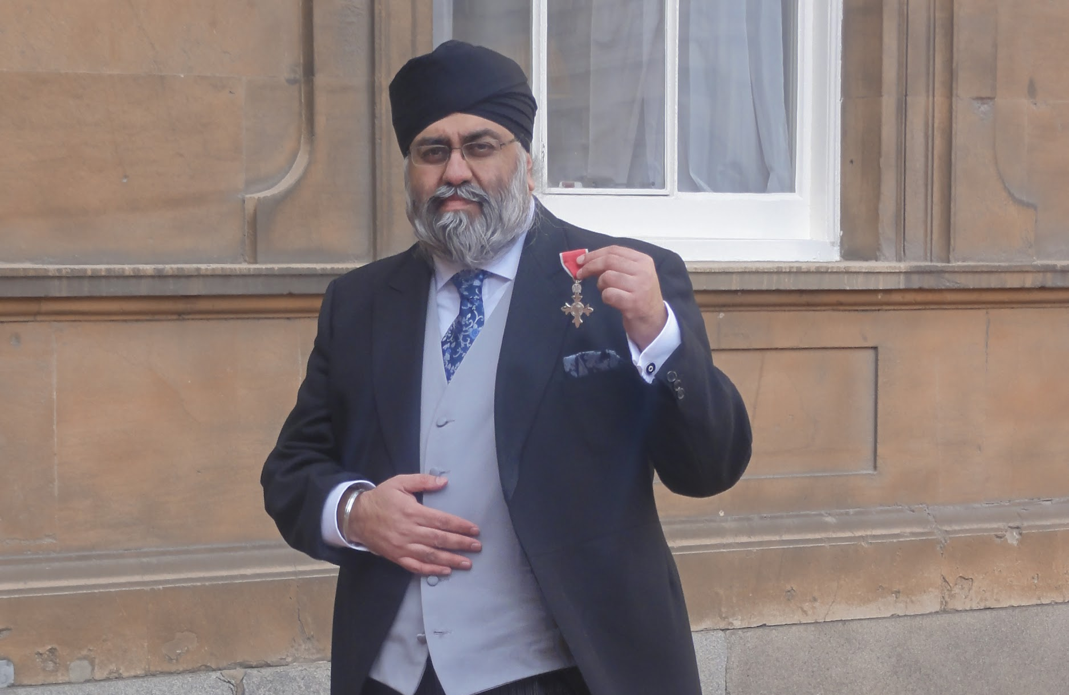 | 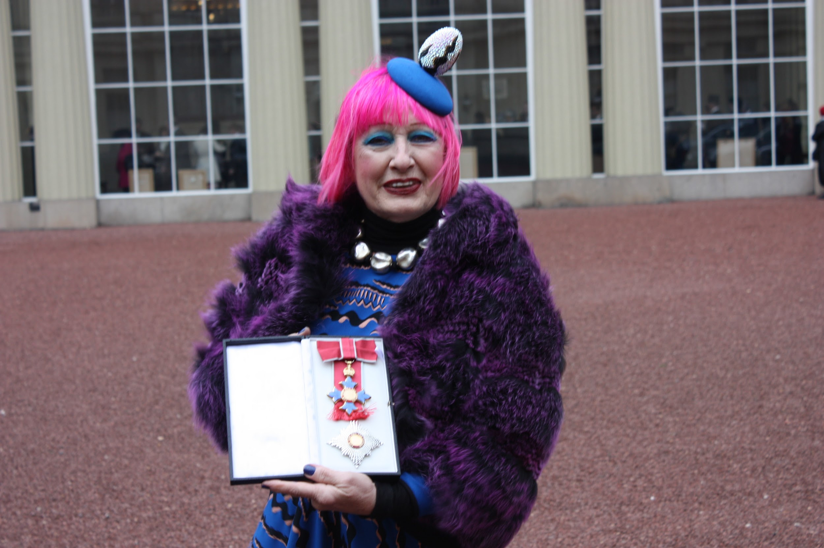 | 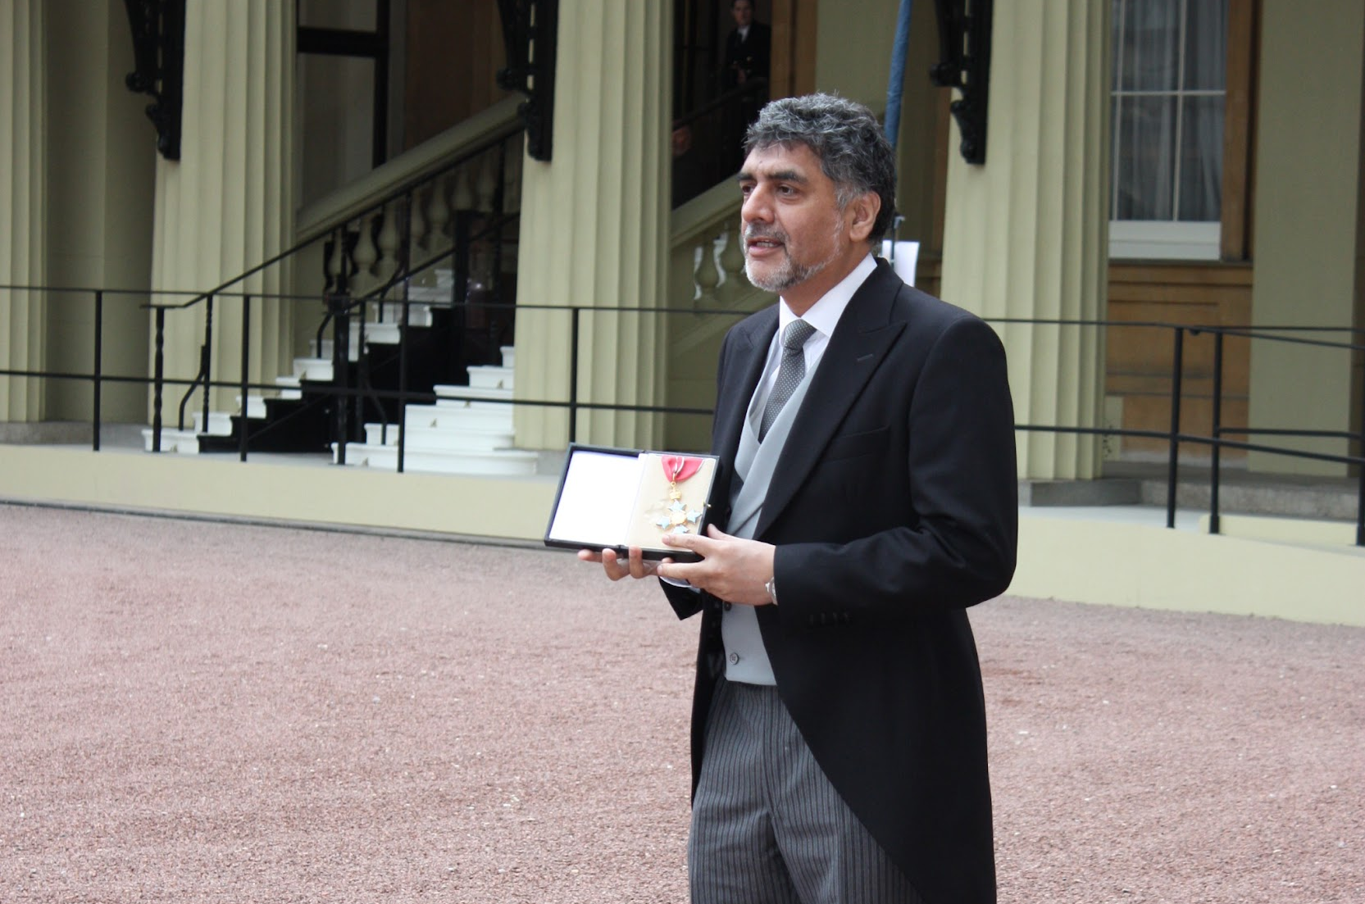 | 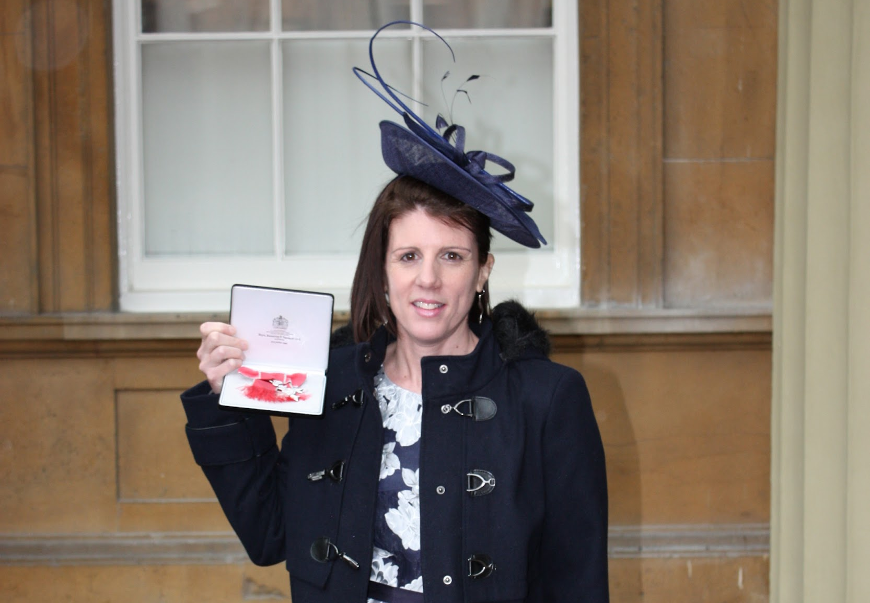 | 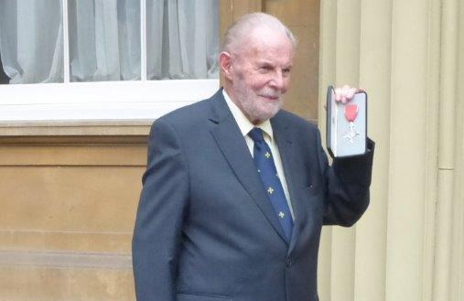
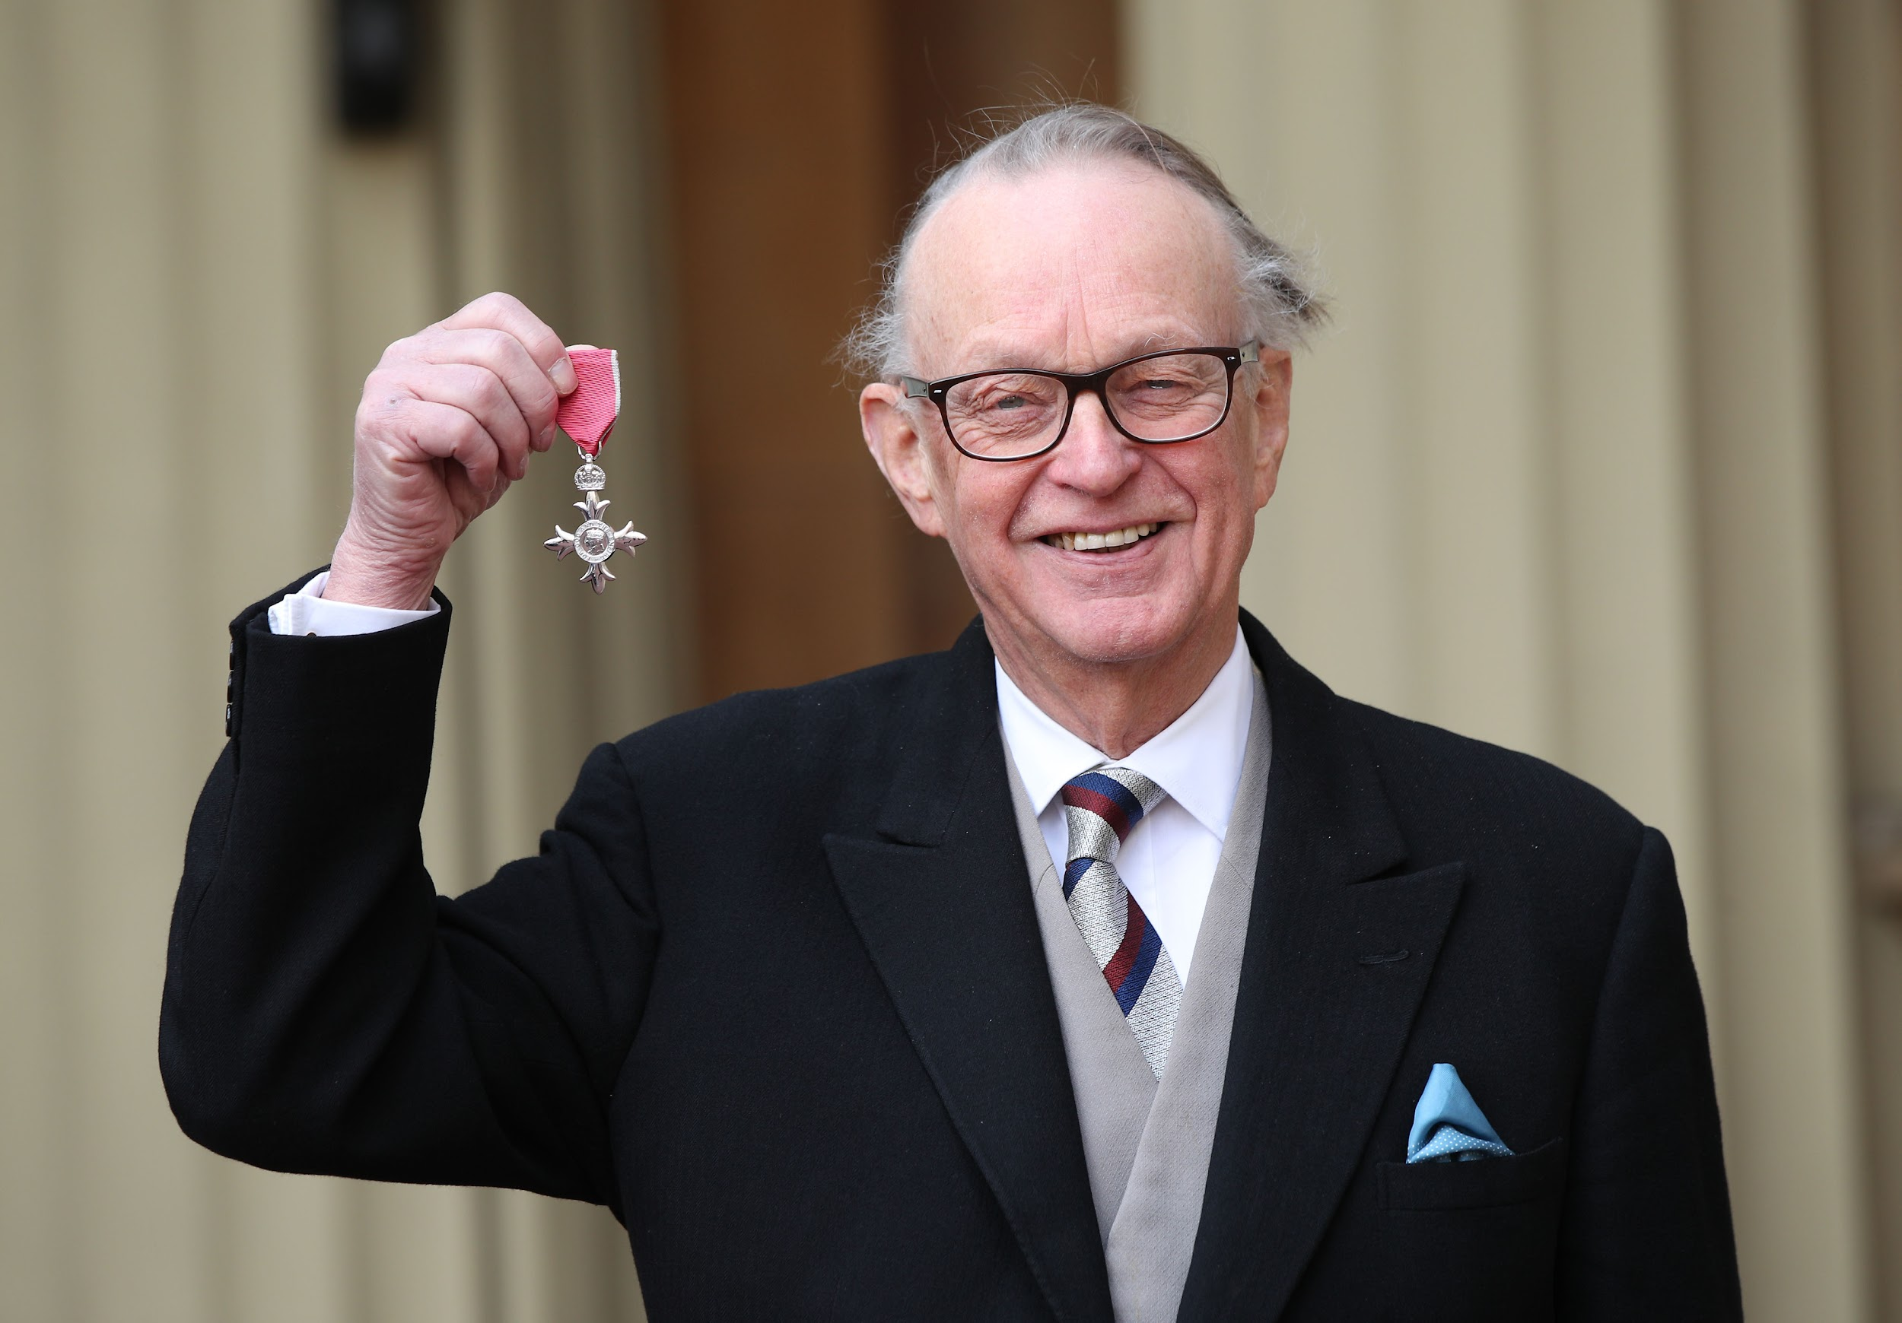 | 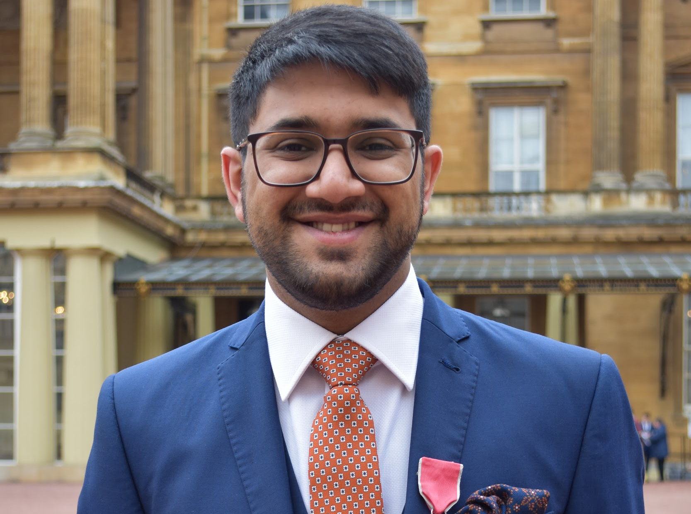 | 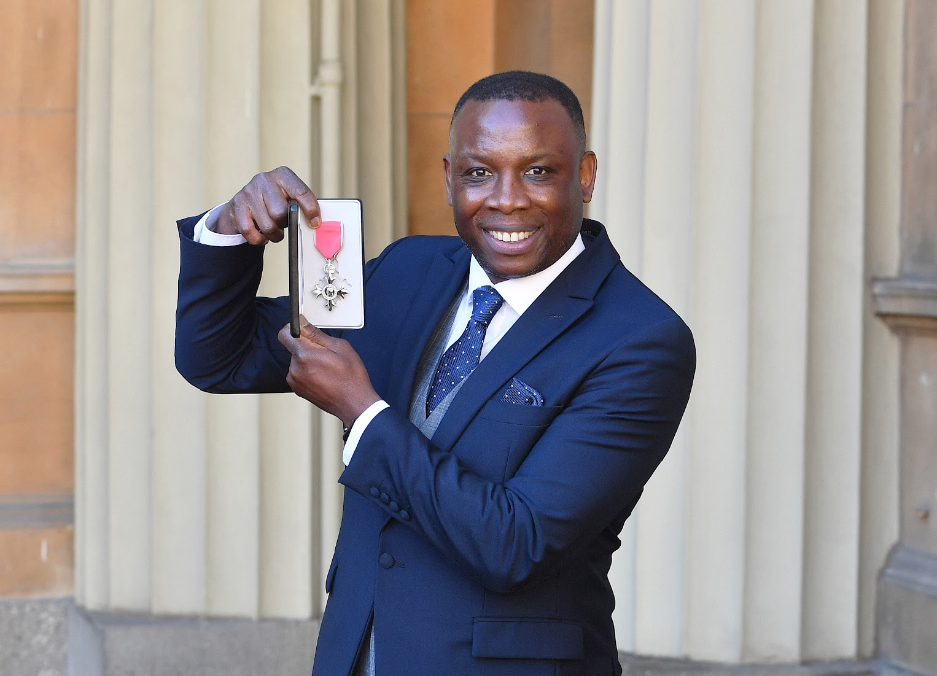 | 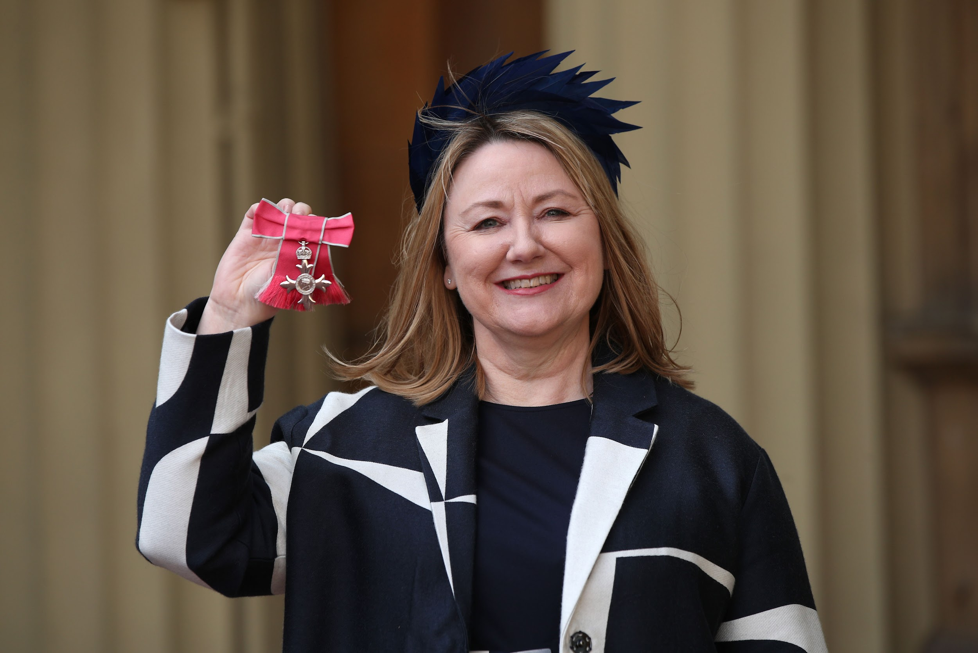 | 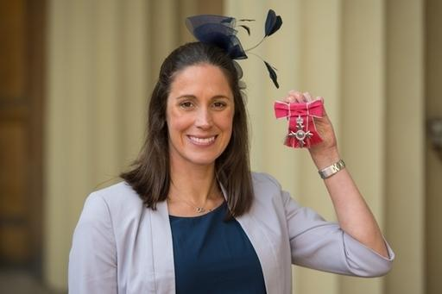
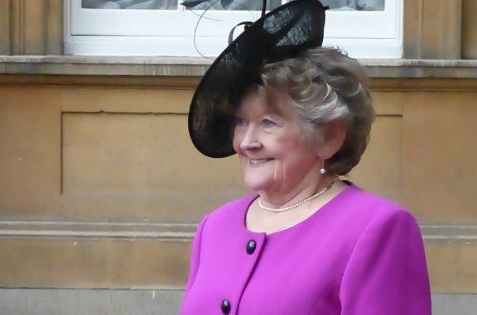 | 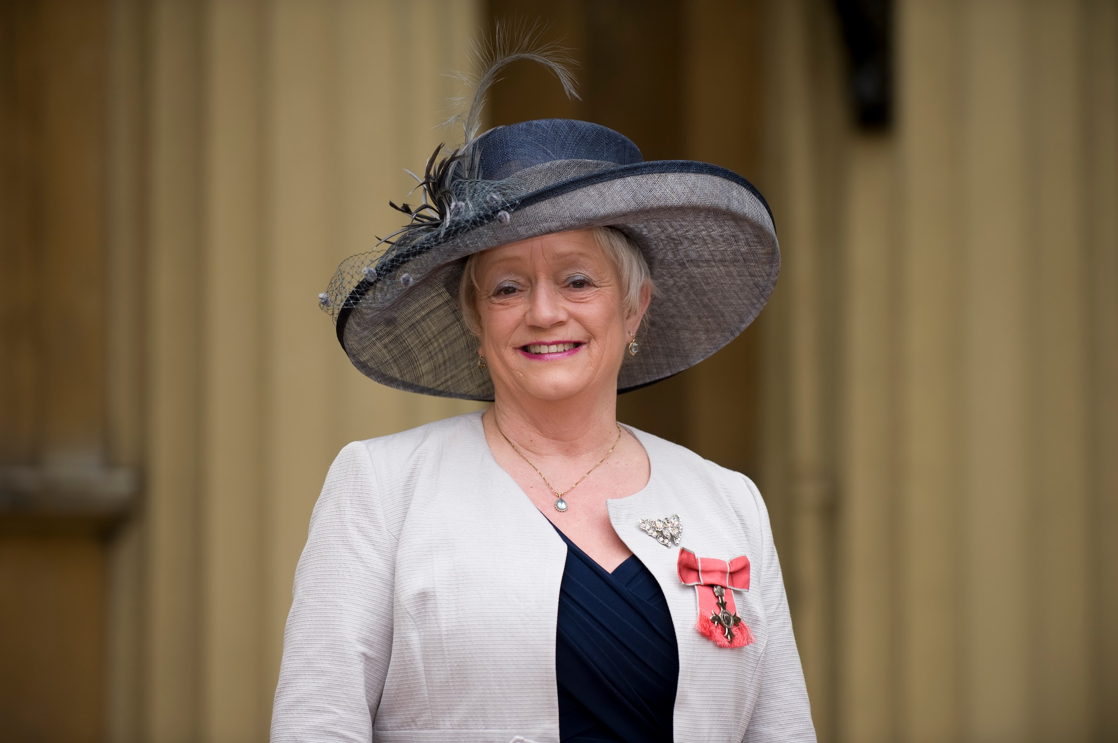 | 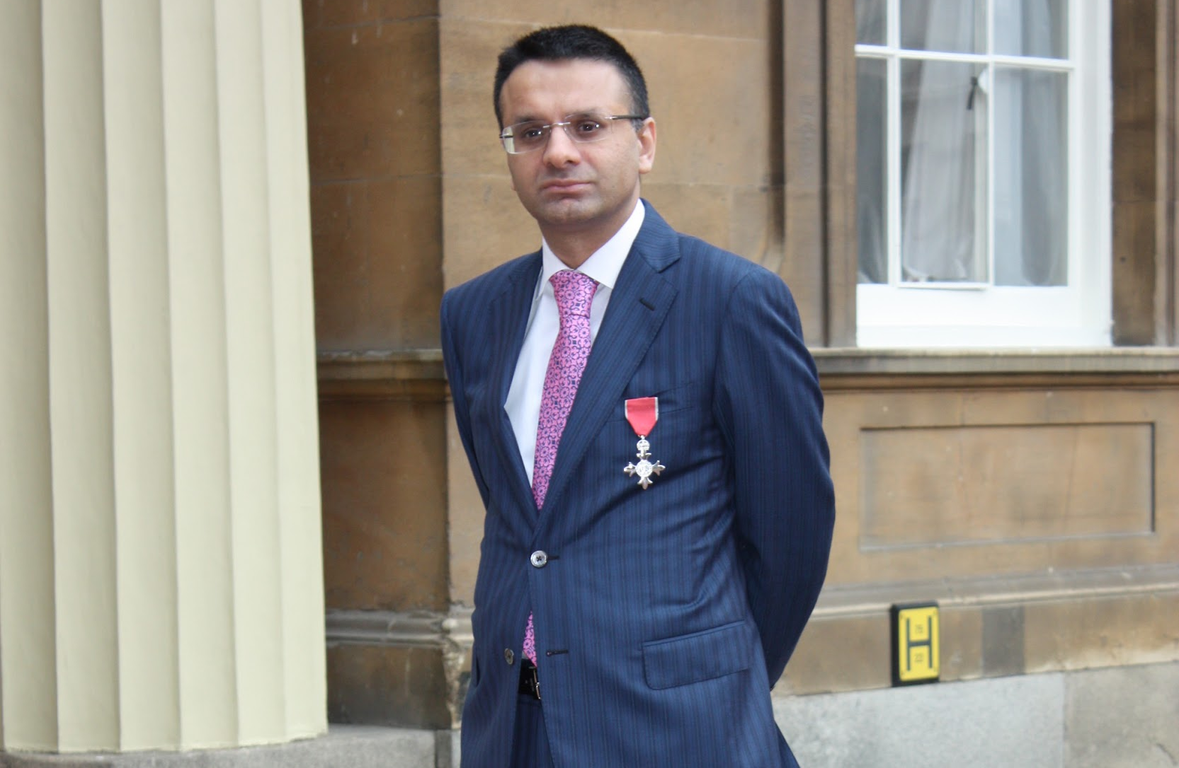 | 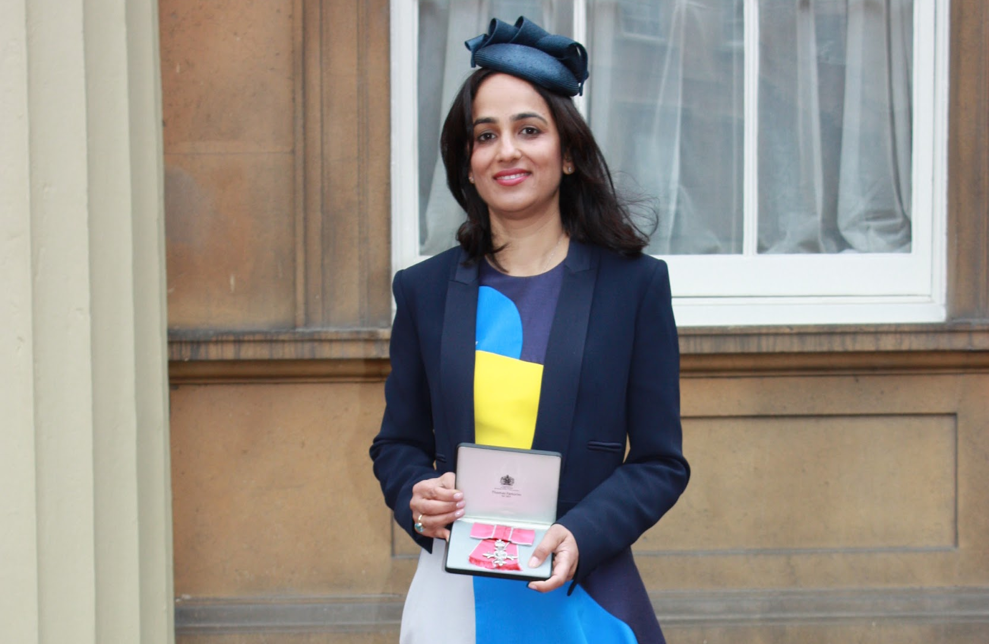 | 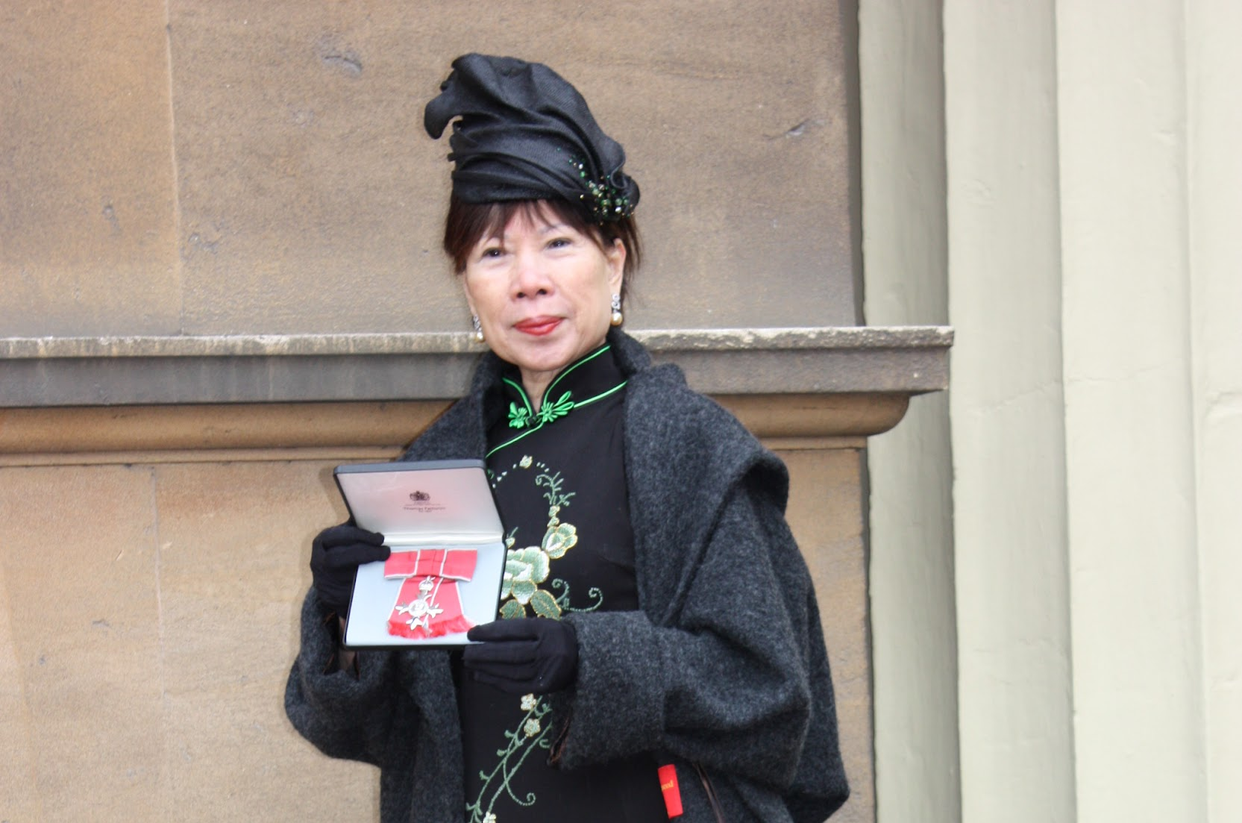

CANDIDATE INFORMATION PACK

Closing date for this post is: 23rd April 2024

Prime Minister's strategic priorities for the honours system

The honours system is there to recognise those exceptional individuals who have committed themselves to serving and helping the UK, and ensure that those who have made an outstanding contribution in their sector are rewarded.
The Prime Minister is determined to make sure our honours represent the length and breadth of the country. He wants to ensure the “levelling up” of the honours system so that it captures every corner of the UK - particularly regions that have too often been underrepresented.
The Prime Minister would like to see the honours system especially recognise those:
- who provide high quality, responsive healthcare, built around patient needs;
- who deliver the highest possible standards in education;
- who deliver meaningful change locally in tackling crime and improving their community;
- who support families to contribute to society and help children achieve their potential;
- public servants who have delivered an outstanding service to the people of the United Kingdom and Overseas, supported the levelling up agenda and provided exceptional value to the taxpayer;
- entrepreneurs and innovators who create thriving businesses and deliver growth across the country;
- philanthropists and those who give their expertise and help support public sector, cultural and charitable institutions.
Mr Sunak reaffirmed that honours should be awarded on ‘merit first’ – those who give service above and beyond their job. There should be representation from the length and breadth of the country, reflecting the incredible contributions made across every part of the United Kingdom.

Diversity and Equality of opportunity
Diversity of opportunity is something the Cabinet Office cares passionately about.
Applications are encouraged from all candidates regardless of ethnicity, religion or belief, gender, sexual orientation, age, disability, and gender identity. We particularly welcome applications from women, those with a disability, those from a black or ethnic minority background and those living outside of London and the South East. We want to explore the widest possible pool of talent for these important appointments.
Offering an Interview to Disabled People (GIS scheme)
As a Disability Confident employer, we will ensure that disabled applicants who meet the minimum criteria for this position will be offered an interview.
The Equality Act 2010 defines a person as disabled if they have a physical or mental impairment and the impairment has a substantial and long term adverse effect on their ability to carry out normal day-to-day activities. If you wish to indicate that you are disabled or have a long-term health condition, please complete the Disability Confident - Offering an Interview to Disabled People declaration in the supporting documents and send it with your application.
Location
Meetings are usually held in London.

Background to the Honours System
The modern honours system is intended to recognise merit, achievement and excellence in all areas of UK life. The Prime Minister of the day sets strategic priorities for the honours system. Successive Prime Ministers have asked that the system honours people who give service above and beyond – and not those who are just doing their job.
Honours lists are published twice a year at New Year (usually 30 or 31 December) and on the Sovereign’s Official Birthday (currently the middle of June). Three separate lists make up the New Year and Official Birthday lists:
The Prime Minister’s List – managed by the Cabinet Office.
- This list is for those contributing to the UK. It consists of around 1,300 people (although some people living outside the UK may also be considered);

The Overseas and International List – managed by the Foreign, Commonwealth and Development Office (FCDO).
- This is for members of the Diplomatic Service and for those UK citizens working in the UK’s interests abroad. It consists of around 150 people; and

The Defence Services List – managed by the Ministry of Defence (MOD).
- This is for members of the Armed Forces, consisting of around 200 people.
There are ten independent committees which assess nominations for the Prime Minister’s List. The majority of awards recommended by the honours committees are in the Order of the British Empire.
Typically, the Prime Minister’s List is made up of around 30 people appointed as Dames or Knights, with around 120 people awarded a CB/CBE. These are considered the highest honours and in all they represent no more than 15% of the list.
The overwhelming majority of people recognised will receive OBEs, MBEs and BEMs, and generally represent those who have made valuable contributions at a relatively local level.

Role of the Independent Committees

The Honours committees meet twice a year, in advance of each honours list being published. Your commitment as a member is to attend the meetings, one between January and March for the Birthday honours round and one between September and October for the New Year honours round. There is extensive pre-reading for each committee meeting.
As an honours committee member, you are asked to:
- attend each honours committee meeting whenever possible;
- read and develop views on the honours committee papers in advance of the meeting;
- play a role in supporting Government departments to build pipelines of possible future nominees in your area of expertise;
- act as an ambassador for the honours system in outreach activities, particularly by promoting the honours system through your professional networks.
Committee members act independently, recommending honours candidates to the Prime Minister and His Majesty The King.
Nominations are assessed case-by-case on their specific merits. This is a high profile area of work, which attracts considerable public and media interest.
Committees are supported by the Honours and Appointments Secretariat, which currently consists of approximately 25 team members who are based in the Cabinet Office.
Current committee membership can be found at www.gov.uk/honours.

About the Education Committee

The Education Committee is one of ten specialist honours committees which assess honours nominations put forward by members of the public, government departments and professional bodies.

The Committee has to select those it wishes to recommend to the Prime Minister and The King for inclusion in the New Year and Birthday Honours Lists.

The Committee considers candidates for honours in the following areas of service:

- Scholars; academics; researchers; teachers in all educational organisations from schools to universities (state & independent); children's services staff ; educational charities and philanthropists.

About the Cabinet Office
The Cabinet Office supports the Prime Minister and ensures the effective running of government. The Department is the corporate headquarters for government, in partnership with HM Treasury, and takes the lead in certain critical policy areas.
The Cabinet Office has responsibility for:
- supporting collective government, helping to ensure the effective development, coordination and implementation of policy;
- supporting the National Security Council and the Joint Intelligence Organisation, coordinating the government’s response to crises and managing the UK’s cyber security;
- promoting efficiency and reform across government through innovation, better procurement and project management, and by transforming the delivery of services;
- promoting the release of government data, and making the way government works more transparent;
- creating an exceptional Civil Service, improving its capability and effectiveness; and
- political and constitutional reform.
The Department’s priorities are to:
- support the Prime Minister and Cabinet to deliver the government’s programme;
- drive efficiencies and reforms that will make government work better;
- create a more united democracy; and
- strengthen and secure the United Kingdom at home and abroad.

Person Specification and Eligibility Criteria
All candidates must demonstrate, in their CV and supporting letter, how they meet the following criteria, through their knowledge, skills and experience.
Person Specification and Eligibility Criteria
Due to the nature and high profile of the honours system, the work and outcomes often attract considerable public and media interest. The candidate should therefore be someone of outstanding integrity and be open to promoting the honours system within their sector or region.
The successful candidates should be experts in their field whose expertise has been gained by paid, voluntary or academic work in these areas. They must be able to command the confidence of other experts in the sector and will be persons of distinction in their own fields, who are well qualified to judge the relative merits of different candidates for honours.
They will be able to act with independence of judgement and be individuals of the highest standards of probity and discretion. They will need to be sympathetic with the aims of the honours system and have an awareness of the importance of diversity in the honours process. We would particularly welcome applications from those with a proven track record of championing and improving diversity (including geographical diversity) in their field.
Essential Criteria
The successful candidate will need to demonstrate the following skills:
- a commitment to add to the breadth of experience and expertise on the committee, including strengthening diversity of thought and representation from across the United Kingdom;
- excellent judgement, and knowledge of those in the sector they are representing;
- ability to consider all the information presented, identify key issues and make objective and balanced decisions;
- an understanding of the workings of the Honours committees;
- a strong intellect and ability to act impartially and with sound judgement;
- experience of committee, board or trustee work; and
- evidence of collective decision-making, and resolving conflict

We are particularly looking for:
- candidates with experience of the Higher and Further Education sectors;
- candidates who are based outside of London and the South East.
- candidates with experience of children’s social care

For these posts, a person cannot be appointed to an honours committee if they are employed in the civil service of the state, have unspent criminal convictions, are subject to bankruptcy, or disqualification as a company director.

There must be no employment restrictions, or limit on your permitted stay in the UK.
Conditions of Appointment
Remuneration, allowances and abatement
Members can claim reimbursement for reasonable travel and subsistence costs incurred on Committee business.
This post is not remunerated and is not pensionable.
Appointment and tenure of office
- Committee members are appointed by the Prime Minister for a three to five year term, in the first instance. This is currently under review and may change.
- It will be important that the successful applicant’s other commitments (whether paid or unpaid) do not cast any doubt on their ability to act impartially in discharging the role; any potential conflict of interest must be declared.
- All committee members are required to adhere to the Seven Principles of Public Life (see Appendix 1).
Time commitment
Honours Committee members will be expected to attend the two committee meetings a year and additionally attend a pipelining meeting, as required.
The person in this role would be expected to undertake promotional and outreach activity on behalf of the honours system.
In addition, all members of the Education Committee must:
- ensure they understand their duties, rights and responsibilities, and that they are familiar with the function and role of independent honours committees and the honours system;
- ensure they act in accordance with the Code of Practice for members and the Seven Principles of Public Life (see Appendix 1);
- comply with any rules set by the Cabinet Office regarding the reimbursement of expenses, the acceptance of gifts and hospitality, conflict of interest and declaration of interests; and
- not misuse information gained in the course of their public service for personal gain or for political purposes. Nor should they use the role of public service to promote their private interests or those of closely connected persons, firms, businesses or other organisations.

Indicative timetable and how to apply
Timetable for recruitment
Closing date: 23rd April 2024

Shortlisting: w/c: TBC

Interviews held:TBC
Provisional appointment start date: Tuesday 16 January - the Birthday 2024 Honours Education Committee meeting will be held on Tuesday 6 February. Successful candidates will be required to attend this meeting.
Due to limited availability of selection panel members, shortlisted candidates should ensure that they are available to attend on the advertised interview date as it is unlikely that an alternative date can be accommodated.
In order for us to progress your application please submit the following completed documentation:
1. A Curriculum Vitae (maximum of two A4 pages) with your education, professional qualifications and full employment history. Please ensure your full name is clearly noted at the top of your CV.
2. An accompanying Supporting Letter (maximum of two A4 pages) – setting out your suitability for the role and how you meet the essential criteria set out in the person specification. Please ensure your full name is clearly noted at the top of your letter.
3. Diversity monitoring form (attached separately) - this form will not be disclosed to the panel involved in assessing your application.
4. Disability Confident form – offering an interview to disabled people declaration, if applicable (attached separately).
Please submit your application via the Cabinet Office Public Appointments website.
General enquiries about Honours Committee recruitment can be made to: copublicappointments@cabinetoffice.gov.uk

How We Will Handle Your Application
Appointments to the independent honours committees follow the OCPA principles and are made by the Prime Minister, in tandem with the agreement from the Cabinet Secretary.
We will deal with your application as quickly as possible and will keep you informed at key stages:
- After the closing date we will acknowledge receipt of your application (by email if you have provided this).
- Your application will be assessed against the candidate profile and your experience relevant to the post. Please ensure that your application includes a supporting letter (as set out above), providing evidence that demonstrates how you meet the criteria. Submitting a Curriculum Vitae alone will not be sufficient.
- At the shortlisting stage, a selection panel will decide which candidates will be invited for interview, taking account of the evidence provided by the candidates. You will be advised of the outcome of your application (by email) as soon as possible. If successful, you will be invited to an interview in central London.
We regret that we are only able to offer detailed feedback to candidates who have been unsuccessful at the interview stage.
If you have a complaint about the way your application has been handled at any stage of the process, please see the section on “How to complain” below.
Candidates should be aware that due diligence will be carried out on candidates shortlisted for interview. This will include searches of previous public statements and social media, blogs or any other publicly available information.
Use of your personal information
Your personal information will be held in accordance with the General Data Protection Regulation. You will not receive unsolicited paper or electronic mail as a result of sending us any personal information. No personal information will be passed on to third parties for commercial purposes.
When we ask you for personal information, we promise we will:
- only ask for what we need, and not collect too much or irrelevant information;
- ensure you know why we need it;
- protect it and insofar as is possible, make sure nobody has access to it who shouldn't;
- ensure you know what choice you have about giving us information;
- make sure we don't keep it longer than necessary; and
- only use your information for the purposes you have authorised.
We ask that you:
- give us accurate information;
- tell us as soon as possible of any changes; and
- tell us as soon as possible if you notice mistakes in the information we hold about you.
If you apply for a post, the manner in which we share information with the interview panel is described above.
Our data protection policy is in line with the General Data Protection Regulation.
If you would like these details to be removed from our records as soon as this recruitment exercise is complete, please inform the Honours and Appointments Secretariat via the email address to which you sent your application

Standards in Public Life, Political Activity, Disqualification from Appointment and Conflicts of Interest
Standards in public life
Members of the independent honours committees will need to confirm that they understand the standards of probity required of public appointees outlined in the “Seven Principles of Public Life” drawn up by the Committee on Standards in Public Life (see Appendix 1 below).
Political Activity
Members of the independent honours committees will need to show political impartiality during their time on the committee and must declare any party political activity they undertake in the period of their appointment.
Due to the nature of independent honours committees it is not appropriate for independent members of the committee to occupy paid party political posts or hold sensitive, senior or prominent positions in any political organisation. Nomination for election to political office, for example, the House of Commons, the Northern Ireland Assembly, Scottish Parliament, the European Parliament, is not considered compatible with membership of independent honours committees.
Subject to the above, committee members are free to engage in political activities, provided that they are conscious of their general responsibilities and standards for public life and exercise proper discretion.
You are required to fill out a Political Activity Declaration as part of your application (please see monitoring forms), which will be kept separate from your application and will only be seen by the selection panel prior to interview. However, it is appreciated that such activities may have given you relevant skills, including experience gained from committee work, collective decision-making, resolving conflict and public speaking. If, therefore, you have had such experience and you consider it relevant to your application for this post, you should include it separately in the main body of your application.
If you are successfully appointed to the post, details of your response to the Political Activity Declaration will be included in any announcement of your appointment.
Disqualification from appointment
Anyone in the categories listed below will not be considered for appointment as a member of an independent honours committees (also see ‘Political Activity’ above):
- Employed in the Civil Service of the state
- Unspent criminal convictions
- Bankruptcy
- Disqualification as a company director.
Conflict of interests
The Honours and Appointments Secretariat maintains a register of committee members’ interests to avoid any danger of the committee member being influenced, or appearing to be influenced, by their private interests in the exercise of their duties. Candidates invited to interview will be questioned about any real or perceived conflicts of interest. These do not constitute an automatic bar to appointment, but they must be manageable.

Appendix 1
The Seven Principles of Public Life
All candidates for public appointments are expected to demonstrate a commitment to, and an understanding of, the value and importance of the principles of public service. The seven principles of public life are:
Selflessness
Holders of public office should act solely in terms of the public interest.
Integrity
Holders of public office must avoid placing themselves under any obligation to people or organisations that might try inappropriately to influence them in their work. They should not act or take decisions in order to gain financial or other material benefits for themselves, their family, or their friends. They must declare and resolve any interests and relationships.
Objectivity
Holders of public office must act and take decisions impartially, fairly and on merit, using the best evidence and without discrimination or bias.
Accountability
Holders of public office are accountable to the public for their decisions and actions and must submit themselves to the scrutiny necessary to ensure this.
Openness
Holders of public office should act and take decisions in an open and transparent manner. Information should not be withheld from the public unless there are clear and lawful reasons for doing so.
Honesty
Holders of public office should be truthful.
Leadership
Holders of public office should exhibit these principles in their own behaviour. They should actively promote and robustly support the principles and be willing to challenge poor behaviour wherever it occurs.

