Transport Focus
Two Non-Executive Directors
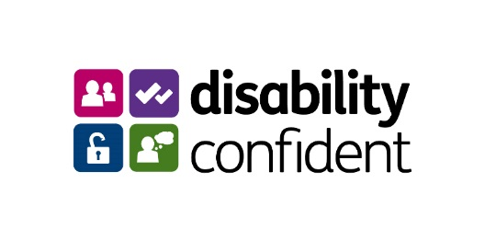
August 2023

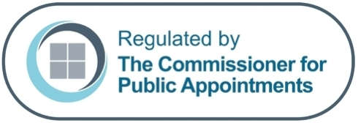



Contents

Welcome Note from Huw Merriman, Minister of State 3
Welcome Note from Nigel Stevens, Chair of Transport Focus 5
About the Sponsored Body 6
About the role 8
How to Apply 9
Indicative Timetable 10
Terms of Appointment 11
Annex A – Seven Principles of Public Life 17

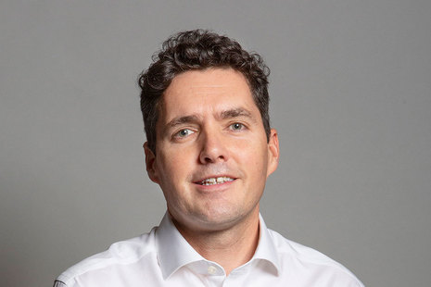

Welcome Note from Huw Merriman MP, Minister of State, Department for Transport

Dear Applicant,
Thank you for your interest in becoming a Non-Executive Director on the Board of Transport Focus.
This is an important time for transport in our country – with the Government delivering on major improvements across the sector to improve the experience of transport users. We are reforming our railways, supporting buses and investing heavily in infrastructure and public transport to improve journeys, boost connections, level up the country and support economic growth. Central to our mission is delivering transport that works effectively for its users – delivering on what they need and expect. Transport Focus play a central role in this agenda as the independent, statutory, consumer watchdog for Britain’s rail passengers, England’s bus, coach and tram passengers (outside of London) and users of the Strategic Road Network in England.
We are now recruiting two Non-Executive Directors for the Board of Transport Focus, who will play a key role in ensuring that Transport Focus delivers on its important mission. Both roles will play a role in supporting Transport Focus’s future reform and development, with one particularly focussed on the organisation’s strategic highways remit. We are looking for enthusiastic individuals who are passionate about making a difference.

We strongly welcome applications from all backgrounds. As part of the Department’s commitment to diversity, we believe our public appointments should reflect our customers - the travelling public – who come from all walks of life and have different experiences. We very much welcome fresh talent, expertise, and perspectives, to help us better understand the needs of the communities we serve and support better decision making for all. This includes people who may have never applied for a public appointment – but could bring new ideas, insights and energy.

If you are interested in the role and work of Transport Focus and want to make a real difference to the experience of transport users, I would like to encourage you to apply.
Our dedicated DfT Public Appointments Team would be happy to talk through the process and answer your questions.

Huw Merriman MP
Minister of State, Department for Transport


Nigel Stevens
Chair, Transport Focus

Thank you for your interest in joining the Transport Focus Board.
Being a non-executive director of Transport Focus is a challenging, interesting and rewarding role. You will play a critical role in shaping the work of the organisation and supporting the executive team in delivery on the agreed work plan. You will be joining the Board at a critical time as we re-shape our organisation and output to support the changing needs of the transport sector.

Transport Focus is the voice of Britain’s transport users, championing the cause of the transport user today, influencing policy for tomorrow and contributing to the debate on their future needs. We are proud of our objective, evidence-based work and the value it brings to our stakeholders. It is a changing time for those using all modes of transport and therefore the role of Transport Focus is more important than ever in representing the users’ needs.

We need a Board that can really think differently and see issues from alternative perspectives. It’s therefore exceptionally important that we draw our non-executive directors from a wide range of backgrounds and geographies, so please don’t think that your background or viewpoint aren’t right for this role – in fact, that maybe precisely the reason we will be interested in your application!

I really hope that you will feel inspired to apply and would urge you to contact us, if you want to explore the two roles currently on offer in more detail.

About Transport Focus

Our changing role and structure
- Transport Focus has existed in some form since 1947. Today, it is structured as an executive non-departmental public body, sponsored by the Department for Transport. The Scottish and Welsh Governments and the London Assembly each appoint a member to the Board. The remaining appointments, including the Chair, are made by the Secretary of State for Transport through an appointments process regulated by the Commissioner for Public Appointments.

- Current board member and management profiles can be found on our website. The Board meets approximately three times per year in public, and monthly in private. The Board meets in London, Manchester and other places across Great Britain. Transport Focus is proud of its insight and research, all of which is published on our website.

- Since the autumn of 2022, Transport Focus has embarked upon a fundamental review of the way it works and, consequently, how it is structured - partly as a response to the Government’s plans for rail reform. This journey is continuing; new Board members will find this is an exciting time to be joining Transport Focus as we implement our new vision for serving transport users today, tomorrow and in the future.

What does Transport Focus do?
As the voice for Britain’s transport users, we:

- Champion the needs of the transport user today

- Ensure the transport user is at the centre of policy making and decisions for tomorrow

- Inspire future transport thinking

How do we do it?

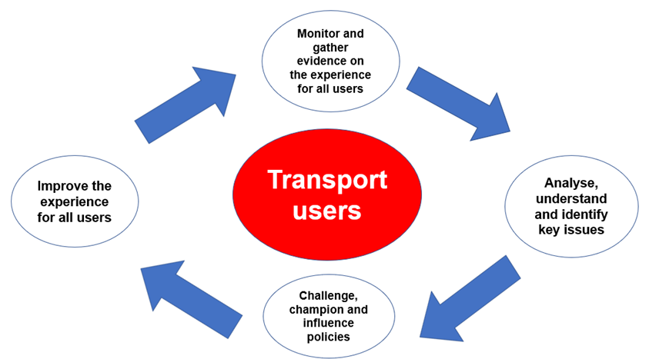

About the Role

Title: Transport Focus Non-Executive Board members (Two)

Reports to: Transport Focus Chair

Duration: An initial term of 4 years, with the possibility of re-appointment
Remuneration: £13,243 per annum for up to 4 days contribution per month, averaged across the year.

Essential criteria:

We welcome applications from candidates who will add value to the important role the Board plays. There is no ‘model’ Board member, but you must be able to demonstrate in your application, and at interview, you have the time to devote to these roles, and:

For role one: an ability and professional experience that will allow you to be the NED lead for our strategic highways remit. This could be a professional background in road haulage, strategic highways management or from a representative body of the motorist.

For role two: a background in business operations which includes demonstrable experience of commercial acumen and the management of risk, this could include a number of background disciplines including commercial law, commercial governance, general management or finance.

For both roles:
- A clear interest in the issues facing transport users with a capacity to quickly grasp the detail.
- A capacity for strategic thinking so that issues can be identified, and solutions developed.
- Strong people skills with the ability to build and maintain constructive relationships with staff and stakeholders.
- A keen understanding of the political environment and how this interfaces with the provision of public services in general and public transport in particular.
- An ability to constructively challenge to support change and drive improvements.

Candidates’ suitability for the role will be assessed against the requirements for role one or role two, plus criteria i-v above.

When making your application, please make it clear which role you are applying for in your supporting summary.

As a member of the Transport Focus Board, you will work collaboratively with staff and key stakeholders across the country. You will help ensure that the voice of the transport user is not only heard but understood and acted upon by those in positions of influence. You will be a proactive person with the capacity to identify the need for, and to promote, transformational change, both within Transport Focus and across the transport network.

You will use your skills and experience to make a difference for transport users. Specifically, you will:

- Help ensure our work represents good value for money for the taxpayer
- Contribute to the development of strategy, and provide guidance and challenge to the work of the management and staff teams
- Lead/participate in work streams as discussed and agreed with the Chair
- Represent the organisation on other bodies; and/or chair or speak at public meetings and conferences
- Participate at monthly meetings of the Board, work collectively and collaboratively with other Board colleagues and staff, promote good governance, sound decision-making and best practice across the organisation
- Expect to be nominated to or chair at least one committee of the board

How to Apply
If you wish to apply for these positions, please apply through the Cabinet Office’s Public Appointments website by 17 September. Any applications submitted after the closing date, or that are missing any of the following documents, will not be accepted.

- A CV or equivalent biographical information (maximum two sides A4, minimum 12 font) setting out your career history and including details of any professional qualifications.
- Provide a summary of why you are interested in the role and how you meet the specification and essential criteria. This can be in any form that allows you most ably to present your interest and credentials, for example a short, bullet-point slide presentation, a short video (no more than 2 mins) or supporting letter (no more than two A4 pages, minimum 12 font). Make sure you refer to the contents of this document and provide specific examples. If you wish to provide your supporting summary in video format, please contact Jessica Hall in advance of the closing date.
- You will also be asked to provide diversity data, and to declare any potential conflicts of interest or reputational issues.

When making your application, please make it clear which role you are applying for in your supporting summary.

If you have any queries about this role, please contact Jessica Hall by email DfTPublicAppointments@dft.gov.uk
If you feel an informal conversation with the Chair may be helpful in deciding whether to apply, please email jon.carter@transportfocus.org.uk to arrange.
Indicative Timetable

Please note that these dates are only indicative at this stage and could be subject to change. Please let us know if you are unable to meet these timeframes.

Advert Closing Date | 17 September
Short List Meeting | Week commencing 9 October
Final Panel Interviews | Week commencing 6 November
Meeting with Secretary of State (if required) | Week commencing 13 November

Selection Process

This role is being competed in accordance with the Governance Code (January 2017), which sets out the regulatory framework for public appointments processes. The Code is based on three core principles – merit, openness, and fairness.
The selection panel for this appointment competition is:
- Oliver Mulvey (Deputy Director, Rail Markets Strategy, DfT)
- Nigel Stevens (Chair, Transport Focus)
- Emma Moir (Independent Panel Member)

At the short-listing meeting the selection panel will assess each application against the essential criteria and decide who to invite for interview.

Interviews are expected to take place in central London and to last for between 45 and 60 minutes. Please contact Jessica Hall to discuss alternative interview options if required. Candidates will be asked to make a short presentation on matters of interest and/or concern to transport users and broader challenges facing Transport Focus. The specific topic will be notified to shortlisted candidates nearer the time.

The decision to appoint to these roles rests with the Secretary of State. Appointable candidates may be invited to meet with the Secretary of State, or another Department for Transport Minister, before they make a final decision.

Please note: Expenses incurred by candidates during the recruitment process will not be reimbursed except in exceptional circumstances and only when agreed in advance with the DfT Public Appointments Team.

You can expect the recruitment process to take approximately 3 months, however, applicants will be kept informed of progress.

Additional Information

Appointment Term
- Your appointment as a Non-Executive Board member of Transport Focus will be made by the Secretary of State.
- The appointment will be for an initial term of four years, with the option of re-appointment for up to a further four years by mutual agreement.
- It should be noted that this post is a public appointment; Non-Executive Board members are neither employees of the Crown nor the Department for Transport. Such appointments are not normally subject to the provisions of employment law.
- Appointments may be ended prior to the conclusion of the period of appointment.

Time Commitment
The anticipated time contribution is up to 4 days per month, averaged across the year. The role involves attendance at Board meetings either in person or remotely, providing specialised advice as required, preparation time, travel, and work outside of meetings. In-person meetings will take place in London and around the country.

Remuneration
- £13,243 per annum for up to 4 days contribution per month, averaged across the year.
- Remuneration is taxable through payroll, and the appointment is not pensionable.
- Members can claim reimbursement for reasonable travel and subsistence costs necessarily incurred at rates set centrally by the Department for Transport.
- Applicants should note that the successful candidates cannot be remunerated for this role if they are being paid for an existing full-time role from the public purse.

Location
The roles will be based in London. In-person meetings will take place in London and around the country.

Availability
The successful candidates are expected to commence the role in December 2023, subject to the successful completion of pre-appointment checks and security clearance.

Security clearance
The successful candidate will be required to have or be willing to obtain security clearance to Baseline Personnel Security Standard (BPSS) level. Pre-appointment checks will also be undertaken on immigration and criminal convictions. It usually takes between 4-6 weeks to obtain the security clearance. The role will be offered on a conditional basis until the successful candidate has passed all checks.

Equal Opportunities Monitoring
We believe that by being a diverse and inclusive workplace, where everyone is valued, we are more motivated, higher performing and more committed to our team. We welcome all applicants, regardless of gender, sexual orientation, social background, religious beliefs, ethnicity, or age.
As part of the application process we ask candidates to complete equal opportunities monitoring information in the application portal. This will help us to monitor selection decisions to assess whether equality of opportunity is being achieved. This part of the form will be treated as confidential and used for statistical purposes only. The form will not be treated as part of your application.

Disability Confident
The Department for Transport values and promotes diversity and is committed to equality of opportunity for all and to the appointment of disabled people. As part of the Disability Confident scheme, we guarantee an interview to anyone with a disability whose application meets the essential criteria for the post.
In order to guarantee an interview to all disabled candidates (as defined by the Equality Act 2010) who satisfy all the essential criteria for the role and wish to be considered under the Disability Confident Scheme, we need candidates to declare a disability and that they wish to be considered under the Scheme.
What do we mean by a disability?
To be eligible for consideration under the Scheme, you must be considered disabled under the Equality Act 2010.This means that you must have or have had in the last 12 months, a physical or mental impairment which has a substantial long-term adverse effect on your ability to carry out normal day-to-day activities. This includes those whose disability has lasted, or is likely to last, for 12 months, or if the disability or condition is likely to progress or recur.
You do not have to be registered as a disabled person to apply under this scheme.

Nationality
This is a non-reserved post and therefore open to UK Nationals, British Nationals Overseas, British Protected Persons, Commonwealth Citizens, EEA Nationals and certain non-EEA family members and Swiss Nationals under the Swiss EU Agreement. There must be no employment restriction or time limit on your permitted stay in the UK. You will not be asked to produce evidence to confirm your eligibility at the application stage, but you will be required to do so should you be invited to the final panel interview.

Standards in public life
You will be expected to demonstrate high standards of corporate and personal conduct. All successful candidates will be asked to subscribe to the Review Body’s “Codes of Practice”. Candidates will be expected to abide by the “Seven Principles of Public Life” set out by the Committee on Standards in Public Life in Annex A.

Disqualification for appointment
There are circumstances in which an individual will not be considered for appointment. They include:
- people who have received a prison sentence or suspended sentence of three months or more in the last five years.
- people who are the subject of a bankruptcy restrictions order or interim order.
- in certain circumstances, those who have had an earlier term of appointment terminated.
- anyone who is under a disqualification order under the Company Directors Disqualification Act 1986.
- anyone who has been removed from trusteeship of a charity; and
- Roles listed under the House of Commons Disqualification Act 1975 or the Devolved Administrations equivalent.

- The appointment is subject to compliance with the Transport Focus Membership Code [insert link] including (specifically but not limited to) those provisions in respect of conflict of interest.
- You may not be a Member of Parliament, the Scottish Parliament, the Senedd or the London Assembly. If you stand for election to any of these bodies during your term of office, you will be expected to stand aside from your Transport Focus duties during any campaign and, if elected, to resign from the Board. The Addison rules will apply if you are, or become, a member of the House of Lords.

Registration of interests

The purpose of these provisions is to avoid any danger of Board members being influenced, or appearing to be influenced, by their private interests in the exercise of their public duties.
Public appointments require the highest standards of propriety, involving impartiality, integrity, and objectivity, in relation to the stewardship of public funds and the oversight and management of all related activities. This means that any private, voluntary, charitable, or political interest which might be material and relevant to the work of the body concerned should be declared. It is important, therefore, that you consider your circumstances when applying for a public appointment and identify any potential conflicts of interest, whether real or perceived.
There is a requirement to declare any actual or potential conflict of interest you may have in being appointed to the Board via the application portal. Any actual or perceived conflicts of interest will be fully explored by the Panel at interview stage.

Political activity
Members will need to show political impartiality during their time on the Board and must declare any party-political activity they undertake in the period of their appointment. Details of the successful candidate’s declared political activity must be published by appointing departments when the appointments are publicised.
Your political activity will be kept separate from your application and will only be seen by the Panel prior to interview – the Panel may at that stage explore with candidates any potential for conflict of interest. It is appreciated that political activities may have given you relevant skills, including experience gained from committee work, collective decision making, resolving conflict and public speaking. If, therefore, you have had such experience and you consider it relevant to your application for this post, you may if you choose include it separately in the main body of your application.

Due diligence
Due diligence will be carried out as part of the application process. As well as checks made regarding the above, searches will be carried out via internet search engines and any public social media accounts. It will be seen by the Panel prior to interview – the Panel may at that stage explore with candidates any findings.

Data Protection
The Department for Transport (DfT) is the joint controller, with the Cabinet Office, for any personal data which you provide to us as part of your application.

Information provided as part of this application will be kept securely within DfT and destroyed within 5 years of the conclusion of the recruitment campaign.

DfT uses this form to gather evidence on DfT’s public appointments.

The lawful basis that applies to this processing is that it is necessary for the performance of a task carried out in the public interest to inform DfT’s recruitment policies in accordance with the Department’s public sector equality duties. For processing special category personal data (disability, religion, sexual orientation and ethnicity), we rely on Article 9(2)(g), reasons of substantial public interest (equality of opportunity and treatment).

Complaints

If you are not completely satisfied with the way your application is handled at any stage of the competition, please raise any complaint in the first instance with:

Via email: DfT Public Appointments DfTPublicAppointments@dft.gov.uk

Public Appointments Team
Shareholding, Appointments and Inquiry Response
Department for Transport
Great Minster House
33 Horseferry Road
London
SW1P 4DR

We will reply to your complaint within 20 days.
If you remain unsatisfied, please contact the Office of the Commissioner for Public Appointments. The Commissioner can only investigate complaints relating to regulated Public Appointments.
Annex A

Seven Principles of Public Life
The principles of public life apply to anyone who works as a public officeholder. This includes all those who are elected or appointed to public office, nationally and locally, and all people appointed to work in the civil service, local government, the police, courts and probation services, NDPBs, and in the health, education, social and care services. All public officeholders are both servants of the public and stewards of public resources. The principles also have application to all those in other sectors delivering public services.
Selflessness
Holders of public office should act solely in terms of the public interest. They should not do so in order to gain financial or other material benefits for themselves, their family, or their friends.
Integrity
Holders of public office should not place themselves under any financial or other obligation to outside individuals or organisations that might seek to influence them in the performance of their official duties.
Objectivity
In carrying out public business, including making public appointments, awarding contracts, or recommending individuals for rewards and benefits, holders of public office should make choices on merit.
Accountability
Holders of public office are accountable for their decisions and actions to the public and must submit themselves to whatever scrutiny is appropriate to their office.
Openness
Holders of public office should be as open as possible about all the decisions and actions that they take. They should give reasons for their decisions and restrict information only when the public interest clearly demands.
Honesty
Holders of public office have a duty to declare any private interests relating to their public duties and to take steps to resolve any conflicts arising in a way that protects the public interest.
Leadership
Holders of public office should promote and support these principles by leadership and example.

https://www.gov.uk/government/publications/governance-code-for-public-appointments

