


Candidate Brief

Appointment of Budget Responsibility Committee Member of Office for Budget Responsibility

The information provided in this document is for background information only. As such it does not constitute the terms, whether express or implied, of any future contract of employment.
The Office for Budget Responsibility

The OBR was created in 2010 to enhance the accountability of the Government, by providing independent and authoritative analysis of the UK’s public finances. The independent OBR has executive responsibility for producing the official UK economic and fiscal forecasts and assessing progress against the fiscal mandate. Despite being a small organisation employing around 45 civil servants and with an annual budget of around £4 million, the OBR has considerable influence both nationally and internationally.

Work of the Office

The main legislative duty of the OBR is to examine and report on the sustainability of the public finances, which it is required to do objectively, transparently, and impartially. The Office’s objective and impartial analysis is key to informing the policy decisions made by ministers and increasing transparency and the wider understanding of the UK’s public finances.

Within its broader remit the OBR is specifically required to produce:

Fiscal and Economic Forecasts
The economic and fiscal forecasts produced by the OBR represent the Budget Responsibility Committee’s (BRC’s) collective view of the UK’s economic and fiscal future. It is based on the analysis produced by OBR staff and draws on the work and expertise of officials across government. The government has chosen to adopt the OBR’s forecasts as the UK’s official forecasts, and they are used for the formation of government policy. The OBR publish their forecast in the Economic and fiscal outlook (EFO). The OBR has a statutory obligation to publish at least two forecasts per financial year, the timing of which is decided by the Chancellor of the Exchequer and one of which must be alongside the Budget.

The OBR is also required to produce an assessment of how likely it is that the government’s fiscal mandate will be achieved. This function of the OBR is key to improving the transparency of the government’s fiscal policy framework.

- Forecast Evaluation Reports
Forecast evaluation reports (FER) are published by the OBR each year to examine how past forecasts compared to subsequent outturn data. Investigating the causes of forecast errors allows the OBR to identify lessons for future forecasts and enables the BRC to explain the reasoning behind its judgements.

- Fiscal Risks and Sustainability
The OBR are required to report on the sustainability of, and risks to, the public finances. The Fiscal risks and sustainability report includes long term projections of the UK’s public finances at least once every two years. The report focuses on specific risks to the public finances each year.

- Welfare Trends Reports
The biennial WTR assesses the government’s performance against the welfare cap and produces analysis on both long and shorter term trends in spending on social security benefits and tax credits.

The OBR also publishes devolved tax and spending forecasts alongside the Economic and fiscal outlook and is the official forecaster for devolved Welsh taxes.

The OBR has complete discretion in how it fulfils its remit and additionally produces a wide range of working and discussion papers on topics relating to the sustainability of the public finances.

Producing Forecasts

The OBR is responsible for the production of the official economic and fiscal forecasts. To date these forecasts have been adopted by the Chancellor as the UK’s official forecasts. The establishment of the OBR enhanced the transparency and credibility of the government’s official economic and public finance forecasts in two ways – by tasking the production of forecasts to an independent and objective organisation, and subsequently publishing more information than had ever been made public previously. The OBR’s forecasts are essential inputs to the government’s ongoing policy making.

The forecasting process starts with the production of an initial economic forecast by OBR staff. This forecast takes into account information that has emerged since the last published forecast and reflects BRC judgements and assumptions. The OBR consults widely with external forecasters and analysts to ensure they are aware of as much relevant data and evidence as possible. This initial view on the shape of the economic forecast is used to produce the key fiscal determinants, allowing production of the public finance forecast to begin.

The public finance forecast is highly disaggregated, and the production of the majority of individual tax and spending lines is undertaken by a wide range of expert analysts working across government. The OBR scrutinises and challenges the assumptions and modelling for all of the individual elements of the forecast and makes adjustments where necessary. The BRC takes ultimate responsibility for the entire forecast and all of the underlying assumptions. These forecasts are brought together by the OBR, resulting in a detailed bottom-up up forecast of the public finances consistent with the economic forecast.

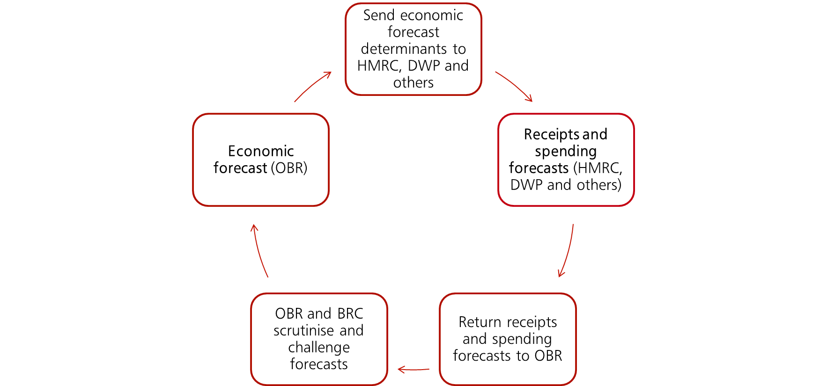
This is the start of an iterative process that continues over several rounds - with subsequent economy forecasts incorporating the output from the previous public finance forecast and vice versa. The economy and public finance forecasts are interdependent so these iterations ensure that the effects of changes to one element of the forecast are fully reflected in the forecast as a whole. The OBR also assesses the potential economic impact of any new policy measures that the Chancellor plans to announce alongside their forecast. The BRC judge whether these measures are likely to have a non-negligible impact on the economic outlook and, if so, how to adjust the forecast accordingly.

Governance

The OBR’s organisational structure can be split into 4 key components, shown below:

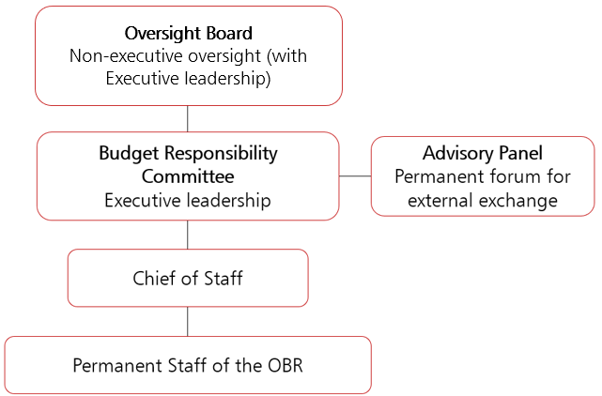

Budget Responsibility Committee

The Budget Responsibility Committee provides the executive leadership for the OBR as it carries out its core functions. This includes providing strategic leadership by determining how the OBR can fulfil its remit of examining and reporting on the sustainability of the public finances. In practical terms the BRC’s role includes, but is not limited to, making judgements to produce economic and fiscal forecasts (and long-term sustainability analysis), scrutinising forecast returns from government departments, determining the more detailed sustainability issues to be analysed by the OBR and providing insight into fiscal risks and welfare trends.

The BRC is made up of three members, one of whom is the Committee’s Chair. Appointments to the BRC are made by the Chancellor of the Exchequer with the agreement of the Treasury Committee. The Chancellor of the Exchequer is required to consult the Chair of the BRC for appointments to the two other positions on the BRC. BRC members are generally appointed for 5 year terms and are eligible to be reappointed once at the end of that term.

Oversight Board

The OBR’s Oversight Board is accountable for ensuring the operations of the OBR conform to its legislative mandate. This includes monitoring the relationship between the OBR and government departments to ensure independence, and provide assurance on risk management, governance, and internal control. The Oversight Board is comprised of the three members of the BRC and the two non-executive members. The non-executive members keep under review the extent to which the OBR is delivering against its duties under the Budget Responsibility and National Audit Act and associated guidance.

Advisory Panel

The OBR is currently undertaking a process to reorganise the external advisory panel. It will consist of subject-specific subgroups, with members drawn from academic and professional backgrounds who can provide expertise and guidance on the OBR’s analytical challenges.

OBR Staff

The OBR currently has 45 members of staff, who are all civil servants, reporting to the Chair of the OBR. Staff members work within teams covering economic analysis, fiscal analysis, policy costing and devolution, fiscal risks and long-term sustainability analysis and strategy, operations and communications. The OBR staff and analysts are led by a Chief and Deputy Chief of Staff, who are also a civil servants.

Governance Documents
The Budget Responsibility and National Audit Act 2011
The Budget Responsibility and National Audit Act (BRNA) 2011 is the primary legislation that established the OBR. It sets out the OBR’s functions, broad governance structure and overarching duty to examine and report on the sustainability of the public finances.

Charter for Budget Responsibility
The Charter for Budget Responsibility sets out the OBR’s remit, how it is to perform its duties, the required content of its key publications and the arrangements for determining the timing of its forecasts and other key publications. It also sets out the Government’s fiscal targets and has therefore been updated a number of times in recent years. The most recent Charter was updated in January 2023.

Framework Document
The OBR’s governance and management arrangements are set out in greater detail in a Framework document drawn up by the Treasury and agreed with the OBR. This describes the purposes of the OBR, how it is accountable to Parliament and the Chancellor, its governance and structure, the responsibilities of the accounting officer, the content of the annual report, the audit arrangements, and its managements and budgeting processes. The Framework document was reviewed and amended in May 2014 and again in March 2019.

Memorandum of Understanding
The Memorandum of Understanding sets out the agreed working relationship between the OBR, HM Revenue and Customs, the Department for Work and Pensions, and HM Treasury. It sets out the arrangements needed for effective working, covering each institution’s key responsibilities, coordination of the forecast process, and the process for information sharing. The Memorandum was most recently updated in March 2017.

Equality of Opportunity

The Office for Budget Responsibility and HM Treasury have strong commitments to diversity and equality of opportunity, and welcome applications from candidates irrespective of their background, gender, race, sexual orientation, religion, or age, providing they meet the required criteria. HM Treasury is a signatory to the Women in Finance Charter, Disability Confident Employer and a Top 50 Social Mobility Employer. Applications from women, disabled and BAME candidates in particular are encouraged.

This role is being offered on a part or full time basis, and Andy King has undertaken the role on a 0.9FTE basis. We are keen to attract a diverse range of candidates and there is flexibility to suit the right candidate.

All disabled candidates (as defined by the Equality Act 2010) who satisfy the minimum criteria for the role will be guaranteed an interview under the Disability Confident Scheme (DCS).

To be eligible for consideration under the DCS, you must be considered disabled under the Equality Act 2010. This means that you must have or have had in the last 12 months – a physical or mental impairment which has a substantial long-term adverse effect on your ability to carry out normal day-to-day activities. This includes those whose disability has lasted, or is likely to last, for 12 months, or if the disability or condition is likely to progress or recur.

If you wish to apply under the DCS, then please indicate this as you progress your online application.

Candidate Profile and appointment criteria

This is a high profile and important role. Under legislation, the Chancellor of the Exchequer shall appoint a member to the BRC only if that person has knowledge or experience which is likely to be relevant to the Committee’s functions.

External reviews of the OBR concluded that personnel have been the driving force behind the Office’s successes and that the BRC, in particular, have played an important role in establishing and building credibility. As such the Chancellor is committed to ensuring that the reputation and quality of the BRC’s membership is maintained.

The requirements for this role are as follows:

- World class expertise in fiscal analysis – candidates should have a strong and proven knowledge of the UK’s public sector finances, fiscal forecasting and the tax and welfare system. Candidates must demonstrate that they have used their fiscal expertise operating at a very senior level in business, a policymaking environment or academia - as a leader in their chosen profession.

- Analytical ability – candidates will need to be able to absorb large volumes of complex information and reach reasoned and robust conclusions quickly.

- Independence of thought and interpersonal skills – candidates must be independently minded and be able to exert their influence within the BRC and when representing the OBR to government, Parliament and the public. Candidates must be able to form their own views and decisions, whilst working closely and constructively with other members of the Committee.

- Undisputed integrity and standing – candidates must have the ability to maintain discretion and engender trust in staff, peers and stakeholders. The OBR must perform its duties objectively, transparently and impartially and BRC members are expected to lead the Office in a way reflective of this.

Terms of Appointment

Members of the BRC are appointed by the Chancellor of the Exchequer, following consultation with the Chair of the OBR, and with the consent of the Treasury Committee. Appointments to the BRC are normally for a five-year term. There is the possibility of reappointment at the end of the term and members can serve a maximum of two terms. BRC Members are required to request the consent of the Chancellor prior to taking any appointment, employment, or other duties that might lead to a conflict with BRC responsibilities.

The appointment is expected to commence in September 2023, or as soon as possible thereafter, subject to the consent of the Treasury Select Committee and to the requirements of both the successful candidate and the OBR.

This is a role that can be undertaken on a part or full time basis: Andy King has undertaken the role on a 0.9 FTE basis. We are keen to attract a diverse range of candidates and there is flexibility to suit the right candidate. The full-time salary for the role will be in the region of £132,000, (plus a 20 per cent private pension contribution) although there may be some flexibility depending on the skills and experience of the successful candidate. This will also be adjusted proportionately to the candidate’s time commitment.

BRC members are not required to hold UK nationality, but to fulfil their duties are expected to be resident in the UK.

The Budget Responsibility Committee is committed to hybrid working. Employees are expected to attend the office at the OBR’s 102 Petty France accommodation in London at least once or twice per week.

How to apply and appointment process

How to Apply

In order to apply you will need to create an account or sign in.
Once you are logged into your account, click on 'apply for this role' and follow the on-screen instructions. To apply, all candidates are required to provide:
- a Curriculum Vitae (CV)
- a supporting statement
- equality information
- information relating to any outside interests or reputational issues
We will ask you to check and confirm your personal details to ensure your application is accurate.
You will also have the opportunity to make a reasonable adjustment request or apply under the disability confident scheme before you submit your application.

Applications must arrive no later than midday 10th July.

If you have any queries concerning your application, or technical queries on completing the application, please email PublicAppointments-HMT@hmtreasury.gov.uk

Appointment Process

Once the closing date for applications has passed, applications will be sifted according to the candidate profile. Those applicants who have not been successful will be notified at this stage and a short list of the most closely qualified applicants will be invited to final panel interviews. The interview panel will be chaired by Sam Beckett, Chief Economic Adviser at HM Treasury, Head of the Government Economic Service and Second Permanent Secretary. The successful candidate must attend a pre-appointment hearing with the Treasury Committee, who have a veto on BRC appointments.

The closing date for applications is midday on 10th July. Interviews are expected to take place on or around the week commencing the 24th July. The successful candidate is expected to be announced in the summer and the appointment will commence in September 2023, or as soon as possible thereafter, subject to the consent of the Treasury Select Committee and to the requirements of both the successful candidate and the OBR.

Applicants should be aware that a due diligence exercise may be undertaken and should expect this to include searches of previous public statements and social media, blogs or any other publicly available information.

Panel Members

Sam Beckett (Panel Chair, Chief Economic Adviser to the Treasury)

Richard Hughes (Chair of the Office of Budget Responsibility)

Other panel members to be confirmed in due course.

Expenses

If you are invited for interview, reasonable and necessary travel expenses (standard class) will be reimbursed. Those invited to interview will be advised on how to claim their expenses.

If you feel you have reason for complaint about the appointment process or the manner in which your application was handled, please contact Public Appointments, Permanent Secretary’s Office, HM Treasury, 1 Horse Guards Road, SW1A 2HQ

HM Treasury Public Appointments: Privacy Notice
Public appointments are generally ministerial appointments to the board of a public body or advisory committee and HM Treasury advertises its public appointments on the Cabinet Office’s Public Appointments website. For the purposes of the UK General Data Protection Regulation (UK GDPR), this means that HM Treasury and the Cabinet Office are considered joint data controllers for any personal data processed for HM Treasury’s public appointments advertised on the public appointments website.
The purpose of this notice is to set out how HM Treasury uses personal data and special category data for the purpose of public appointments and explains your rights under the UK GDPR.
Data subject categories
The personal data to be processed for this activity relate to individuals applying for a Treasury public appointment which has been advertised on the Cabinet Office’s public appointments website.
Data categories
In most cases, the following personal data will be collected for the purposes of your application:
- name, address, telephone number and email address
- date of birth
- curriculum vitae and any covering letter
- employment references
- employment history and qualifications
- other background information relevant to your application including sift and interview assessments made by the advisory assessment panel
- right to work documentation (where necessary)
- any political activity
- details of any public appointments held
- alongside your own conflicts of interest and declaration of relevant interests, this may also include information relating to your conduct or professional capacity gathered as part of departments conducting appropriate checks on information appearing in the public domain
This list of data categories is not exhaustive and may vary, depending on the appointment you are applying for and what data you supply to us as part of your application.
Purpose of processing
Your personal data will be processed for the purpose of considering your application for a public appointment or reappointment in accordance with the Governance Code on Public Appointments published by the Cabinet Office.
Lawful basis for processing personal data
Personal data processed for the purpose of a public appointment or reappointment complies with Article 6(1)(e) of the UK GDPR in that it is necessary for the performance of a task carried out in the public interest. This public task is that of ensuring the suitability of those applying for public appointments.
Special category data
We are responsible for monitoring the diversity of our public appointments by assessing any diversity data collected as part of applications. This diversity data may include your:
- race or ethnicity
- religious beliefs
- sexual orientation
- sex/gender
- political beliefs
- disability information (where applicable)
We may also ask you to supply us with any relevant health information where this may be needed to make reasonable adjustments to facilitate your access to offices and participation at events. 6. Lawful basis for processing special category data Where we process special category data (as defined in Article 9(1) of the UK GDPR), it is for reasons of substantial public interest (under Article 9(2)(g) of the UK GDPR) and in accordance with the requirements set out in section 6(2)(b) of Part 2 of Schedule 1 to the Data Protection Act 2018 (i.e., for the exercise of a function of the Crown, a Minister of the Crown, or a government department).
Recipients of your personal data and special category data
Data appearing in applications made via the Cabinet Office’s public appointments website, will be available to the Cabinet Office (as site owners). It will also be available to the Prime Minister’s Office as they have a role in Public Appointment work, the relevant recruiting body, and HM Treasury as the advertising department. Applications are only seen by HM Treasury staff and/or those of organisations working on our behalf, who have a business need to see them. Where it is necessary for us to use third parties to process applications on our behalf, activities they may undertake will include (but will not be limited to):
- processing your application
- advising you of the outcome of your application
- arranging interviews for successful candidates
- equality and diversity monitoring
- vetting
We may also need to share your data with the Office of the Commissioner for Public Appointments (OCPA) for the purpose of ensuring that our appointment practices are fair, open, made on merit and encourage a diverse range of candidates.
How the Commissioner uses your personal data is set out here: https://publicappointmentscommissioner.independent.gov.uk/privacy-andcookies-policy/ Others with whom we may need to share your personal data will vary, depending on the nature of the position being applied for. They may include:
- The Prime Minister’s Office
- Prime Minister’s Appointment Unit
- Cabinet Office
- The recruiting body
- The Royal Household (where applicable for Crown appointments)
- The Ministry of Justice (for some Crown appointments)
- HM Revenue and Customs for the purpose of vetting
- The organisation responsible for base line security checks.
- The Office of the Commissioner for Public Appointments
- Government ministers and officials involved in public appointment work
The legal basis for the sharing of this data with these relevant organisations is the same as paragraphs 4 and 6 (above) and is in line with the Governance Code for Public Appointments.
Retention
HM Treasury is required to keep information provided in support of applications in order for us to complete the appointment process, satisfy the purposes of audit and to facilitate onboarding should your application be successful. The data will only be visible to HM Treasury, Cabinet Office, and other relevant departments’ officials. Some of this data will also be available to other individuals involved in the recruitment process, including Advisory Assessment Panel members, members of the Commissioner for Public Appointments team and our IT providers.
Unsuccessful applicants
If your application is unsuccessful, the Treasury and the recruiting body will keep your application on file for 2 years following the announcement of the successful appointment. This is to allow the Treasury to; provide any requested feedback, satisfy complaints or legal challenge and provide evidence for audit purposes. After that time your CV, letter of application, declaration of conflicts, political activity and diversity form will be destroyed. This will include all contact details that we hold for you, unless you have indicated that you would like your name to be kept on file for future public appointment opportunities.
Successful applicants
If your application is successful, the Treasury and the recruiting body will keep your application on file for the duration of your role plus 2 years. After that time your CV, letter of application, declaration of conflicts, political activity and diversity form will be destroyed. This will include all contact details that we hold, unless you have indicated that you would like your name to be kept on file for future public appointment opportunities.
You may expect to receive further privacy notices as part of the onboarding process from the body that you are appointed to. Where we share information with Ministers’ Offices for the purposes of the public appointments process, HM Treasury will retain this information for a period of 20 years, but this will not include personal contact details.
Your data protection rights
You have the right to request:
- information about how your personal data are being processed and to request a copy of that personal data
- that any inaccuracies in your personal data are rectified without delay
- that your personal data are erased if there is no longer a justification for them to be processed
in certain circumstances, for the processing of your personal data to be restricted e.g., where accuracy is contested
HM Treasury contact details
For general queries relating to the processing of your personal data for the purposes of your public appointment application, contact: PublicAppointments-HMT@hmtreasury.gov.uk
How to submit a Data Subject Access Request (DSAR)
To request access to personal data that HM Treasury holds about you, contact:
5 HM Treasury Information Rights Unit
Ground Orange 1
Horse Guards Road
London
SW1A 2HQ
dsar@hmtreasury.gov.uk
Complaints
If you have concerns that your personal data has been misused or mishandled, you can contact HM Treasury’s Data Protection Officer (DPO) at:
HM Treasury Data Protection Officer
Ground Orange
1 Horse Guards Road
London
SW1A 2HQ
privacy@hmtreasury.gov.uk
If you are unhappy about Treasury’s handling of your concerns, you may contact the UK Information Commissioner’s Office at:
Information Commissioner's Office
Wycliffe House
Water Lane
Wilmslow
Cheshire
SK9 5AF
0303 123 1113
ico.org.uk

