
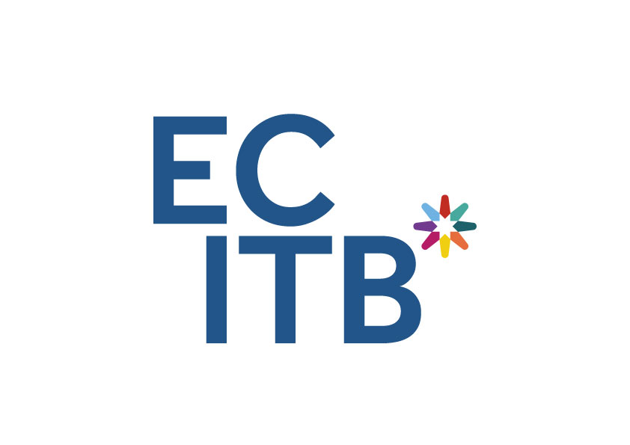

Board Member -

Engineering Construction Industry Training Board

Closing date:

12noon, 12th June 2023





Contents

Introduction 3

Your work 6

Who we’re looking for 8

Board diversity 9

How to apply 10

Terms of appointment 11

Complaints 12

Introduction

Dear Candidate

I am delighted that you are considering joining the board to take the Engineering Construction Industry Training Board (ECITB) forward and advance its mission of delivering engineering construction excellence through leadership on skills.

The Department for Education is keen to support equality of opportunity for a truly diverse population. Of course, diversity means many things. It means gender, ethnicity and people with disabilities - but it also includes people with a variety of viewpoints and from the widest range of backgrounds, such as underrepresented groups, or those based outside London and the South East. It would also include applicants who have achieved success through non-traditional educational routes and with diverse life experiences, expertise and backgrounds.

As the statutory skills body for the engineering construction industry in Great Britain, the ECITB facilitates training and skills development across the industry and its approximately 190,000 strong workforce. We do this by working closely with employers, training providers and governments, to attract, develop and qualify personnel across a wide range of craft, technical and managerial disciplines, as well as supporting the transferability of skills between sectors and projects.

In September 2022 we launched our new strategy for 2023-25. Building on measures enacted by the ECITB to secure skills during the pandemic, the strategy pledges £87 million to support workforce training and tackle labour shortages and skills gaps over the next three years.

The publication of our strategy was followed by a consultation on our levy proposals for 2023-25. This consultation, which takes place every three years, confirmed that engineering construction companies had voted resoundingly in favour of our proposed levy rates, with 85% of levy-paying employers, representing 97% of the industrial training levy paid, supporting the proposal. This result provides us with a strong and renewed mandate to lead industry learning.

We have an exciting agenda ahead of us. Over the next 3 years, the ECITB will focus on supporting growth in the engineering construction industry by helping to address skills challenges, as employers look to expand the workforce to deliver a growing number of projects earmarked on the horizon. These projects are forecast to require an additional 25,000 workers by 2026 and span a range of sectors including nuclear, renewables, oil and gas, water treatment, food, and drink. They will also include hydrogen and carbon capture projects linked to the decarbonisation of the industrial clusters, which are at the heart of the country’s net zero plans.

Becoming a trustee for the ECITB is an opportunity to contribute to the prosperity of Great Britain by helping to deliver the skills for this cornerstone industry.

If this prospect inspires you, I look forward to receiving your application and meeting with you in due course.
Yours sincerely,



Lynda Armstrong
OBE Chair



Information about the Engineering Construction Industry Training Board.
Please see below for links to more information about this Public Body including their aims, their core values, how they are funded and what their long-term objectives are.

About the ECITB - ECITB
The ECITB Strategy 2023 - 2025: Leading Industry Learning - ECITB
The ECITB Industrial Training Levy - ECITB

Your Work

Body: |  | Engineering Construction Industry Training Board
Appointing Department: |  | Department for Education
Sector: |  | Education
Location: |  | The Board meets six times a year. Meetings generally take place in London. Trustees will also be required to undertake occasional travel to meetings with stakeholders as an ECITB ambassador.
Number of Vacancies: |  | Up to four
Remuneration: |  | All reasonable travel expenses incurred in connection with the role are payable by the ECITB.
Time Requirements: |  | Up to 12 days per year for a duration of four years.

Role Purpose

It is a fascinating time to join the Board of the ECITB. The criticality of engineering construction skills to delivering the country’s net zero ambitions has been brought into even sharper focus by recent global events. Finding sufficient people to meet the needs of the industry is high on the agenda and is one of the factors driving an industry-wide attempt to improve the diversity of its workforce. The Board, under the guidance of its chair Lynda Armstrong OBE, has successfully concluded a strategy consultation with industry and the governments of England, Scotland and Wales on a new three-year strategy.

The ECITB is now looking for exceptional candidates who will quickly understand the needs of the engineering construction industry, and drive the organisation towards helping the industry attract, train and develop the skilled workforce it needs.
Trustees will work with the Chair to hold the Executive Team to account for delivery of the organisation’s offer to the engineering construction industry. They will also act as motivated and enthusiastic ambassadors of the ECITB.

The ECITB is looking for individuals engaged in the employment of people in engineering construction as well as those with a wider skills background, particularly with an understanding of the technologies for industry 4.0 and net zero. Candidates from SMEs, as well as large companies, from the engineering construction industry are welcome and we positively encourage applications from candidates from differing cultural and ethnic backgrounds.

Principal Responsibilities:

- support the Chair in ensuring ECITB policies and actions meet the needs of the engineering construction industry and support the wider strategic policies of governments in England, Scotland and Wales.
- ensure the ECITB meets its statutory, legal and regulatory obligations, and delivers against its core purposes.
- promote the support ECITB provides to the industry and represent the organisation at external functions, meetings and events.
- enthusiastically lead and participate in committees such as the Audit and Risk Committee, Remuneration and Nominations Committee and Qualifications and Awards Committee, bringing impartiality and objectivity to the decision-making process.
- furthermore, one of the Trustees will be Chair of the Advisory Council. This will require a dynamic and inclusive approach to leading this important advisory body.
- ensure that decisions are taken in the best, long-term interests of the organisation and industry and take collective ownership of Board decisions.
- conduct regular self-assessments and assessments of Board and Council effectiveness, as well as undertake an annual performance review with the Chair.

Who We’re Looking For

Applicants will be assessed against the following criteria. In your application you should demonstrate clearly how you meet each of the following essential requirements of the post:

- demonstrate a strong and visible commitment to the ECITB and its role in helping the industry attract, train and develop the skilled workforce it needs
- strong interpersonal communication and influencing skills to successfully engage and influence a range of senior stakeholders
- understanding and commitment to the skills needs of the engineering construction industry in Great Britain
- recent experience at a senior level and a successful track record of achievement.

You should also have skills in one or more of the following areas:
- engineering
- digital
- Finance/Audit, including risk management
- skills and training
- governance and legal understanding
- qualifications and awards
- knowledge of at least one of the following sectors: oil & gas, power generation, nuclear, renewables, food & drink, pharmaceutical and chemicals
- experience of industry associations

Desirable criteria
- A good understanding of the employment needs and emergent trends and developments within the engineering construction industry and a capability to use that knowledge to shape the future development of the ECITB is preferable but not essential.

We will sift on the essential criteria. The desirable criteria will be reviewed in the event of a tie.
Board Diversity
The Department is focused on equality of opportunity and is committed to ensuring that public appointments better represent the views of the communities which they serve. We particularly encourage applicants from underrepresented groups, those based outside London and the South East and applicants who have achieved success through non-traditional educational routes.

The Department for Education has a strong culture of inclusion and diversity and it wants to encourage applications from people with a diverse range of backgrounds and educational routes. In 2018 we launched a five year strategy to create a department where everyone is able to bring their whole self to work and where honesty, challenge and innovation are encouraged and valued. We are recognised by leading diversity organisations for promoting diversity in the workplace.

We want to ensure any appointee to the Department’s arm’s length bodies is committed to promoting diversity, in its broadest possible sense. This will include embedding a commitment to the principles of levelling up and championing opportunity for all across the organisation, helping to ensure that the organisation is one which a genuinely diverse range of views can be expressed, without fear or favour.

CHAMPIONING SOCIAL MOBILITY
The Department champions social mobility in all of its policies and is committed to opening up opportunities for people from all backgrounds, all socio-economic classes and all regions of the UK. We are committed to embedding this principle into our recruitment and public appointments and expect all our leaders, including in arm’s length bodies, to take action to attract and retain staff from all backgrounds, while also supporting them to progress within their careers.

DISABILITY CONFIDENT
We are a member of the Government’s Disability Confident scheme and have achieved Disability Confident Leader status, signifying our role as champions of the scheme. We use the Disability Confident symbol, along with other like-minded employers, to show our commitment to good practice in employing people with a disability.
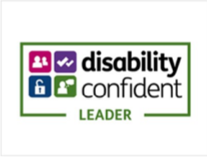
We ask that all applicants complete an anonymised Diversity
Monitoring Form used for gathering data only in order to
ensure departments are recruiting from the widest possible
pool. The information you provide is held by the
Public Appointments team and not shared with the selection panel

How to Apply
The closing date for applications is 12noon, 12th June 2023.

In order to apply you will need to create an account or sign in to the public appointments website.

Once you are logged into your account, click on 'apply for this role' and follow the on-screen instructions.

To apply, all candidates are required to provide:
- a Curriculum Vitae (CV)
- a supporting statement
- equality information
- information relating to any outside interests or reputational issues.

We will ask you to check and confirm your personal details to ensure your application is accurate.

You will also have the opportunity to make a reasonable adjustment request or apply under the disability confident scheme before you submit your application.

Terms of appointment
Location
Various. Board Meetings are usually held in London, in person but can be made accessible virtually, if required. Trustees may also be required to conduct visits at Employer sites from time to time and some Board Meetings may occasionally be held at different locations across the UK.

Time requirement
Up to twelve days per year

Term
Four years

Remuneration
Not remunerated

Expenses
All reasonable travel expenses incurred in connection with the role are payable by the ECITB.

Pension
The post is not pensionable.

Conduct and standards in public life
Members are expected to demonstrate high standards of corporate and personal conduct and are required to adhere to the code of conduct for board members and demonstrate a sound understanding of and commitment to the 7 principles of public life, both of which can be found here: https://www.gov.uk/government/publications/code-of-conduct-for-board-members-of-public-bodies,
https://www.gov.uk/government/publications/the-7-principles-of-public-life.

Complaints
If you would like to make a complaint regarding your application please contact Emma Davies c/o Jennifer.weir@education.gov.uk. We will acknowledge your complaint upon receipt and respond within 15 working days.

If you are not content with our response, please contact the Commissioner for Public Appointments at: publicappointments@csc.gov.uk .

Further information on complaints can be found on the Commissioner for Public Appointment’s website:
https://publicappointmentscommissioner.independent.gov.uk/


