

Deputy Further Education Commissioner (Quality)
Candidate information pack
January 2023

Closing date for applications: Friday 24 February 2023

Contents
Closing date for applications: Friday 24 February 2023 1
Introduction from the Secretary of State for Education 3
Introduction from the Further Education Commissioner 4
Your work 5
Who we’re looking for 6
Board Diversity 7
Championing social mobility 7
Disability Confident 7
How to apply 8
Terms of appointment 9
Principles of Public Life 10
Complaints 11

Introduction from the Secretary of State for Education
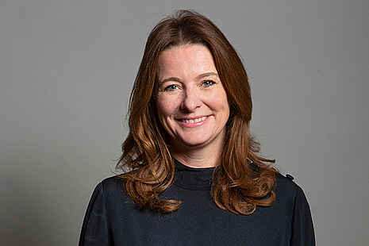
Thank you for your interest in applying to join the Further Education Commissioner’s team as a Deputy Further Education Commissioner.
In this sector-leading role, you will have the opportunity to support colleges and further education providers across England, making sure that they are equipped with the tools to provide outstanding education and training.
You will work directly with the Further Education Commissioner to support their work, engaging with ministers, civil servants, and of course colleges and other members of the further education sector.
With the work of the Further Education Commissioner now more focussed than ever on providing active support to all colleges, you will have a pivotal role in shaping this offer, engaging directly with institutions to share your experience and expertise. You will also lead on cases where colleges require more in-depth support and intervention, helping to drive up standards. In addition to working with the Further Education Commissioner’s team, you will engage with members across my department to provide insight on policy.
At the Department for Education we are keen to support equality of opportunity and to ensure that we are a reflection of the people we serve. We champion diversity across gender, race and disability, and encourage applications from a wide range of viewpoints and backgrounds, including those based outside London and the South East, and those who have achieved success through non-traditional educational routes.
If you are someone with a deep understanding of the FE sector, excellent leadership and people skills, and a passion for ensuring outstanding education and training is available to all, I look forward to hearing from you.

Rt Hon Gillian Keegan MP
Secretary of State for Education

Introduction from the Further Education Commissioner

Thank you for your interest in applying for a role as Deputy Further Education Commissioner.
As a key member of my team, you will be playing a direct part in ensuring that FE and sixth form colleges across England are in the strongest possible position to provide an outstanding standard of education and training. We are also extending this support to Local Authorities who deliver directly funded education and skills.
As a fairly new Further Education Commissioner, I have led a dedicated team of Deputies and Advisers for the past year. The focus of our work has changed to supporting all colleges in the sector and encouraging the sharing of effective practice. There remains a small amount of formal intervention oversight and support.
I am looking for candidates with a deep understanding of the FE sector, who have an outstanding track record of leadership and delivery and are highly motivated, with excellent people skills and the ability to lead and drive work with energy, passion and skill. The start date for terms of office are negotiable and could be as late as the Autumn of 2023.
If you think you have the requisite skills and experience, and if you share my passion and commitment to ensure that we are able to deliver world-class education and training for young people in England, then I look forward to hearing from you.

Shelagh Legrave CBE
Further Education Commissioner

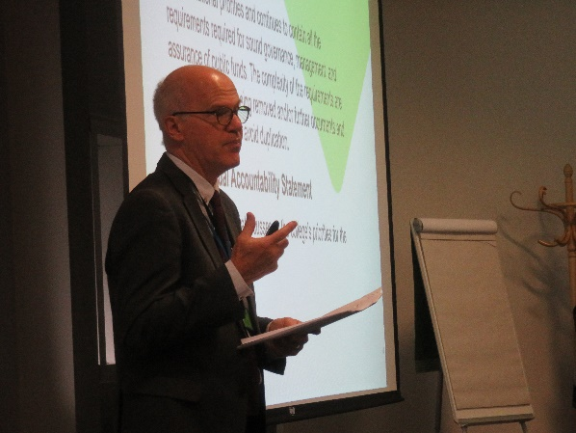
Your work
As part of the government’s approach to support further education (FE) colleges and other FE institutions, Deputy FE Commissioners are providing active support to all colleges.
They also, as required, assess colleges who are in intervention, advising ministers and senior officials on any relevant course of action. They ensure the end-to-end process of assessment is managed effectively and that any necessary changes are delivered swiftly and communicated to those affected.
Deputy FE Commissioners work across the following areas supporting the Further Education Commissioner:
Help and support for colleges, which includes:
- Health checks: supporting colleges who believe that they are at risk from a quality and/or financial perspective (but have not reached a trigger for formal intervention), by looking at their approach to managing the risks they face
- Best practice guides
- Tailored support for colleges
- Active support for the recruitment of senior leaders and board appointments
- Post intervention monitoring and support (PIMS) for those colleges moving out of intervention
Intervention assessments: assessing the capacity of the existing governance and leadership of a college to deliver rapid and sustainable improvements where serious weaknesses and risk of failure have been identified. These may be followed up with stocktake visits to review the progress of the college against the recommendations made within the intervention report.
FE Commissioner local provision needs assessments: examining the options for achieving long term sustainable provision in a local area where the issues cannot be solved by looking at individual institutions in isolation.
FE Commissioner led structure and prospects appraisals: a structured way of assessing options to change a college’s structure and/or provision in a clear, objective and evidence-based way.

Who we’re looking for
The FE Commissioner determines the allocation of activities between Deputy Commissioners and FE Advisers.
Deputy Commissioners work with the FE Advisers and the ESFA to determine the best way in which further education can be delivered in any given area, having regard to the needs of learners, employers, national and local FE policies and value for money, the overall quality of work undertaken, and the outputs.
A key element of the Deputy FE Commissioner role will be the leadership and management of FE Advisers.
Successful candidates are required to demonstrate the following essential criteria:
- Senior level academic experience of measuring success in an education context.
- Ability to lead and influence complex organisational change within an educational context, delivering at pace.
- Ability to develop and implement quality and improvement strategies.
- Outstanding written and verbal communication skills and the ability to influence, persuade and engage stakeholders at the highest levels, in addition to excellent management and interpersonal skills.
- Ability to work effectively with ministers, civil servants, college leaders and key stakeholders, demonstrating resilience and the ability to maintain a positive approach in challenging circumstances.
- An understanding of the regulatory framework within which FE institutions operate.

There is a degree of flexibility around start dates, but we expect all successful candidates to take up their position in autumn 2023.

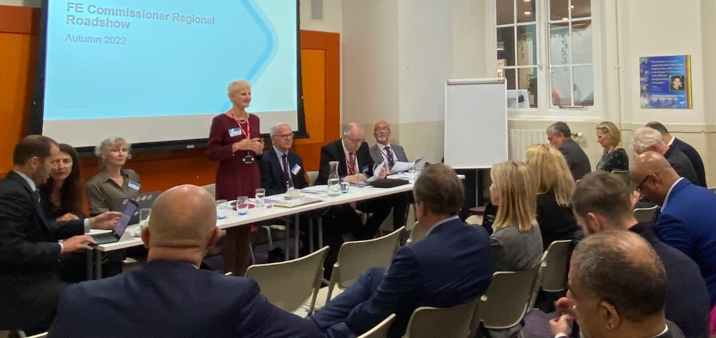

Board Diversity
The Department is focused on equality of opportunity and is committed to ensuring that public appointments better represent the views of the communities which they serve. We particularly encourage applicants from underrepresented groups, those based outside London and the South East, and applicants who have achieved success through non-traditional educational routes.
The Department for Education has a strong culture of inclusion and diversity, and it wants to encourage applications from people with a diverse range of backgrounds and educational routes. In 2018 we launched a five-year strategy to create a department where everyone is able to bring their whole self to work and where honesty, challenge and innovation are encouraged and valued. We are recognised by leading diversity organisations for promoting diversity in the workplace.
We want to ensure any appointee to the Department’s arm’s length bodies is committed to promoting diversity, in its broadest possible sense. This will include embedding a commitment to the principles of levelling up and championing opportunity for all across the organisation, helping to ensure that the organisation is one which a genuinely diverse range of views can be expressed, without fear or favour.

Championing social mobility
The Department champions social mobility in all of its policies and is committed to opening up opportunities for people from all backgrounds, all socio-economic classes and all regions of the UK. We are committed to embedding this principle into our recruitment and public appointments and expect all our leaders, including in arm’s length bodies, to take action to attract and retain staff from all backgrounds, while also supporting them to progress within their careers.

Disability Confident
We are a member of the Government’s Disability Confident scheme and have achieved Disability Confident Leader status, signifying our role as champions of the scheme. We use the Disability Confident symbol, along with other like-minded employers, to show our commitment to good practice in employing people with a disability.

We ask that all applicants complete an anonymised Diversity Monitoring Form used for gathering data only in order to ensure departments are recruiting from the widest possible pool. The information you provide is held by the Public Appointments team and not shared with the selection panel.

How to apply
The closing date for applications is Friday 24 February at 23:59.

Information on the timetable for this campaign, selection process and the Advisory Assessment Panel can be found on the Centre for Public Appointments website: Search and apply – Apply for a public appointment – GOV.UK.

Please submit the following documents by email to:
PublicAppointments.APPLICATIONS@education.gov.uk

- A CV.
- Candidate application form.
- Diversity form.

Please include the vacancy title in the subject box and submit each application document as a separate attachment.

We are happy to accept applications in alternative formats from applicants who, for reasons of disability, may find it difficult to fill in our standard form. If you would like to have a chat with us about reasonable adjustments please contact us at: PublicAppointments.APPLICATIONS@education.gov.uk

Please note the following:
- we cannot accept applications submitted after the closing date;
- applications will be assessed solely on the documentation provided; please refer to the advert and checklist above to ensure you have provided everything requested;
- applications will be acknowledged upon receipt;
- feedback cannot be given at application stage; it will only be given to candidates unsuccessful following interview.

Terms of appointment

Location
These posts involve significant travel, and it is expected that the successful candidates will use their home as a base.

Time requirement
The Deputy Commissioner will be required for a maximum of 200 days work per year.

Term
This appointment will be made on the basis of a 3-year fixed-term appointment from September 2023 to September 2026. There is no entitlement to paid annual or public holiday leave.

Remuneration
The role of Deputy Education Commissioner will be remunerated at a rate of £700 per day.
It is required that post holders will be engaged on a PAYE basis through the Department’s payroll system.

Expenses
In performing the services required by these roles, out of pocket travel and subsistence costs may be reimbursed by DfE subject to the limits set by the Department.

Pension
The post is not pensionable.
These appointments are made subject to Disclosure and Barring Service (DBS) check clearance and due diligence checks

Conduct and standards in public life
Members are expected to demonstrate high standards of corporate and personal conduct and are required to adhere to the Code of Conduct for Board Members of Public Bodies and demonstrate a sound understanding of and commitment to the principles of public life (see next page).

Principles of Public Life
In 1995, the Committee on Standards in Public Life defined seven principles which should underpin the actions of all who serve the public in any way.
Consistent with the Governance Code, applicants will be assessed on merit, and all candidates for public appointment will need to uphold the standards of conduct set out in the Seven Principles of Public Life. These will be tested as part of the selection process and the Selection Panel must satisfy itself that all candidates for appointments can meet these standards; which are:

Selflessness
Holders of Public Office should take decisions solely in terms of the public interest. They should not do so in order to gain financial or other material benefits for themselves, their family, or other friends.

Integrity
Holders of Public Office should not place themselves under any financial or other obligation to outside individuals or organisations that might influence them in the performance of their official duties.

Objectivity
Carrying out Public Office business, including making public appointments, awarding contracts, or recommending individuals for rewards and benefits, holders of public office should make choices on merit.

Accountability
Holders of Public Office are accountable for their decisions and actions to the public and must submit themselves to whatever scrutiny is appropriate to their office.

Openness
Holders of Public Office should be as open as possible about all the decisions and actions that they take. They should give reasons for their decisions and restrict information only when the wider public interest clearly demands.

Honesty
Holders of Public Office have a duty to declare any private interests relating to their public duties and to take steps to resolve any conflicts arising in a way that protects the public interest.

Leadership
Holders of Public Office should promote and support these principles by leadership and example.

Complaints
Please contact the Department for Education’s Public Appointments team if you would like to make a complaint regarding your application at: PublicAppointments.DFE@education.gov.uk
We will acknowledge your complaint upon receive and respond within 15 working days.
If you are not content with our response please contact the Commissioner for Public Appointments at: publicappointments@csc.gov.uk
Further information on complaints can be found on the Commissioner for Public Appointment’s website:
https://publicappointmentscommissioner.independent.gov.uk/

© Crown copyright 2022
This publication (not including logos) is licensed under the terms of the Open Government Licence v3.0 except where otherwise stated. Where we have identified any third party copyright information you will need to obtain permission from the copyright holders concerned.
To view this licence:
visit www.nationalarchives.gov.uk/doc/open-government-licence/version/3
email psi@nationalarchives.gsi.gov.uk
write to Information Policy Team, The National Archives, Kew, London, TW9 4DU
About this publication:
enquiries www.education.gov.uk/contactus
download www.gov.uk/government/publications

 | Follow us on Twitter: @educationgovuk |  | Like us on Facebook:  facebook.com/educationgovuk

