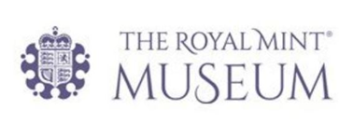
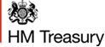

Non-Executive Member (Artist)
Royal Mint Advisory Committee
2022 Recruitment Information Pack

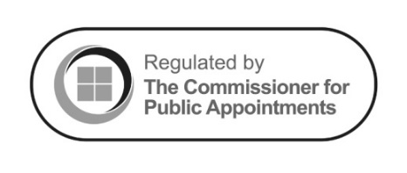

Contents:
Welcome Note | 3
About the Royal Mint Advisory Committee | 4
Candidate Specification | 5
Time Commitments | 6
Recruitment | 6
Equal Opportunity | 6
Timetable | 7
How to Apply | 7
Complaints | 8

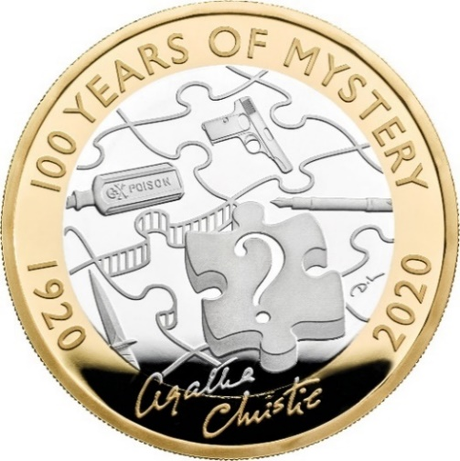
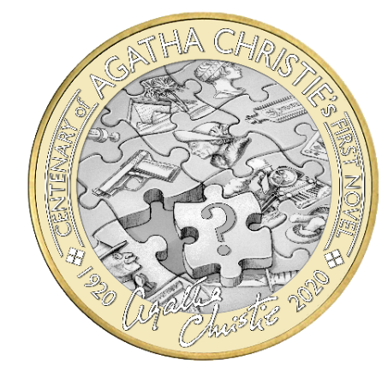

One of the initial drawings received for the Agatha Christie two-pound coin (left) and the final coin (right).
Welcome Note from the Chair of the Royal Mint Advisory Committee
Dear Applicant,
Thank you for your interest in this role. The Royal Mint Advisory Committee (RMAC) is an organisation with an outstanding place in the cultural history of the United Kingdom. Established in 1922 with the approval of George V, since then we have sought continually to raise the standard of numismatic and medallic art in the United Kingdom. From innovative designs in the 1930s, to the 1977 Silver Jubilee crown, the 2012 London Olympics series, the new £1 coin and the 2020 Diversity Built Britain 50 pence, we have been at the forefront of the United Kingdom’s most iconic coin designs. Furthermore, working with Government departments throughout Whitehall, we have led efforts to design medals, seals and decorations for several organisations across the nation. We actively engage with partners from public life in the United Kingdom to provide independent, bold advice on numismatic matters, ensuring excellence in delivery. We take a long-term view, understanding the permanent nature of coinage and this philosophy, of expertise in public service, is a core tenet of our operations.
We have several high-profile partners and stakeholders, including HM Treasury, Cabinet Office and the Crown.
The Committee, HM Treasury and the Royal Mint celebrate diversity in all our work and promote equality of opportunity. We are open to new ideas and challenges, and we are actively searching for a diverse range of candidates and encourage applicants from all backgrounds, irrespective of race, age, disability, gender, marital status, religion and sexual orientation.
We wish you the very best of luck with your application.

Baroness Gisela Stuart, Chair of the Royal Mint Advisory Committee

About the Royal Mint Advisory Committee
Our work
United Kingdom coinage: We advise the Chancellor of the Exchequer, as Master of the Mint, and ultimately the Crown on designs for new United Kingdom coins. Generally, competitions are run between artists, or in limited cases the public, to prepare designs that RMAC judges on artistic merit and whether they are significant to the nation.
Official medals, seals and decorations: Every official medal issued since 1922 has been considered by RMAC, and we continue this proud tradition by advising Government departments on medals, seals and decorations. Generally, these are instigated by Government departments, with approval of the Crown or a Royal Warrant and the Committee seeks initial designs from several specialist artists.
Our partners
We deal with several Government departments in our work. However, coin designs are approved by the Chancellor of the Exchequer, before Royal approval by the Crown. Furthermore, when designing medals, seals or decorations we work closely with the sponsoring department, Cabinet Office and the Crown to ensure excellence in the delivery of our brief. We have championed a close, successful working relationship with Government departments across the United Kingdom, and we will look to strengthen these relationships further, moving forwards.
Membership
Our members are appointed by the Crown, on the recommendation of the Chancellor of the Exchequer and the Prime Minister. Members serve for an initial term of five years, with the opportunity of reappointment for a second term of five years.
Appointments to the Committee, which is classified as an Advisory Non-Departmental Public Body (lower tier), are regulated by the Office for Commissioner for Public Appointments. HM Treasury is the sponsoring Government department.
Ourselves, HM Treasury and the Royal Mint celebrate diversity in all our work and promote equality of opportunity. The Royal Mint and HM Treasury are disability confident employer scheme members.
We encourage applicants from all backgrounds, irrespective of race, age, disability, gender, marital status, religion and sexual orientation.

Candidate Specification – Non-Executive Member (Artist)
The Committee plays a central role in recommending designs for United Kingdom coins, official medals, seals and decorations. A non-executive member position is available. Specifically, the committee is looking for an Artist to fill this role, who occupies a senior position through the reputation of their work or their contribution to British art.
The purpose of a non-executive member is to play an active part in raising the standard of numismatic art in Britain, through judging artwork submitted, offering constructive comments on how it can be amended, suggesting suitable means of briefing artists and suggesting new artists to become involved in the design of coins and medals.
In selecting appropriate designs for coins and medals to commemorate royal, state and historic events, the nature of the role is necessarily national in its coverage, requiring a breadth of view and a clear sense of what constitutes good design.
The member will be expected to attend meetings of the Committee where, upon reaching consensus, design proposals will be forwarded for approval to the Government department concerned before being passed on to the Palace for royal approval.
The main specific skills that we are looking for in this appointment are:
- A strong awareness of the visual arts and a highly developed aesthetic sense.
- A solid awareness of historical and cultural art trends.
- Good knowledge of artists and designers, across a range of subject areas and disciplines, currently working in Britain.
- The stature to be able and willing to contribute constructively to discussions, and to influence the outcome of meetings.
The successful candidate will have the following experience:
- An artist occupying a senior position through the reputation of their work or their contribution to British art.
- Experience of group decision making.

Any successful candidate will be expected to abide by the Seven Principles of Public Life, these are:
1. Selflessness
2. Integrity
3. Objectivity
4. Accountability
5. Openness
6. Honesty
7. Leadership
More information on the Seven Principles can be found here: https://www.gov.uk/government/publications/the-7-principles-of-public-life/the-7-principles-of-public-life--2
As part of the recruitment process, this will be reviewed in due diligence checks, including social media checks that will be undertaken on short-listed candidates.

Time Commitments
Members are appointed for a five-year term, with the option of extending that term for a further five years. Members are expected to commit to attending five RMAC meetings per year. Under normal circumstances, the Committee meets in London. Some meetings can be held virtually or in a hybrid manner. Each of these meetings occur over one day. In between meetings, light level contact is expected. All travel and accommodation expenses will be paid.
The membership of the Royal Mint Advisory Committee does not receive remuneration.

Recruitment
The recruitment process will include an interview. The selection panel make a recommendation to HM Treasury who are responsible for proposing RMAC appointments to the Prime Minister, who in turn recommends appointments to His Majesty the King.
The selection panel will include:
- Baroness Gisela Stuart (Panel Chair, Chair of the Royal Mint Advisory Committee)
- Kunal Patel (Deputy Director of Debt and Reserves Management at HM Treasury)
- Roger Smith OBE (Independent Panel Member, Luxury Watchmaker)
If you have any interests that might be relevant to the work of the Royal Mint Advisory Committee, and which could lead to a real or perceived conflict of interest if you were to be appointed, please provide details in your covering letter.

Equal Opportunity
The Royal Mint and HM Treasury embrace diversity and promote equality of opportunity; we encourage applicants from all backgrounds, irrespective of race, age, disability, gender, marital status, religion and sexual orientation.
The Royal Mint and HM Treasury are disability confident employer scheme members.

Timetable
The recruitment timetable: (dates TBC)
Campaigns open | 7 November 2022
Closing date for receipt of applications | 6 January 2022
Panel sift | 16 January 2022
Interview with selection panel* | February 2022
Possible interview with the Exchequer Secretary to the Treasury** | TBC
Anticipated start date | March 2022
*Interviews may be conducted virtually. Further details will be provided closer to the time.
**Candidates recommended as suitable for appointment may be required to attend an interview with the Exchequer Secretary to the Treasury.

How to Apply
The closing date for applications is 6 January 2022. To apply for this role please send applications to:
Kevin.Clancy@royalmintmuseum.org.uk
All applications must include:
- The role title in the subject line (RMAC Non-Executive Member, Artist). We are recruiting in parallel for a RMAC Non-Executive Member, Art Historian, so please specify that you are applying for the Art Historian position. If you are applying for both, please specify in the email subject line, or send two separate applications.
- A CV, which provides details of your qualifications, employment history, skills and experience;
- A covering letter in which you succinctly address how your skills meet the requirements of the role;
- Names of at least two referees who may be contacted at short list stage, i.e. before final interview;
- Confirmation from you that you are happy for HM Treasury or HM Government to undertake any vital background checks, including career, credit and qualifications, or similar at the appropriate stage in the process. No checks will be undertaken without your prior knowledge.
Furthermore, the following forms should also be completed and attached to all applications:
- Diversity Monitoring Form: Annex 1
- Disability Confident Scheme, Political Activity, and Conflict of Interest Questionnaire: Annex 2
All applicants are encouraged to review the Public Appointment Recruitment Privacy Notice which can be found at Annex 3. If you have any questions about the appointment or the process, please do not hesitate to contact us by email at Kevin.Clancy@royalmintmuseum.org.uk
Stay informed
You can keep up to date with news about HM Treasury and the Royal Mint through a range of communication channels:
HM Treasury: https://www.gov.uk/government/organisations/hm-treasury
Twitter: @hmtreasury
Royal Mint: https://www.royalmint.com/
Twitter: @royalmintuk
Royal Mint Museum: https://www.royalmintmuseum.org.uk/about-us/royal-mint-advisory-committee/
Annual Report of the Committee in the Trading Fund Annual Report: Royal Mint Trading Fund: Annual Report and Accounts 2020 to 2021 - GOV.UK (www.gov.uk)

Complaints
This campaign is regulated by the Commissioner for Public Appointments and as such, if you are not completely satisfied with the departmental response to your complaint, you may refer it to the Office of the Commissioner for Public Appointments, at this link: Investigating Complaints - Commissioner for Public Appointments (independent.gov.uk)

